Shirley, Maria and Jake Block 5
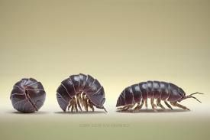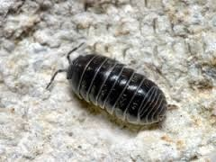

What Environment Do Pill Bugs Prefer?

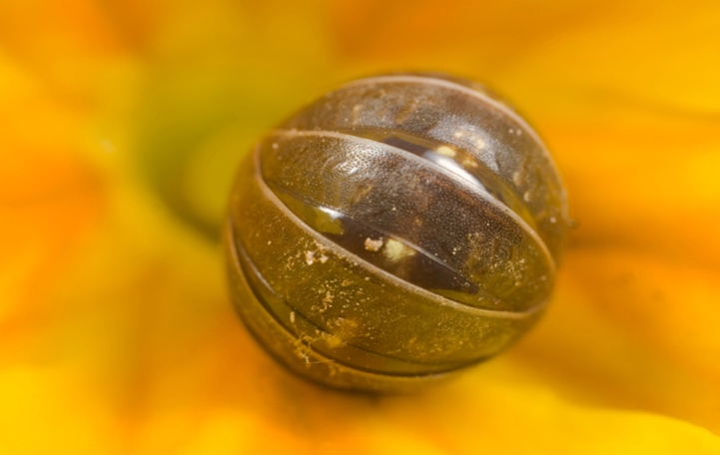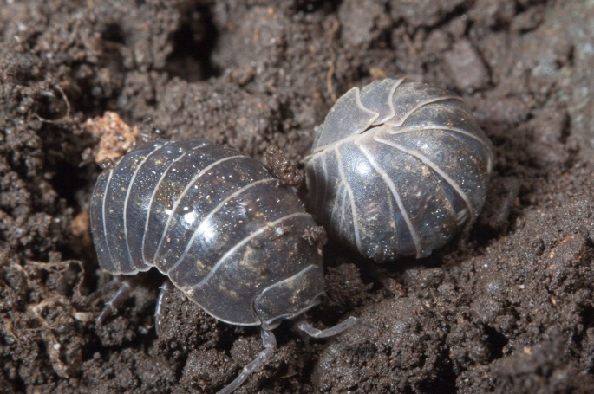

Habitat
Pill bugs like to live in places where there is moisture and dead plants they can eat, but they mostly live in forests and other humid habitats. They need a humid environment to live therefore, lots live under fallen trees. After it rains, lots of wood bugs come out because of the moisture the rain creates.

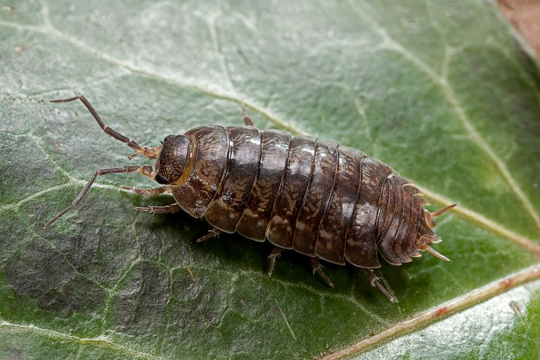

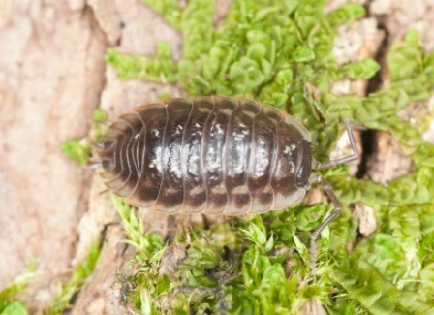

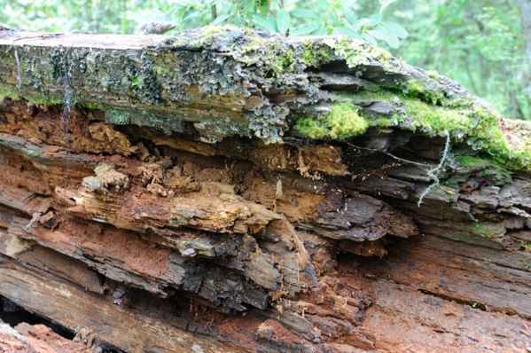
Hypothesis
Our hypothesis is that the wood-bugs will prefer the dark and moist environment over all the other options as wood-bugs prefer moist and wet environments in the wild. Wood-bugs are sensitive to the light therefore they will desire the dark more than the light.

Material List
- Wood
- Dirt
- Leaves
- Branches
- Water
- Paper
- Container
- Wood-bugs

Procedure:

Step 1: Collect your wood bugs
Step 2: Setup the environment depending on which environment is being tested
Step 3: Put wood bugs into centre of container
Step 4: Let wood bugs chose freely which side they want for 3 min
Step 5: Record the results

Procedure Picture
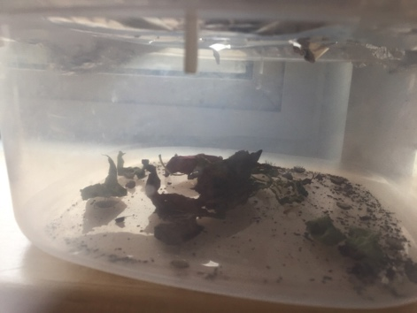

Qualitative Observations
We observed that since the wood-bugs didn’t have a long time discovering the environment we don’t believe the data is completely accurate. We also observed that the wood-bugs may be less intelligent as we expected because of the irregular pattern of the preference of the environments.

Graph And Data Table
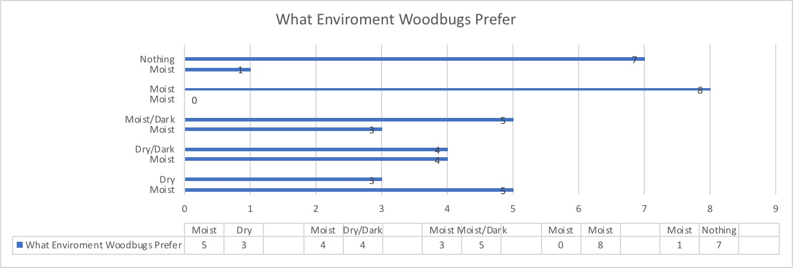

Conclusion
In conclusion, our hypothesis was mostly correct from our data, we could tell that the would bugs like the moist and dark environment the most. We also think that it may be subjective because when we did this experiment the wood-bugs couldn’t really tell what environment they prefer within the 3 minutes we gave them. We think they would need spend at least a day to figure out which environment they like.

