Take your kids to work day 2019 Jakub Strunc

Name of your host: Jan Strunc Relationship: Father
What is your title? Software engineer
2. What is your description?
My dad worked as a software engineer. He developed communication protocols and a graphical user interface for a telecommunication switch.
3. What are the duties and/or tasks you perform at your job?
He worked in the small team of software engineers. They designed, developed and tested communication protocols and graphical user interface for provisioning telecommunication switch. Specifically, my dad was responsible for development a software package, which was used for fault and performance monitoring of network communication.
4. What qualifications do you have for this job in the following areas?
a) training? C++ and Java programing languages, network protocols, software development tools for building and testing code
b) education? university degree in computer science
c) experience? Collaborative development, testing, and building software packages
d) skills and attributes (personal qualities)? work independently and work in the team, “can-do” attitude
5. What are some of the things you like about the job?
My dad created a product, which other people could use and see. He had to be creative, resolve challenges, work with others.
6. What are some of the things you dislike about this job?
I see a challenge that I would need to study for a long time and get some experience before I can do this job.
7. How do you anticipate this job changing in the next 5 years or so?
New technologies would come, there will be more and more automation in development and testing, also people will work more and more from their home.
Student Reflections:
1. Give three reasons why you would like this job (be specific):
- Work with different people in multinational team
- Learning new technologies
- Good salary
2. Give three reasons why you would not like this job (be specific):
- Must study and gain experience for a long time
- I want to have freedom, travel and work from home
- Work too long hours
3. Is this job for you? Why or why not?
I want to build new things, work with new technologies, be creative, work with different people.
4. Explain the value of the TYKTW experience in relation to your ideas about your post secondary (after high school) plans (education?, training?, travel?, work?).
After high school, I want to study computer engineering at the university.

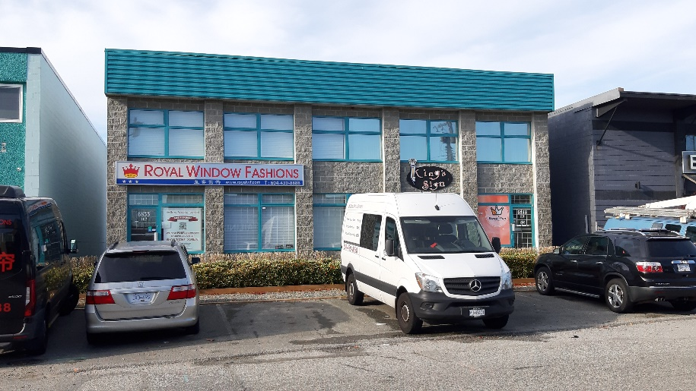
This is place, where my dad started his first job.

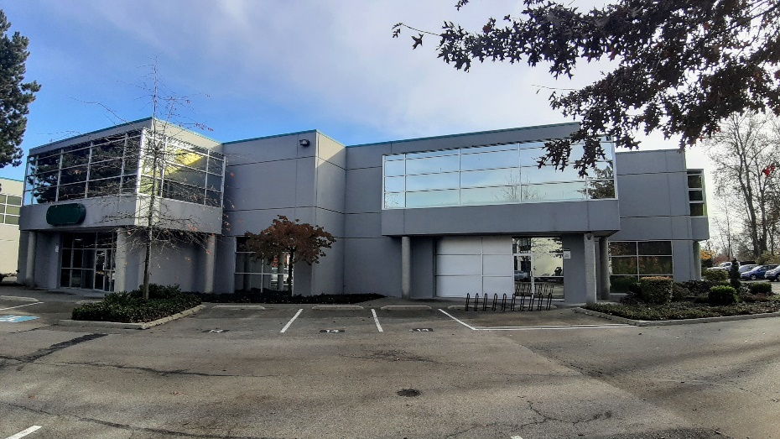

This is place, where his company moved.

