On an average day after school, I am usually going to one practice then rushing to get to my next sport. Most people would hate this, but for me this is what makes me happy. I am a multi-sport athlete. I play soccer, lacrosse, volleyball and cross country running. When I am playing sports, I feel free. All my worries about homework and friends go away. No matter what sport I am playing, I feel like it is a safe place. I can tell my teammates anything and they will be there for me. One thing that is hard about playing so many sports is time management. I play soccer 4-5 days a week all year round, in the fall I play volleyball 3 times a week, in the fall I do cross country 1-2 a week and, in the spring, I play lacrosse 5 times a week. I also must complete homework and get enough sleep. Not only that, but as a teenager, I like to hang out with friends and spend time with family. But as a student athlete, I knew that when I first started playing my sports and that I would have to work harder than most to manage my time.
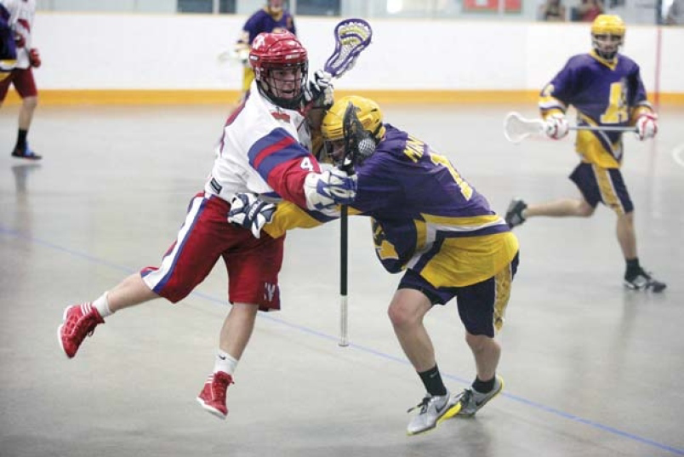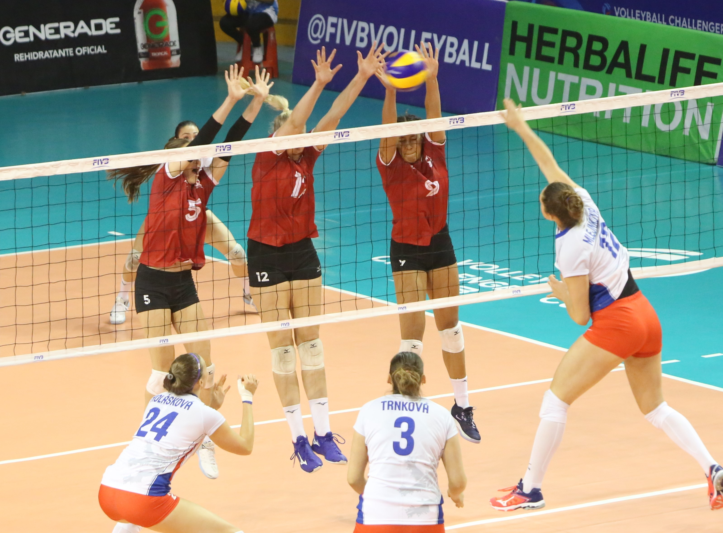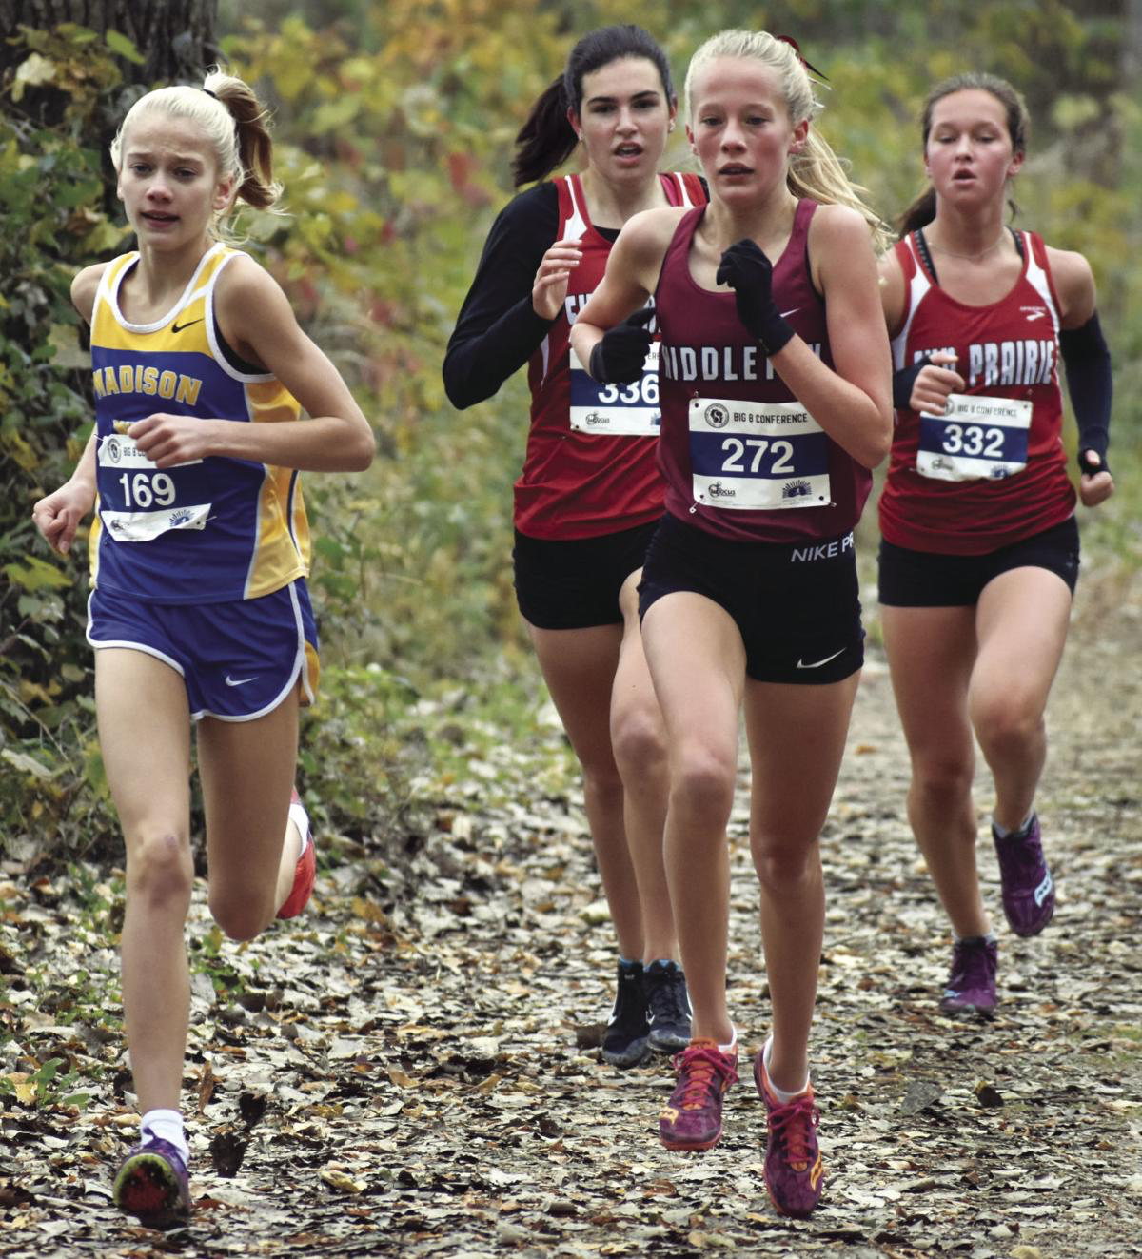
I have been playing soccer since I was 4 years old. It has been my passion since the first day I stepped on the pitch. I started it because of my sister playing from a young age as well, and I was always so intrigued by the sport. I remember the days where we would shop at Canadian Tire for soccer cleats and just buy the cheapest pair we could find. I still remember the dirt stains of the gravel field. When we fell our knees would get so scratched up and our eyes and mouth would be filled with gravel. At this age I was playing for Port Moody Soccer Club. Soccer didn’t change much for me until I turned __ in ___. I was on a team called the Grasshoppers. We played at Westhill every Sunday morning with Pug nets as goals. Our rivals were the Strikers. It was always a good battle when our two teams played each other. In _____, development soccer had started. We were only _ years old and already had the stress of tryouts! We were named the Diamonds. We were the best ream in the league. We went undefeated all season. It was on this team where I met some of my best friends for life. The Diamonds still make me who I am today. In ____, our team had to split because fields were getting better and we needed to switch clubs because little Port Moody Soccer Club just didn’t have enough girls show up at tryouts. Most of us went to Coquitlam Metro Ford Soccer Club. I hated switching clubs because I would have to play on the same team as my former rivals. I played in Coquitlam for two years, but it just wasn’t the right place for me. The coaching, players and atmosphere wasn’t the same as before.
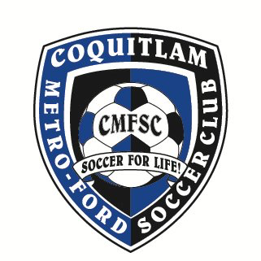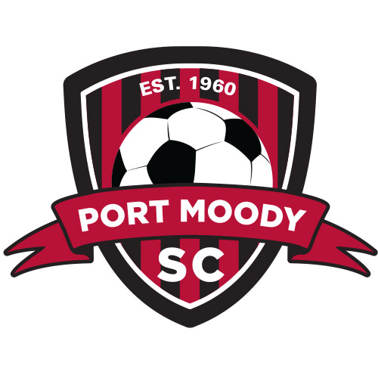
Soccer got to the point where soccer just wasn’t fun anymore, so I contacted the technical director at Burnaby District Metro Soccer. This took me to where I am today. I had my first training session with BDMS last December and knew that this is where I was going to play for the rest of my youth soccer years. My team was so kind and welcoming from the first time we met. About a month later I was offered a spot on the team. I was overjoyed! I couldn’t join the team until April however because I had already committed to Coquitlam for the rest of the season. Although, staying with Coquitlam for the rest of the season was a good thing because we ended up winning Coastal Cup and advancing to Provincials. Winning Coastal Cup gave me a feeling that I had never felt before. After the game ending whistle blew, I dropped to my knees and immediately started crying. It brought me back to my early days playing soccer. As captain of the team, I was the first to raise the cup and bring it home. I smiled all the way home and couldn’t stop taking pictures with the trophy all week. In the Provincial Tournament in Burnaby my team came in second place, but that didn’t hurt too much because I was so excited to be moving on to better things playing with BDMS. And that’s where I am today, I play for Burnaby District Metro Soccer. We have 3 training sessions and a game in one week. Each practice is an hour and forty-five minutes long and a game is eighty minutes. In a typical game I usually play, center mid and forward. My favourite position is forward because it lets me run and I get to go one on one against players and score many goals. In center mid my job is to distribute the ball and set up plays.
Soccer taught me how to work as a team, hard work, self-determination, and respecting coaches and adults. Since I was 4 years old, I was always a leader on the team. This means I help the coach with warm up and drills, I talk to my teammates when they are feeling down, I pump up the team before games and most of all I lead by example. These skills have helped me out so much in out of sports situations. For example, even in a classroom I use these leading by example and helping coaches/teachers. These skills that I have learned physically and mentally have improved my performance in other sports as well. Such as, lacrosse, volleyball and cross-country running.
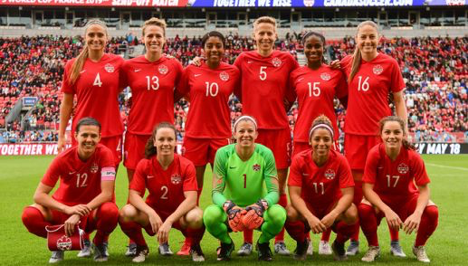
I have been playing box lacrosse for one year now. I had been told for years that I should join because of my size, speed and personality. I had my first practice In February of 2019 with Port Moody Lacrosse association. I automatically fell in love with the sport. However, there were some complications registering for the season, so I had to play with the Salmon Bellies for my first season. This was the best thing that could’ve happened to me. I had heard a little bit of the Salmon Bellies legacy before I joined the, but I didn’t realize how tight of a community it is. Everyone in New West plays lacrosse, and it is a huge deal there. Everyone wears their Bellies merchandise with pride. On an average Thursday spring night in New West you will find people of all ages gathered at Queens Park Arena to watch the Salmon Bellies senior game. It reminded of the movies in America where the whole town watches their local high school football game.
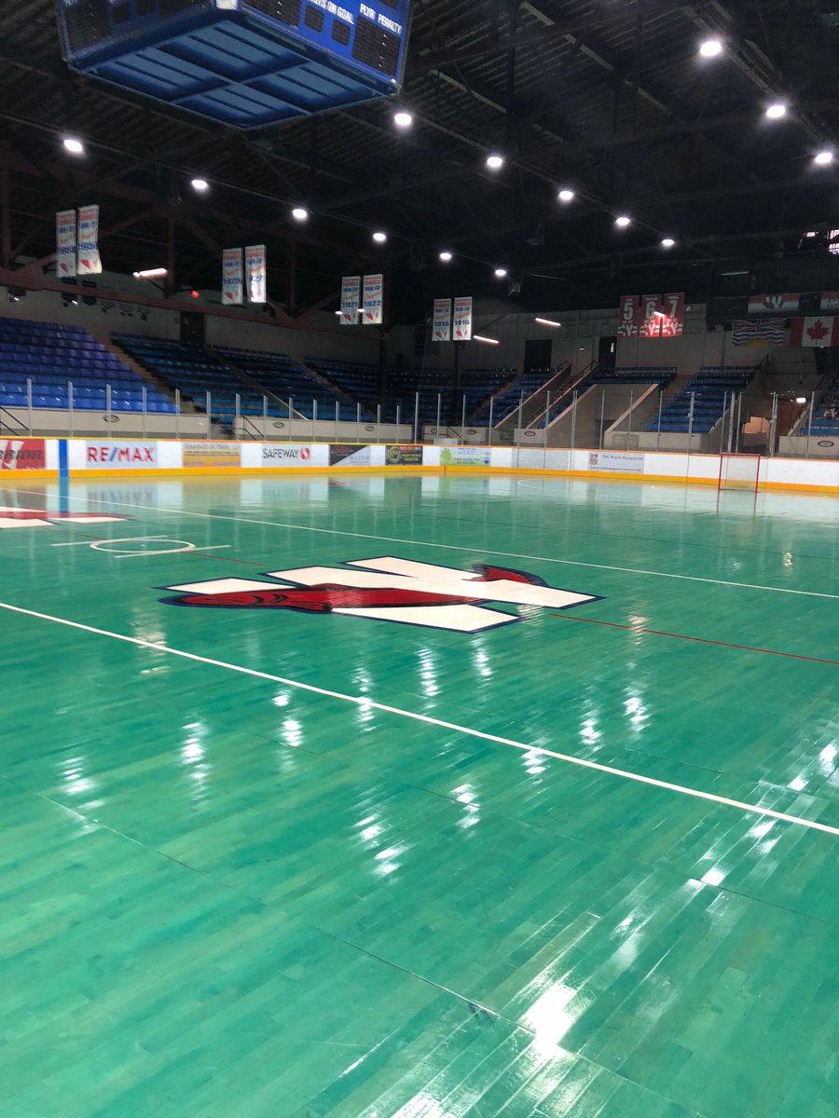
On April 4th, 2019, I played my first lacrosse game. We played against our rivals the Coquitlam Adanacs. This was the first time I had even met my team. It was so scary walking into a change room where everyone who had been playing the sport for years now and it was going to be my first game ever. Everyone on the team was a standing off a little bit because they didn’t know who I was or why I was coming into their team without practicing. At first, my coach was scared to let me go on the floor, but after one shift of me playing he wanted me to be at the front of the line. In the second period, I checked a girl, won the ball and ran all the way down the floor on a breakaway. I was running as fast as I could, and I took a shot on the left side and it went in! I suddenly gained the respect of my teammates and coaches. Throughout the season I continued to score many goals. I fell in love with the sport, and Queens Park Arena became my second home. In the Dorothy Robertson Tournament, I was named tournament MVP for my team and in the Adanac Challenge Tournament I was named game MVP in the final game. In June, we played Langley to qualify for provincials. It was a close game, but we pulled away with the win at the end with a final score of 8-6. Provincials were in Nanaimo this year. Provincials were so much fun, I got to know my team so much better and have a fun lacrosse filled 4-day weekend. Although we finished 4th in the province, I had a blast with my team.
I also enjoy playing sports for my school. So far, I play on the volleyball team, cross country team and field lacrosse team. I hope to join the soccer team and maybe track and field. I have been on a school volleyball team since grade 6. In grade 6, I could barely pass the ball, but as I play more, my skills and knowledge of the sport improve. I was ecstatic when I saw the list posted of the 2019 grade 9 girls volleyball roster. I was the starting middle, and I helped us come 4th in districts. We made it to Fraser Norths, but unfortunately did not advance any further. At the same time, I was doing cross country running. I only do cross country for the fitness so I can improve in soccer, but it’s not as bad as people say it is! The vibes of cross country is my favourite part. Everyone who runs encourages others and treats them as equals. In the districts, my team won and in Fraser Norths I placed 29^{th.}
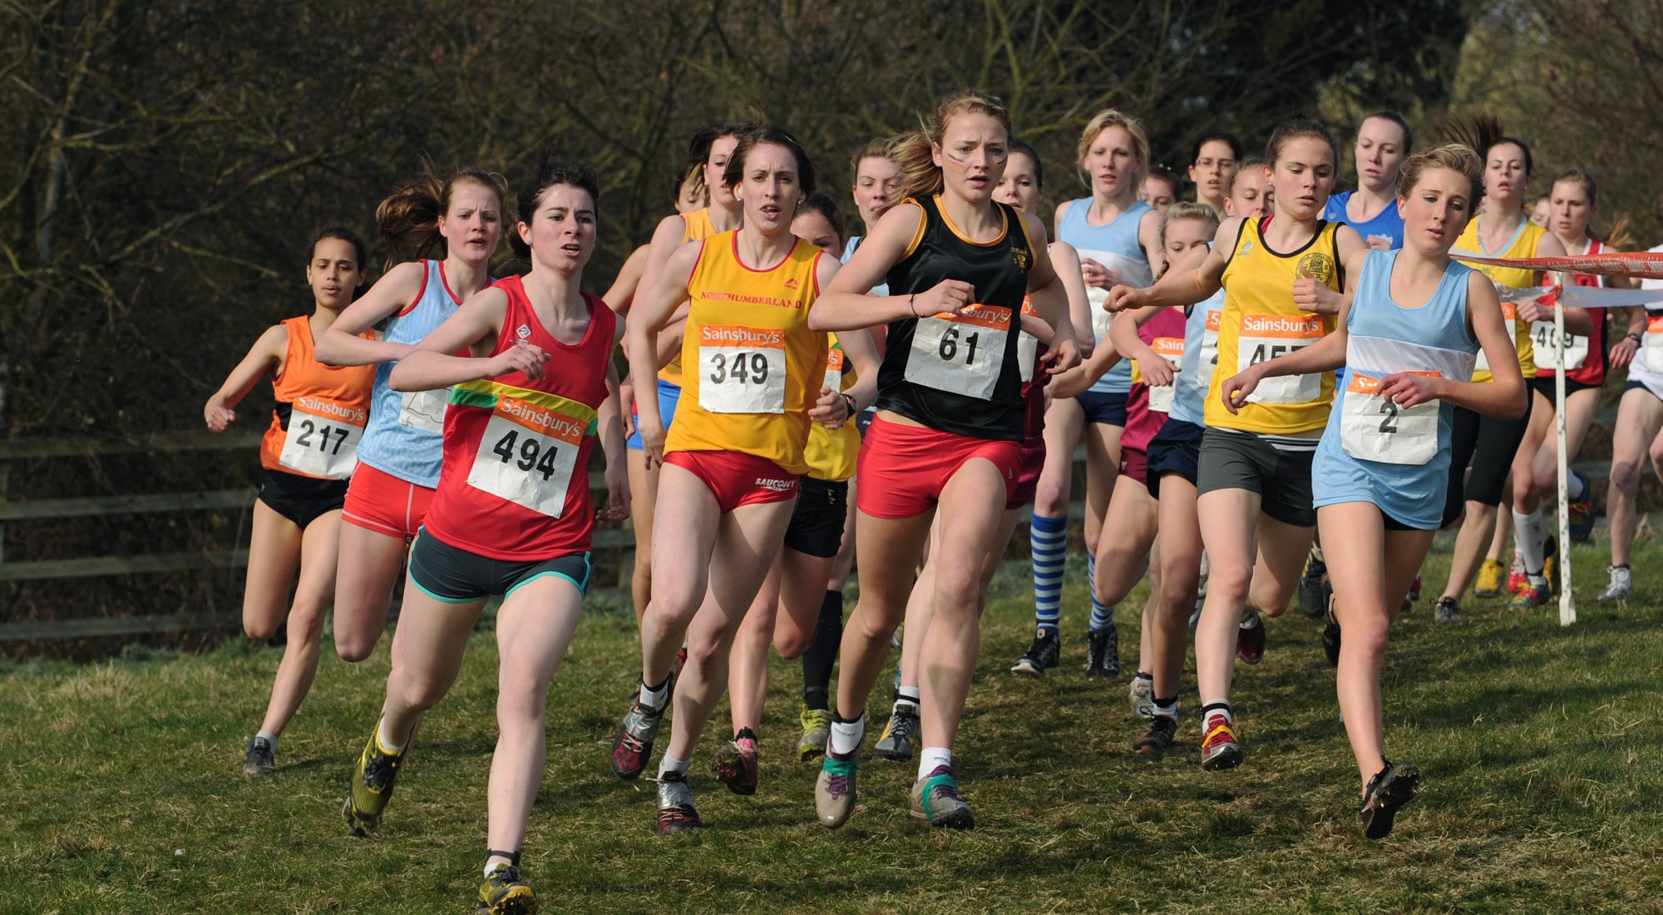
In conclusion, I play many sports and it may be hard to manage, but each sport has taught me so many things that just staying home and reading books could never teach me.

