EGG DROP
Yegrina, Jinyi, Yebitnara, Phil September 11~13, 2019
Plan Diagram (picture)
PLAN A
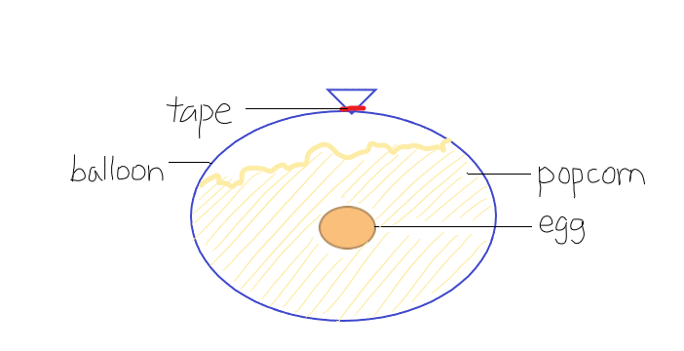
PLAN B
Inside:
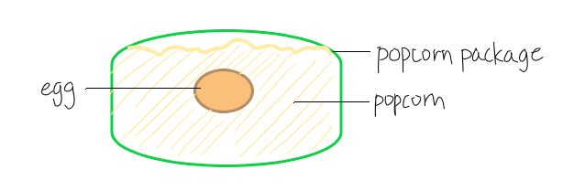
Outside:
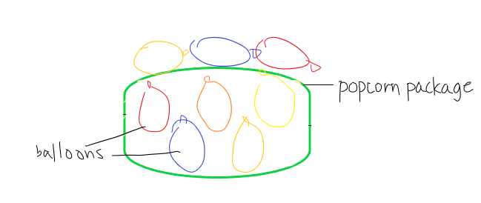
Observation:
BEFORE
Qualitative: Raw Egg – fragile, intact
Quantitative: 1 raw egg, 10 balloons, falling height – 4.55 meters,
AFTER
Qualitative: Raw Egg – buttery, didn’t break. Balloons didn’t pop or get damaged. However, some deflated because of time after preparing
Quantitative:1 raw egg, 10 balloons
Materials used: 1 raw egg, 1 plastic bag of popcorns, balloons, tape
Question: What type of container and materials would protect the egg from fall damage?
Hypothesis: If we use a balloon to keep the egg inside and fill the space with popcorn, then the balloon will keep the contents inside safe, and the popcorn will reduce the impact, because the balloon does not get damaged even if it is dropped, and the amount of popcorn can reduce the shock as the popcorn at the bottom minimizes the effect of the impact, therefore the popcorn at the top get less impact and act as a cushion for the egg.
-We decided to go with plan B-
We could not put the popcorn in, because the balloon was not big enough
Hypothesis: If we put the egg into the bag of popcorn and tape the balloons around the device, then the egg will be protected from impact, because the popcorn inside will reduce the shock, and the balloons will help the device not to flip when it is dropped.
Variables:
- Independent variable: The device
- Dependent variable: Raw egg in the device
- Controlled variable: Raw egg without any protection
Procedures (steps):
- Get a raw egg (dependent variable), a plastic bag of popcorns (independent variable, the device), tape, balloons
- Put the raw egg inside the package filled with popcorn
- Tape the bag to close the opening
- Inflate multiple small balloons
- Tape the balloons on to the bag, except the bottom area
- Check the overall design of the device to see if the opening and the balloons are taped securely
- Drop the device to check the result
- Open the package to check if the raw egg is damaged or not
- Record the data
Conclusion:
When we were researching about airdrops, we found out that foam peanuts are used to protect objects inside the box when sending packages. We thought that popcorn could also do the same job. When there is a large amount of popcorn, the popcorn at the bottom will absorb most of the shock. Popcorn at the top will take less of the impact and act as a cushion for the egg. Popcorn kernels have a variety of shapes, so it would be harder for the egg to sink to the bottom when there is a lot of movement in the device. We used the popcorn package to contain the egg and the popcorn, because it cannot be broken when it is dropped. If the container breaks, the egg could be unprotected. We also wanted the container to be able to keep all the stuff inside. That way, the device would be effective and reusable. The balloons can protect the egg from “aftereffect.” When the package flips after the first collision, it can flip to the side where the egg has less protection. We decided to attach the balloons to prevent damage.
Even though the egg did not crack, we hope that we could make a device that can protect the object for a long period of time; the balloons deflated after few days. Next time we will bring a Ziploc bag to an egg inside, so the egg doesn’t get buttery or contaminate the popcorn.
Sources (include the name of the website, title and the date of the article, then the link):
Leahey, Andrew. "Substances that Absorb Impact for Science Projects." Sciencing, 28 Apr. 2018, https://sciencing.com/substances-absorb-impact-science-projects-8400100.html

