**5.5 Conditional Probability**

**By the end of the lesson you will be able to:**

1. Understand and solve problems that involve dependent events

**Dependent events** are events where the ________________ of the event depends on the outcome of another event.



For example, drawing a heart from a standard deck of 52 playing cards and then drawing another heart from the same deck without replacing the first card are **dependent events.**



If one event, A, depends on another event, B, then we use ___________________ **Probability** to determine the probability that A occurs given that B has occurred.



____________ = _________ x _____________



**Example 1**



A computer manufacturer knows that, in a box of 100 chips, 3 will be defective. If you draw 2 chips, at random, from the box of 100 without replacing them, what is the probability that they are both defective?

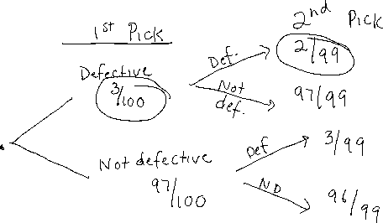

**Example 2**



According to a survey, 91% of Canadians own cellphones. Of those people, 42% have a smartphone. Determine, to the nearest percent, the probability that any Canadian you have met during the month in which the survey was conducted would have a smartphone.



**Example 3**

Hillary is the coach of an ultimate team. Based on the teams record, it has a 60% chance of winning on rainy days and a 70% chance of winning on dry days. Tomorrow, there is a 40% chance of showers. What is the probablity that Hillary’s team will win their game tomorrow?

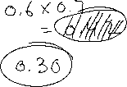

**Assignment**:

