6.1 Exploring the Graphs of Polynomial Functions
By the end of the lesson you will be able to:
- From a graph identify the following characteristics of a function: type (constant, linear, quadratic and cubic), degree, x-intercepts, y-intercepts, end behavior, domain, range and number of turning points.

Terms
Expressions are numbers, symbols and operators (such as + and ×) grouped together that show the value of something.
Example:
Terms: Are separated by ____ or ____
- Letters are variables and represent an unknown and changeable quantity.
- Coefficients are the numbers multiplied with the variables.
- Constant is a number by itself.

A polynomial (poly - _______________ nomial - __________________) is an _________________________ with 2 or more.
For example,

A function is a special relationship where every _________ (____) gives one and only one _________________ (___).
On a graph we can test if something is a function by doing a vertical line test. If we find a spot where
we can draw a vertical line ( ) and the line touches the graph 2 or more times, we know that we ______________ have a function.
For example,
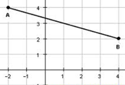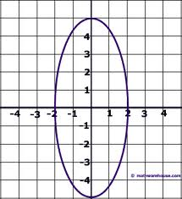
Qualities of Polynomial Functions
X-intercept is the place that the graph crosses the _____________.
We can solve for the x-intercept by reading it off the graph or plugging ___________ into the expression and solving for x.

Domain is the set of all possible _____ or _________ values and is expressed using an inequality or if all values are possible, we say ___________, which means that x is in the set of all real numbers.

Y-intercept is the place that the graph crosses the _____________.
Likewise, we can solve for the y-intercept by reading it off the graph or plugging ___________ into the expression and solving for y.

Range is the set of all possible ____ or _____________ values.

Degree is the _________________ exponent in the expression of a polynomial.
For example, f(x) = 3x³+2x²+ 6x -7 has degree _____.

Turning point is the point where the y-value changes from ___________ _____________.
(a)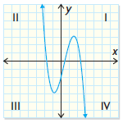 (b) 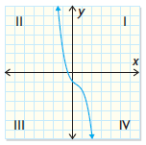
For example (a) has ____ turning points and (b) has _____ turning points.

End behavior is the description of which ________________ the end points of the graph are in.

Graph Quadrants
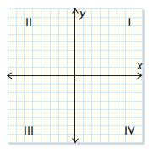

Properties of Polynomial Functions

Type
Degree, n
Sketch | 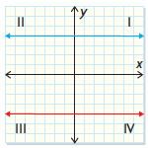 | 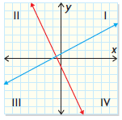 | 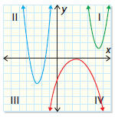 | 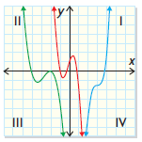
Number of
x-intercepts
Number of
y-intercepts
End Behavior | Line extends from quadrant ll to quadrant l or from quadrant lll into quadrant lV | Line extends from quadrant lll to quadrant l or from quadrant ll into quadrant lV | Curve extends from quadrant ll to quadrant l or from quadrant lll into quadrant lV | Curve extends from quadrant lll to quadrant l or from quadrant ll into quadrant lV
Domain | {x | x$∈$R} | {x | x$∈$R} | {x | x$∈$R} | {x | x$∈$R}
Range | {y | y = constant, y$∈$R} | {y | y$∈$R} | {y | y $≤$ maximum,  y$∈$R} or  {y | y $≥$ minimum,  y$∈$R} | {y | y$∈$R}
Number of Turning Points
Example Expression | y = 5 | y = 2x+5 | y = 3x^{2_} 2x+5 | y = x³ +3x^{2_} 2x+5

Example
Determine the x-intercept(s), y-intercept, end behavior, domain, range and number of turning points for each of the following graphs.

a) y = $\frac{1}{3}$x + 2

x-intercept(s)
y-intercept
end behavior

domain
range
number of turning points

b) y = (x-1)² – 2

x-intercept(s)
y-intercept
end behavior

domain
range
number of turning points

Assignment: P. 383 #1-3

