**Ch 3: Functions (Day 2)**

A function is a type of _______________

For every value of the domain (x-value) there is one and only one range (y-value)

**Are the following relations also functions?**

|  |  |  |  |
| --- | --- | --- | --- |
| *x* | *y* |  | {(1,2),(2,4),(3,6),(4,8)} |
| 1 | 1 |  |  |
| 3 | 9 |  | {(3,5),(3,7),(6,2),(-1,0)} |
| 5 | 25 |  |  |
| 4 | 16 |  | {(-2,1),(0,1),(1,1),(5,1),(6,1)} |
| -1 | 1 |  |  |

**Other ways to recognize a function vs. a relation:**

1. From an equation: to be a function, exponent of *y* must be 1.
2. From a table: a function cannot have repeat *x* values
3. From coordinates: a function cannot have repeat *x* values
4. From a graph: a function must pass **the. vertical line test**

**Ex: Which are functions?**

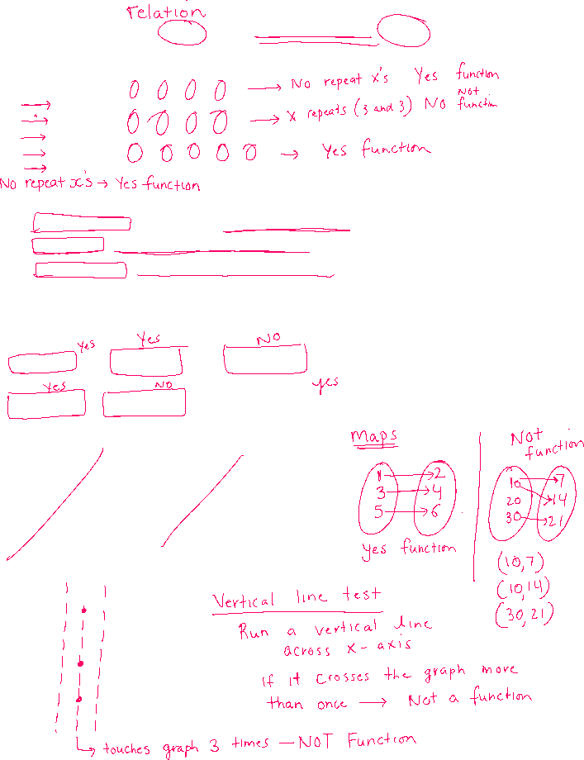

Equations:

  

  

**Coordinates/Tables**:

|  |  |  |  |
| --- | --- | --- | --- |
| *x* | *y* |  | {(1,2),(2,4),(3,6),(4,8)} |
| 1 | 1 |  |  |
| 3 | 9 |  | {(3,5),(3,7),(6,2),(-1,0)} |
| 5 | 25 |  |  |
| 4 | 16 |  | {(-2,1),(0,1),(1,1),(5,1),(6,1)} |
| -1 | 1 |  |  |

**Graphs**:

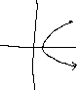

***Function Notation (Needs alternate assignment)***

The following symbolic notation is used when an equation is a function:



Instead of: *y* = 3*x* + 4



We write: *f* (*x*) = 3*x* + 4



This is read as “*f* of *x*”.

**We write *f* instead of *y* and this notation means**

1. that the equation is a function (hence *f* ) and,
2. the variable is *x* (hence the *x* in brackets)

Function notation is also a short-hand for asking us to evaluate an equation. If there is a number in the bracket instead of *x*, we are being told to substitute that number for *x*.

**Function Notation**



**Examples: Given **



i) Find *f* (4) ii) Find *f* (*–*5)



iii) Find *f* ()

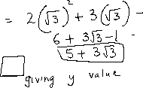

**Ex: Given *g*(*x*) = 5*x* – 3**

i) Find *g*(*a*) ii) Find *g*(4*x*)



iii) Find *g*(*x* + 7) iv) Find *g*(*x –* 6)



v) Find *x* if *g*(*x*) = *–*2 vi) Find *x* if *g*(*x*) = 10



**ex: Given **



i)  ii) 



iii)  iv) 

We can also use function notation to ask for points on a graph, even if we do not know the equation.

*f* (*x*)

|  |  |  |  |  |  |  |  |  |  |
| --- | --- | --- | --- | --- | --- | --- | --- | --- | --- |
|  |  |  |  |  |  |  |  |  |  |
|  |  |  |  | 6 |  |  |  |  |  |
|  |  |  |  |  |  |  |  |  |  |
|  |  |  |  | 4 |  |  |  |  |  |
|  |  |  |  |  |  |  |  |  |  |
|  |  |  | 2 |  |  |  |  |  |  |
|  |  |  |  |  |  |  |  |  |  |
| -4 -2 0 2 4 *x* |  |  |  |  |  |  |  |  |  |
|  |  |  |  |  |  |  |  |  |  |
|  |  |  | -2 |  |  |  |  |  |  |
|  |  |  |  |  |  |  |  |  |  |
|  |  |  | -4 |  |  |  |  |  |  |
|  |  |  |  |  |  |  |  |  |  |

Find

*f* (2)

*f* (*–*3)

*f* (*–*1)

*f* (0)

*f* (5)

*x* if *f* (*x*) = 7

*x* if *f* (*x*) = *–*3