5.4 Mutually Exclusive Events
By the end of the lesson you will be able to:
- Identify and solve problems that involve mutually exclusive and non-mutually exclusive events

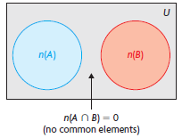
Today we return to set theory to examine situations that are mutually exclusive or non-mutually exclusive and their probabilities.
- The favorable outcome of two _______________ _______________________________, A and B can be represented as two ______________ _________.
- Probability that either A or B will occur by the following formula:
$P\left(A∪B\right)= _________$ + _________

- When two events are mutually exclusive, both formulas are equivalent:

$$n\left(_____________\right)=P\left(_____________\right)=0$$

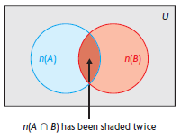

- The favorable outcome of two ____________________ _________________, A and B can be represented as two ____________________________.
- Probability that either A or B will occur by the following formula:
$P\left(A∪B\right)= _________$ + _______ - ________
$$This is the principle of inclusion and exclusion.$$

Example 1 – Two mutually exclusive events
Jennifer rolls two 4-sided dice. Determine the probability that she will roll a sum that is either 6 or an odd number.

Example 2 – Non-mutually exclusive events
Xavier rolls two 4-sided dice. Determine the probability that he will roll a sum that is either even or greater than 5.

Example 3
A school newpaper recently published results of a survey on eatting habits.
- 62% of students skip breakfast
- 24% of students skip lunch
- 22% eat both breakfast and lunch

- Are skipping breakfast and lunch mutually exclusive events?

- Determine the probability that a randomly selected student skips lunch but not breakfast?

- Determine the probability that a randomly selected student skips at least one of breakfast and lunch?

Assignment:

