6.3 Modeling Data with a Line of Best Fit
By the end of the lesson you will be able to:
- Determine the linear function equation that best fits a set of data
- Use this function to solve a problem

Independent Variable - ____ or variable that can be manipulated

Dependent Variable - _____ or variable that results from the independent variable.

Scatter Plot – A set of points on a grid

Line of Best Fit – A straight line that best approximates the trend of the scatter plot

Regression Function – A line or curve of best fit, developed through statistical analysis of data.

Using DESMOS to solve for Line of Best Fit
Find the line of best fit for the following data
x | y
1 | 17
2 | 20
3 | 24
4 | 30
5 | 31
6 | 29
7 | 34
- Setting up a plot
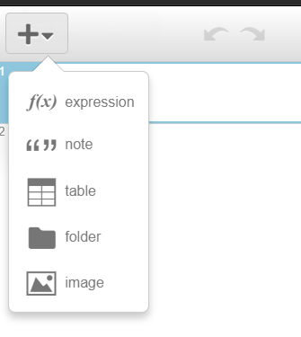
2
1
- Enter data
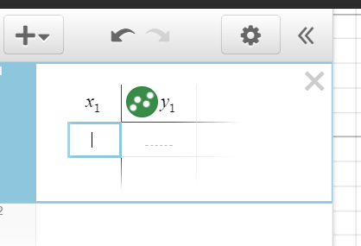
Enter the data line by line
- Once the data is entered, zoom out to see the data points (scatter plot) on the graph
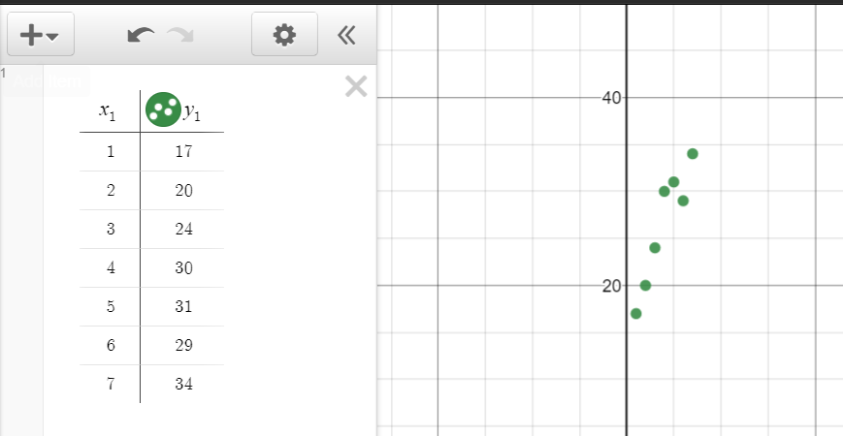

- Add f(x) expression

- Type $y_{1}\sim mx_{1}+b$ and read off the m and b values:

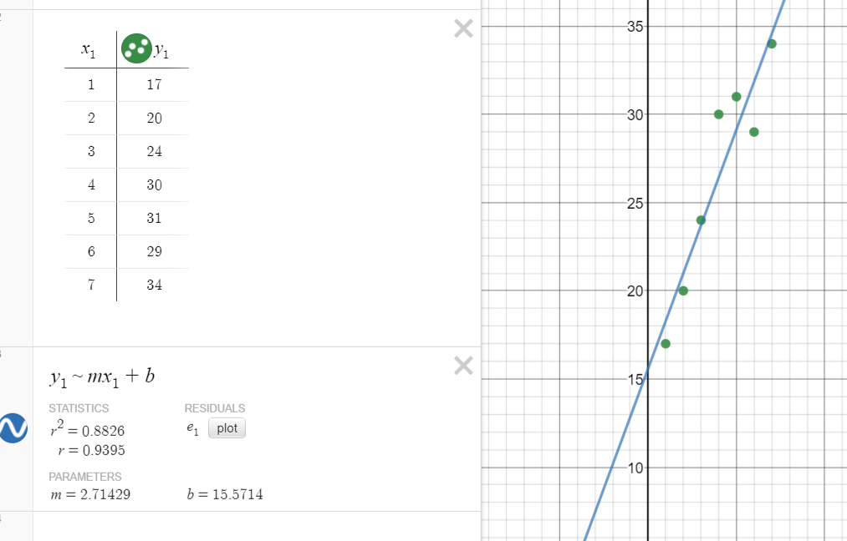

- Write the function:

Example
Matt buys T-shirts for a company that prints art on T-shirts and then resells them. When buying the T-shirts, the price Matt pays is related to the size of the order. Five of Matt’s past orders are listed in the table below.
Number of Shirts | Cost per Shirt ($)
500 | 3.25
700 | 1.95
200 | 5.20
460 | 3.51
740 | 1.69

a) Create a scatter plot and determine an equation of the linear regression function that models the data. What equation models the data?

b) What do the slope and the y-intercept represent in context?

c) Use the linear regression function to extrapolate the size of order necessary to achieve a price of $1.50 per shirt.

Practice:

