8.4 The Graphs of Sinusoidal Functions (Cont.)

By the end of the lesson you will be able to:
- Match the graphs of sinusoidal functions to their equations
- Use sinusoidal functions to solve problems

A sinusoidal function of the form:
$$y=a\sin{b\left(x+c\right)+d}$$
has the characteristics:
- $a$ is the ___________________:
$$a=\frac{\max{value-\min{value}}}{2}$$
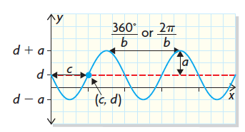
- $b$ is the number of cycles in 360° or 2$π$.
The ___________________ is $\frac{360°}{b}$ or $\frac{2π}{b}$
- $c$ indicates the horizontal translation that has been applied to the $y=\sin{x}$graph.
- $d$ gives the equation of the midline, $y=d$
where $d=\frac{\max{value+\min{value}}}{2}$
- The ______________ value is $d+a$
- The ______________ value is $d-a$

Example 1
Write the equation for each of the following graphs:
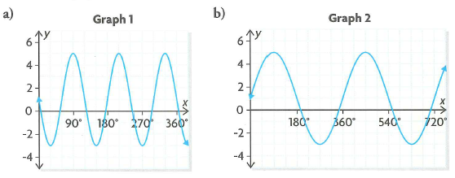

Example 2
The Far North is called “the Land of the Midnight Sun” because during the summer months, in some locations, the sun can be visible for 24 hours a day. The number of daylight hours in Iqaluit, Nunavut, can be represented by the function:
$$y=8.245\sin{0.0172(x-80.988)}+12.585$$
where $x$ is the day number in the year.

a) How many hours of daylight occur in Iqaluit on the shortest day of the year? How many on the longest day of the year?

b) What is the period of this function?

Assignment:

