8.2 Exploring Graphs of Periodic Functions

By the end of the lesson you will be able to:
- Examine the characteristics of sine and cosine graphs including x-intercepts, y-intercepts, domain, range, amplitude, period and midline equations.

Periodic functions are functions whose graph _________________ in ____________________ intervals or cycles.
They describe things like riding a Ferris wheel, where the motion oscillates.

The two most common periodic functions are the sine and cosine functions.

Example 1 – Graphing the Sine Function
$$y=\sin{x}$$
x |  |  | y
0° | 0 rad
45°
90° | $\frac{π}{2}$ rad
135°
180° |  | $π$ rad
225°
270° |  | $\frac{3π}{2}$ rad
315°
360° |  | $2π$ rad
405°
Characteristics of the Sine Graph
1. x-intercept(s)  2. y-intercept | 3. Domain  4. Range

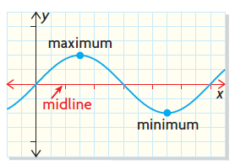
Midline is the horizontal line ______________ between the maximum and minimum values of a periodic function.

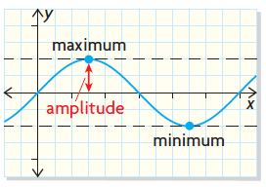

The amplitude is the distance from the ___________ to either the maximum or minimum value of a periodic function; the amplitude is always expressed as a __________ value.

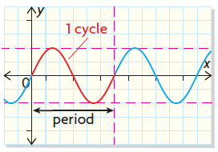

The period is the length of the interval of the domain to complete one cycle.

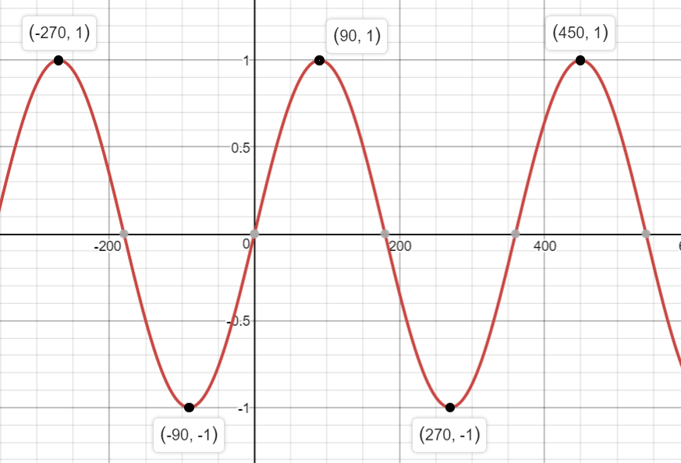
Back to our sine function…
5. Midline equation

6. Amplitude

7. Period

Example 2 – Graphing the Cosine Function
x |  | y
0° | 0 rad
45°
90° | $\frac{π}{2}$ rad
135°
180° | $π$ rad
225°
270° | $\frac{3π}{2}$ rad
315°
360° | $2π$ rad
405°
$y=\cos{x}$

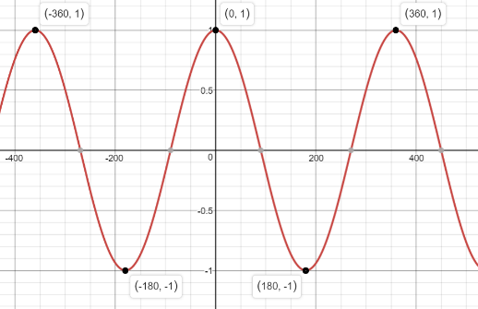
Characteristics of the Cosine Graph
1. x-intercept(s)  2. y-intercept  5. Midline equation  7. Period | 3. Domain  4. Range  6. Amplitude

Practice:

