MIDTERM REVIEW
Chapter 3: Set theory and Logic
Chapter 4: Counting Methods

1. On a survey of 100 people, 78 have been to doctor in last year and 64 have been to see dentist but 18 have to seen either. What % have been to see doctor but not dentist. (section 3.1)

2. John asked 35 people what pizza they liked. Section 3.3
Pizza | # ppl
cheese | 17
Ham | 17
Neither | 6
How many people liked both.

How many people liked only cheese.

Draw a Venn diagram.

3. Betty asked 103 people if they had visited Italy or France within the past year. Section 3.3
8 ppl had not been to either
55 had been to France
70 had been to Italy.
Determine how many ppl had been to both countries.

4. A total of 81 people were asked about their favorite subject. Section 3.4
- 45 liked chemistry, 40 liked biology and 35 liked physics.
- 10 liked both chemistry and biology only
- 15 like chemistry and physics only
- 12 liked biology and physics only
- All students like at least one subject.
How many students like all three?

5. Write the inverse and the contrapositive of the following: (section 3.5)
If Ben eats wheat, he will get a stomach ache.
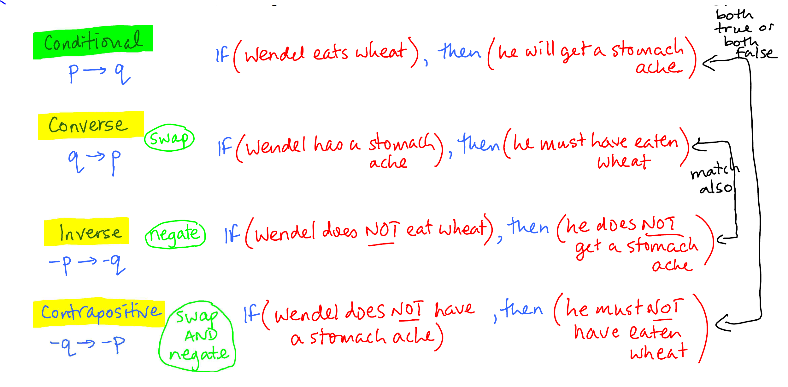

CHAPTER 4
6. Fundamental counting Principle:
a. There are 7 appies, 5 entrees, and 3 desserts on a menu. How many ways can you choose one of each.

b. A license plate has 3 letters followed by 3 numbers. How many possibilities are there.

c. How many ways could we pick a
i) Boy AND girl from a class of 26 ii) Boy OR girl from a class of 26

7. Serge visits 5 cities one after the other. He doesn’t go back to any city after he visits it. How many different travel itineraries are possible. (hint order matters)

8. There are 72 characters you could use for a password. How many possibilities are there for a 8 character password :a)With repetition b)without repetition.

9.

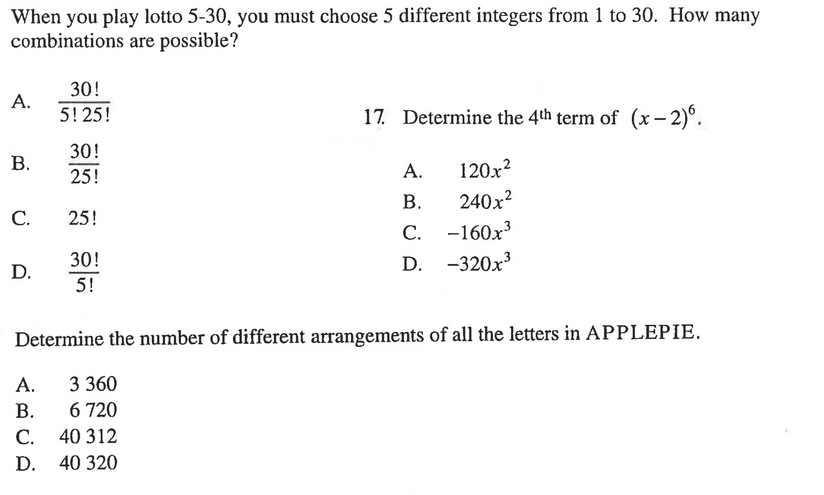

11. 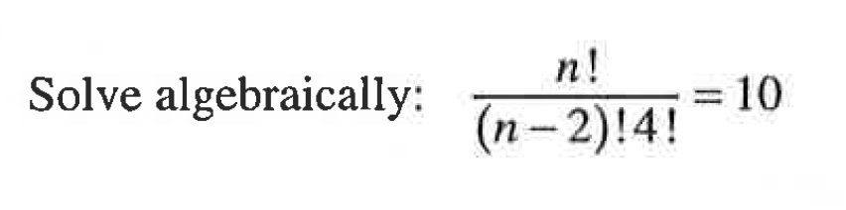

12. 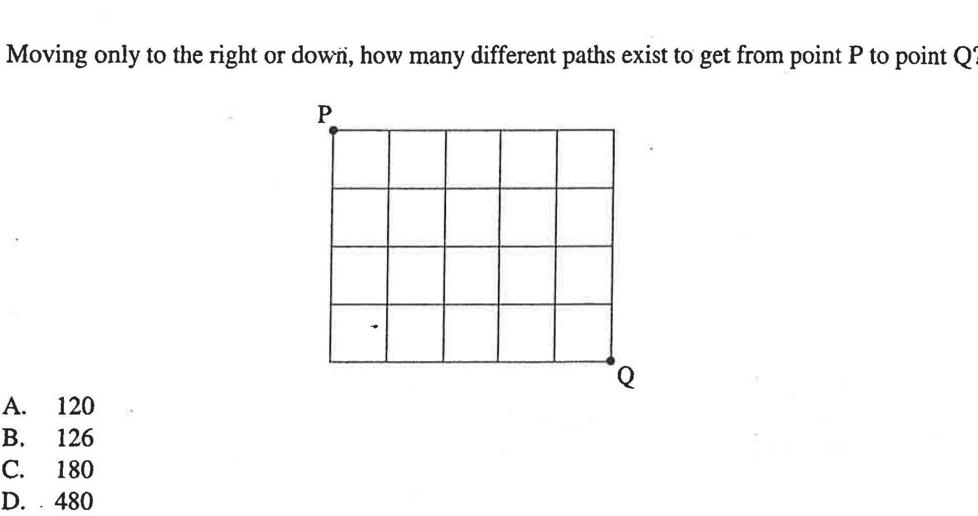
13. 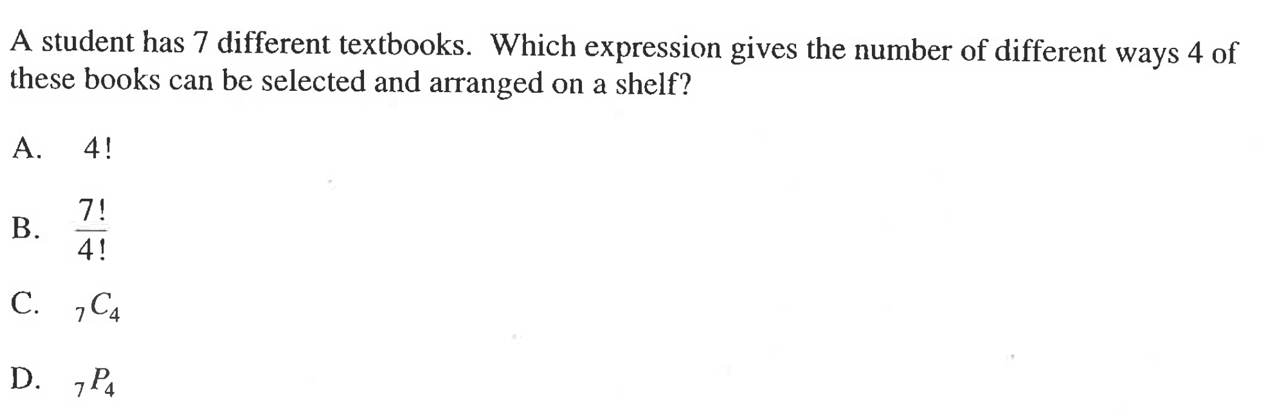

14. 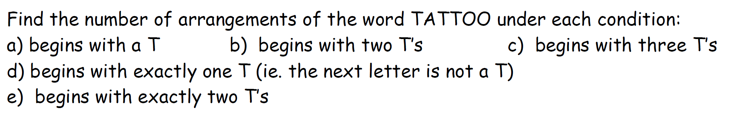

15. How many subcommittees of 4 students can be formed from a student council of 8 students? (hint: order doesn’t matter)

16. You are picking a 10 digit PIN for your bank card. (no repeat digits and 4 OR 5). How many combinations are possible.
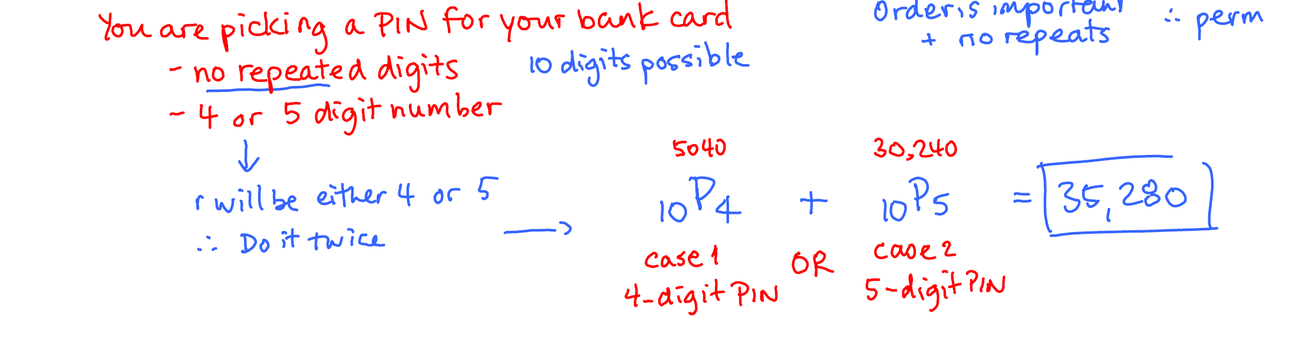

17. Given sets A, B, C : what do the following mean
n(A U C ) n(A\B) n(AUBUC) n ((AUB)\C)

