8.3 The Graphs of Sinusoidal Functions

By the end of the lesson you will be able to:
- Determine the characteristics of sinusoidal functions including x-intercepts, y-intercepts, domain, range, amplitude, period and midline equations from their graphs.

Sinusoidal functions are any periodic functions whose graph has the same shape as that of $______________________$.

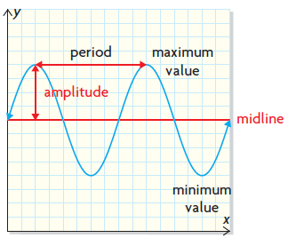
The period is the horizontal distance between ___________________ maximum or minimum values. It is also ___________________ the horizontal distance between a maximum value and minimum value.

The equation of the midline is the ________________ of the minimum and maximum values:
$$y=\frac{maximum value+minimum value}{2}$$

The amplitude is the positive vertical distance between the midline and either a maximum or minimum value. It is also half of the vertical distance between a maximum and minimum value.
$$a= \frac{maximum value-minimum value}{2}$$

Example 1 – Describing the graph of a sinusoidal function in degree measure
Describe this graph by determining the range, the equation of its midline, its amplitude and its period.
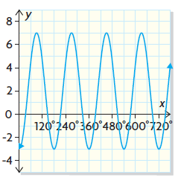

Example 2 – Describing the graph of a sinusoidal function in radian measure
Describe this graph by determining the range, the equation of its midline, its amplitude and its period.
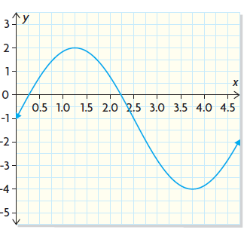

Practice:

