8.4 The Graphs of Sinusoidal Functions

By the end of the lesson you will be able to:
- Identify characteristics of equations of sinusoidal functions.

Today we will examine how change the equation of a sinusoidal function changes the graph of the function.

A. Graph $y=\sin{x}$
Now, on the same screen, graph $y=3sin{x}$ and $y=\frac{1}{2}sin{x}$
Make a sketch of graph you see.

How does changing the $a$ value in $y=a\sin{x}$ effect the graph?
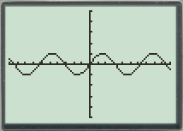

B. Graph $y=\sin{x}$
Now, on the same axes graph $y=\sin{(2x)}$ and $y=\sin\left(\frac{1}{2}x\right)$
Make a sketch of graph you see.

How does changing the $b$ value in $y=\sin{bx}$ effect the graph?

C. Graph $y=\sin{x}$
Now, on the same axes graph $y=\sin{(x-1.6)}$ and $y=\sin{(x+0.8)}$
Make a sketch of graph you see.
How does changing the $c$ value in
$y=\sin{(x+c)}$ effect the graph?

D. Graph $y=\sin{x}$
Now, on the same axes graph $y=\sin{(x)+3}$ and $y=\sin{(x)}-2$
Make a sketch of graph you see.

How does changing the $d$ value in
$y=\sin{x+d}$ effect the graph?

A sinusoidal function of the form:
$$y=a\sin{b\left(x+c\right)+d}$$
has the characteristics:
- $a$ is the ___________________:
$$a=\frac{\max{value-\min{value}}}{2}$$
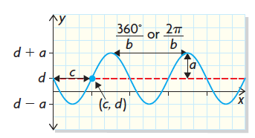
- $b$ is the number of cycles in 360° or 2$π$.
The ___________________ is $\frac{360°}{b}$ or $\frac{2π}{b}$
- $c$ indicates the horizontal translation that has been applied to the $y=\sin{x}$graph.
- $d$ gives the equation of the midline, $y=d$
where $d=\frac{\max{value+\min{value}}}{2}$
- The ______________ value is $d+a$
- The ______________ value is $d-a$

Example 1
Consider the function: $$y=3\sin{2\left(x-45°\right)}$$

a) Without graphing, describe characteristics of the function: amplitude, equation of the midline, range, period and horizontal translation.
b) Verify your description by graphing the function.

Assignment:

