**Ch 4: Slope (Day 1)**



________ slope ________ slope ________ slope

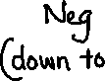

________ slope



**Slope describes the steepness of a line.**



It is defined as 

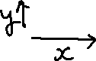

Ex:

1. **Find the slope of the following ramp**:

2m

18m

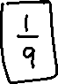

2. A ladder is leaning safely if the distance up a wall to the top of the ladder is 4 times the distance of the base of the ladder to the wall.

a) What is the slope of a safely leaning ladder?

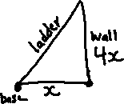

b) A ladder is 2.6 m long and reaches a window 2.5 m above the ground. What is the slope of the ladder and is it leaning safely?

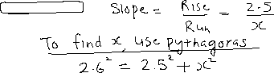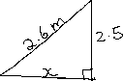

c) A ladder is safely leaning against a wall. The top of the ladder just reaches a window that is 3 m above the ground. How far is the base of the ladder from the wall?

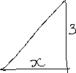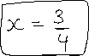

3. **Graph the following pairs of points and find the slope of the line segment joining them.**

|  |  |  |  |  |  |  |  |  |  |  |  |  |  |  |  |
| --- | --- | --- | --- | --- | --- | --- | --- | --- | --- | --- | --- | --- | --- | --- | --- |
|  |  |  |  |  |  |  |  |  |  |  |  |  |  |  |  |
|  |  |  |  |  |  |  |  |  |  |  |  |  |  |  |  |
|  |  |  |  |  |  |  |  |  |  |  |  |  |  |  |  |
|  |  |  |  |  |  |  |  |  |  |  |  |  |  |  |  |
|  |  |  |  |  |  |  |  |  |  |  |  |  |  |  |  |
|  |  |  |  |  |  |  |  |  |  |  |  |  |  |  |  |
|  |  |  |  |  |  |  |  |  |  |  |  |  |  |  |  |
|  |  |  |  |  |  |  |  |  |  |  |  |  |  |  |  |
|  |  |  |  |  |  |  |  |  |  |  |  |  |  |  |  |
|  |  |  |  |  |  |  |  |  |  |  |  |  |  |  |  |
|  |  |  |  |  |  |  |  |  |  |  |  |  |  |  |  |
|  |  |  |  |  |  |  |  |  |  |  |  |  |  |  |  |
|  |  |  |  |  |  |  |  |  |  |  |  |  |  |  |  |
|  |  |  |  |  |  |  |  |  |  |  |  |  |  |  |  |
|  |  |  |  |  |  |  |  |  |  |  |  |  |  |  |  |
|  |  |  |  |  |  |  |  |  |  |  |  |  |  |  |  |

a) A(2,1), B(5,3)

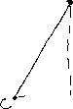

b) M(-3,4), N(-1,-2)



c) R(-2,4), S(5,4)



d) J(1,-2), K(1,3)



e) C(-8,4), D(-5,9)



A horizontal line has 0 slope (as it is perfectly flat; rise = 0)



A vertical line has undefined slope (as it is infinitely steep; run = 0)



A line segment that rises to the right has positive slope

A line segment that falls to the right has negative slope



We can also find the slopes of line segments from their coordinates.

Slope 



4. Use the formula to find the slope:



a) A (9, -2) and B (3, 6) b) C (-1, -4) and D (3, -8)



If a point is on the *x*-axis, its *y*-coordinate = _____



In general such a point is said to have coordinates (*x,*0)

If a point is on the *y*-axis, its *x*-coordinate = _____



In general such a point is said to have coordinates (0,*y*)

