**Ch 4: Rate of Change (Day 2)**



**Rate of Change** = Slope 



Rate of change are special ratios for comparing quantities with different units.

**Examples of Rates of Change in Fraction Notation**

Kilometers per hour = = km/h



Miles per gallon = =



Dollars per hour = =



If the city of Surrey grew 120 000 over a 5 year period, it has a rate of change of:

= 24 000 people per year

If a person runs the 400m race in 56 seconds, he is running at a rate of

=7.14 meters per second

**Example:**

Bernice rents a car with the gas tank full. The odometer registered 86 347 km. Bernice used it for 3 days. Shene the car was returned the odometer reading as 86 721 km and it needed 63 litres to fill up. The cost of renting the car was $96 plus gas which cost 90 cents a litre.



1. Determine the rate of gas consumption in Km/L

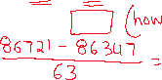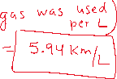

1. Determine the average rate of travel per day in Km/day

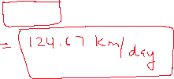

1. Determine the cost of renting the car per day in $/day

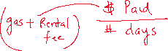

**Example**: Between 2000 and 2010, the cost of a 42” LCD TV dropped from $4600 to $1200. Graph the result, and determine the average drop in price per year.

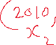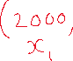

|  |  |  |  |  |  |  |  |  |  |
| --- | --- | --- | --- | --- | --- | --- | --- | --- | --- |
|  |  |  |  |  |  |  |  |  |  |
|  |  |  |  |  |  |  |  |  |  |
|  |  |  |  |  |  |  |  |  |  |
|  |  |  |  |  |  |  |  |  |  |
|  |  |  |  |  |  |  |  |  |  |
|  |  |  |  |  |  |  |  |  |  |
|  |  |  |  |  |  |  |  |  |  |
|  |  |  |  |  |  |  |  |  |  |
|  |  |  |  |  |  |  |  |  |  |
|  |  |  |  |  |  |  |  |  |  |

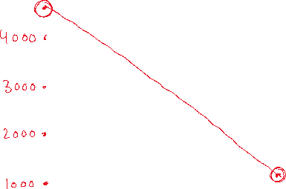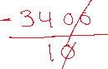

Slope =

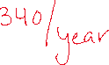

**Example:**

Most cars depreciate as they age. A car costing $30 000 will have a value of $2500 at the ind of 10 years.



1. Write a formula for its value when it is t years old. .



|  |  |  |  |  |  |  |  |  |  |
| --- | --- | --- | --- | --- | --- | --- | --- | --- | --- |
|  |  |  |  |  |  |  |  |  |  |
|  |  |  |  |  |  |  |  |  |  |
|  |  |  |  |  |  |  |  |  |  |
|  |  |  |  |  |  |  |  |  |  |
|  |  |  |  |  |  |  |  |  |  |
|  |  |  |  |  |  |  |  |  |  |
|  |  |  |  |  |  |  |  |  |  |
|  |  |  |  |  |  |  |  |  |  |
|  |  |  |  |  |  |  |  |  |  |
|  |  |  |  |  |  |  |  |  |  |

1. Draw a graph of this linear function

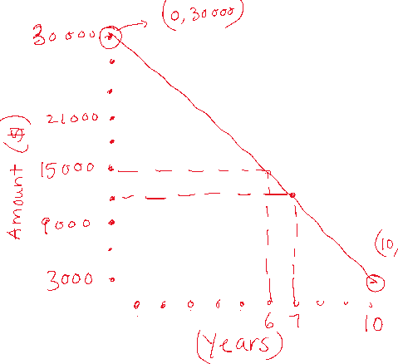

1. Determine the car’s value after 4.5 years



1. When is the car’s value between $12 000 and $15 000?



1. How much value does the car lose every 2.5 years?



1. What is the rate of change of the car’s value with respect to time ($/year)

