**Ch 5 Special Cases of Linear Equations (Day 2)**

**In the system of equations, determine if the lines are parallel, perpendicular or neither?**

a)  b) 



c) 3x – y = 5 d) 4x + 3y = 7

-6x + 2y = 12 2x – y = 4

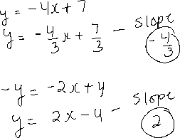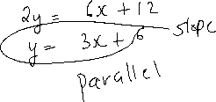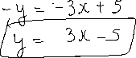

Extra: Write the equation of line passing through given set of points in slope intercept form.



(2, 5) and (-2, 5)

