Midterm Review Part 11
Chapter 5: Probability
Chapter 6: Polynomials

Chapter 5

1. The probability that a child will have brown hair is 25%. What are the odds of parents in favor of having a baby with brown hair. What are the odds against.

2. A family has 6 children. What’s the probability that they will have :
a. 5 girls and boy b. all girls c. at least one boy

3. From a deck of cards, find the probability of
a. drawing heart OR a black king b) drawing a heart OR face card

c) A coin is tossed a die is rolled. What’s the probability of tossing tails and rolling 3

4. Roger has scored 7 times in his last 20 penalty shots. The goalie has blocked 9 of last 10 shots he has faced.
a. determine the odds in favor of Roger scoring (using his data only)

b. determine the odds in favor of Roger Scoring (using the Goalie’s data)

5. Which events are mutually exclusive
a. Rolling 2 4- sided dice. A person can move if product is even or greater than 6.

b. Rolling 2 6-sided die and the probability of showing 5 on first and 1 on the second

6. Your school football team is playing a game against other school. Based on team’s record, it has a 50% chance of winning on rainy days and 70% chance of winning on sunny days. Tomorrow, there is a 25% chance of rain. (no ties)
a. Whats the probability that your school team will win. B. What is the probability of a loss.

Chapter 6:

1. Here is the data from a few weather stations
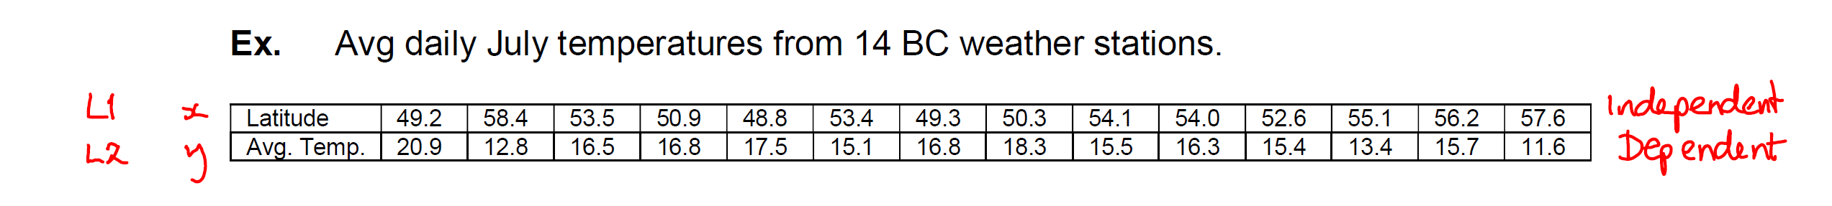

a. What is the linear regression (that means equation)

b. What temp do you expect at latitude 52. (approx. Y = 16.6)

Answers 2nd page: (correction : please add a negative in front of the following equation on second page:
Change from y = x² + 2x + 7 to y = x² + 2x + 7)

Graph 1 matches with

Graph 2 (line) matches with

Graph 3 (parabola face up) matches with

Graph 4 (parabola down) matches with

Graph 5 (cubic ) matches with

Graph 6 (cubic) matches with

