**1.6 Solving Investment Portfolio Problems**

**By the end of the lesson you will be able to:**

1. Determining total future value of a portfolio

A **portfolio** is one or more investments held by an individual investor or by a financial organization.



A portfolio can be built from different types of investments, **single payment** investments and investments involving **regular payments**.



Investments that involve greater principal amounts/greater regular payment amounts or are locked in for a longer term generally have higher interest rates.

At any time, you can solve for the total value of a portfolio by solving for the future value of each the investments and adding them together.

**Example 1**

James started a portfolio 15 years ago.

* He invested $3000 in a GIC (Guaranteed Investment Certificate) that earns 3.2%, compounded annually



* He also bought a $1000 CSB (Canada Saving Bond) at the end of each year which earned 5.2% interested, compounded annually.



What is James’ portfolio’s current value?

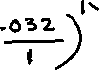

N= _______________

I% = _______________

PV = _______________

PMT = _______________

FV = _______________

P/Y = _______________

C/Y = _______________

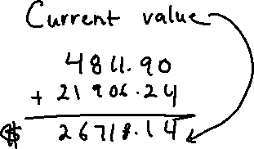

**Example 2**

Phyllis started to build an investment portfolio for her retirement.

* She purchased a $500 CSB (Canada Savings Bond) at the end of each year for 10 years. The first five CSBs earned a fixed rate of 4.2% compounded annually. The next 5 CSBs earned a fixed rate of 4.6% compounded annually.
* Three years ago, she purchased a $4000 GIC that earned 6%, compounded monthly.

What is Phyllis’ portfolio’s current value?

N= _______________

I% = _______________

PV = _______________

PMT = _______________

FV = _______________

P/Y = _______________

C/Y = _______________

N= _______________

I% = _______________

PV = _______________

PMT = _______________

FV = _______________

P/Y = _______________

C/Y = _______________

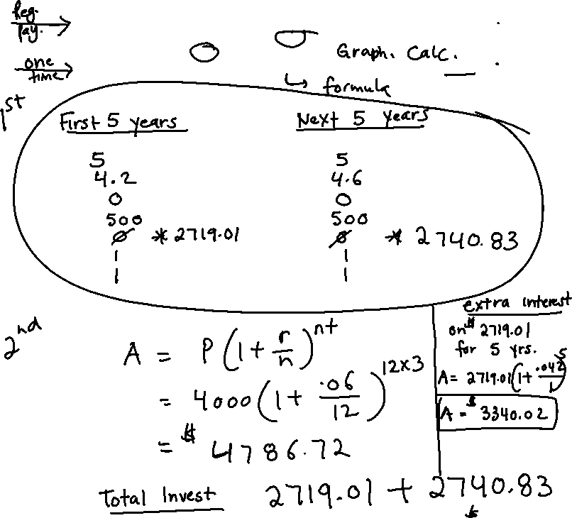

Practice:

