1.6 Solving Investment Portfolio Problems (Continued)

By the end of the lesson you will be able to:
- Analyze investment portfolios
- Compare investment portfolios by rate of return

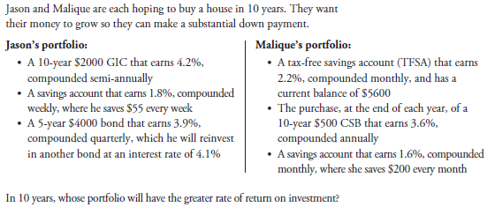
First, solve for the current value of each portfolio.

N= _______________
I% = _______________
PV = _______________
PMT = _______________
FV = _______________
P/Y = _______________
C/Y = _______________

N= _______________
I% = _______________
PV = _______________
PMT = _______________
FV = _______________
P/Y = _______________
C/Y = _______________

Solve for the rate of return of each portfolio.

Practice:

