**8.5 Modeling Data with Sinusoidal Functions**

**By the end of the lesson you will be able to:**

* Determine the sinusoidal function of best fit for a set of data
* Use a modeled equation to solve a problem

**Example 1**

The following expresses the percent of the moon that is visible each evening starting April 1.



|  |  |  |  |  |  |  |  |  |  |  |  |  |  |  |  |  |
| --- | --- | --- | --- | --- | --- | --- | --- | --- | --- | --- | --- | --- | --- | --- | --- | --- |
| **Day** | 1 | 3 | 5 | 7 | 9 | 11 | 13 | 15 | 17 | 19 | 21 | 23 | 25 | 27 | 29 | 31 |
| **%** | 2 | 0 | 6 | 20 | 41 | 64 | 85 | 96 | 100 | 95 | 82 | 63 | 43 | 25 | 10 | 1 |

a) Plot the data on a scatter plot

b) Find the equation of best fit

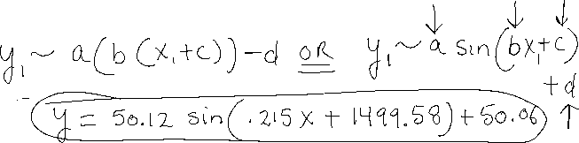

c) What is the synodic period? (Always use **radians** unless you see something in degrees!)



d) How much of the moon would you expect to see on April 14?



e) There was a full moon on April 17. When will the next full moon be?



**Example 2**

In 2011, the Singapore Flyer was the largest Ferris wheel in the world. The table below gives the height of a rider from the ground at different times.

|  |  |
| --- | --- |
| **Time**  **(min)** | **Height (ft)** |
| 0 | 49 |
| 9.25 | 295 |
| 18.5 | 541 |
| 27.75 | 295 |
| 37.0 | 49 |
| 46.25 | 295 |
| 55.5 | 541 |
| 64.75 | 295 |
| 74.0 | 49 |

a) Create a scatter plot of the data and then find the equation of best fit.



b) How long does it take to go all the way around one time?



c) At what time would a rider by 400 ft above the ground?



**Practice**:

