**1.4 Compound Interest: Present Value**

**By the end of the lesson you will be able to:**

* Calculate the present amount of a compound interest investment
* Evaluate the interest rate of investment if the future value and present value (principal) are known

Recall, the formula for calculating the future value of a compound interest loan is:

$A=P{(1+\frac{r}{n})}^{tn}$

Here P represents the _______________. However, we can also think of P as the __________________, the amount that must be invest now to result in a specific future value in a certain time at a given interest rate.



We can re-arrange this formula to solve for the present value:

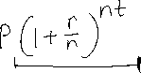

**Example 1**

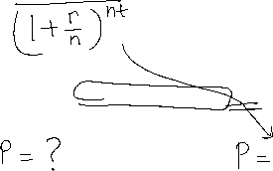

How much money would you need to invest now, at 7.8% interest, compounded annually, to have $60,000 in 10 years?

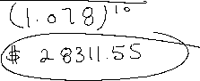

**Example 2**

Ethan has won a valuable cash award in a science fair. He plans to invest some of the cash in an account that offers 6.7% interest, compounded semi-annually. He wants the investment to have a future value of $3000 after 5 years. How much does he need to invest now?

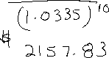

**Example 3**

Emma has invested $12,300 in a registered education savings plan (RESP). Emma wants her investment to grow to at least $40,000, so that her new born can go to university at age 18. What interest rate, compounded annually, will result in a future value of $40,000?

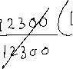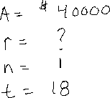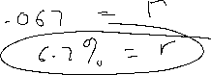

You try!!

Jon is planning to buy a new snowmobile in 2 years. He intends to spend no more than $17000. He has $9000 to invest in an account that compound interest quarterly.

a. What rate will he need to find to meet his goal

