**Ch 6 Solving Linear Systems by Substitution (Day 3)**

**Steps for Substitution:**

1. Isolate a variable



1. Substitute the resulting expression into the second equation
2. Solve for the remaining variable
3. Substitute back to find the second variable

Examples: Solve



i)  ii) 

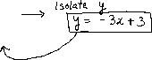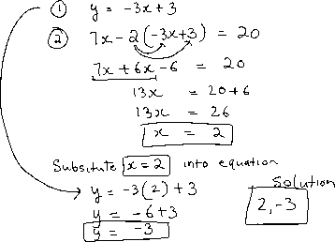

iii) 



Solve:

 

