**Ch 7 Simple and Compound Interest (Day 1)**

Simple interest is based on three pieces of information: ___________, __________, and ___________



**Interest: _________________________**



**Principal: _________________________**



**Rate: _________________________**



**Simple Interest and Future Amount**

Interest = Principal x Rate x Time



***I = P∙r∙t***



**Future Amount = Principal + Interest**

*A = P + I*

A = P(1 + *P∙r∙t*)

**Example 1:** Find the future amount of an $8000 simple interest investment for 5 years at 6%

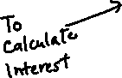

**Example 2:** A $2100 payment is due in 15 months. Find the principal if the money is borrowed at 11% simple interest.

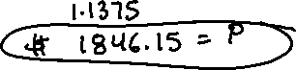

**Example 3:** Nicole borrowed $5200 at 7.5% simple interest to build a swimming pool. If she paid $2340 interest, find the term of the loan and the monthly payments.

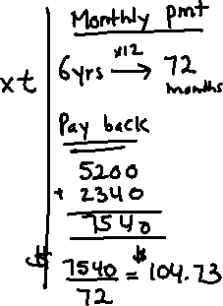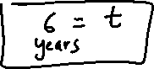

**Example 4: Discount Loans**

Sometimes the interest on a loan is paid up front by deducting the amount of the interest the lender gives you. This type of loan is called a discounted loan.

Charlie obtained a 2 year $6000 loan for university. The rate was 8% simple interest and the loan was a discounted loan.

1. Find the discount
2. Find the amount of money Charlie received
3. Find the actual interest rate

**Compound Interest**

When interest is calculated on the principal plus any previously earned interest it is called compound interest.





*A* = the final amount

*P* = principal or initial amount

*r* = rate of yearly interest

*n* = # of times yearly interest is compounded per year

*t* = time in years

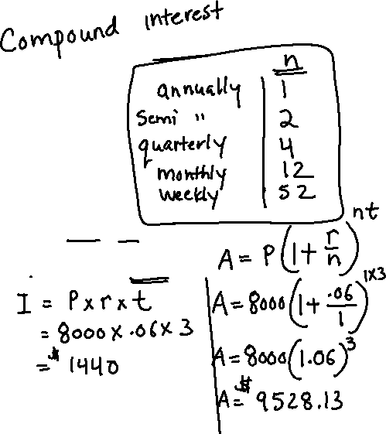

**Example 5:** Suppose that $8000 is invested for 3 years at 6%



1. Find the amount of simple interest paid



1. Find the compound interest, if invested in calculated annually



**Example 6:** To have savings for university, the parents of a child invest $25 000 in a savings plan paying 6% interest compounded quarterly. How much money will they have in 18 years?

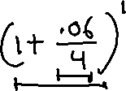

**Example 7:** How much would you have to invest into a 10 year bond paying 4.2% compounded weekly to make it worth $5000 at the end of its term.

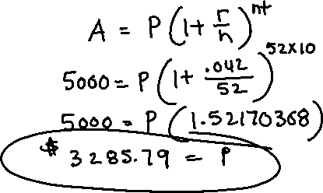

**Example 8:** How long does it take for an investment to double in value if it is invested at 9% compounded monthly?

