Unit 5: Systems of Equations

Unit Review

Topics Covered:

1. Determining the number of solutions to a linear system
- 0 if parallel lines (inconsistent)
- 1 if intersecting lines (consistent)
- if coincident lines (consistent)

2. Solving systems by Elimination Method (addition/subtraction)
3. Solving systems by Substitution Method
4. Solving word problems using systems
5. Sequences and series

Examples:

i) Determine if each system has 0, 1 or infinite solutions

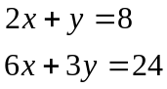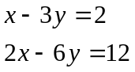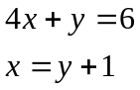

ii) Solve by substitution

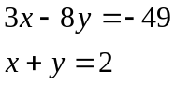

iii) Solve by graphing
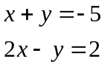

iv) Solve: 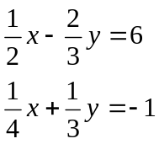

v) A Christmas tree has 100 ornaments on it, some small and some large. 40% of the small ornaments are gold and 30% of the large ornaments are gold. There are 36 gold ornaments total. How many of the ornaments are small and how many are large?

vii) A test out of 50 marks was split into two parts. Adam scored 90% on part A and 75% on part B for a total of 42 marks. How many marks was each section worth?

viii) A test out of 50 marks was split into two parts. Adam scored 90% on part A and 75% on part B for a total of 42 marks. How many marks was each section worth?

ix) Given one equation in a system is 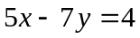. Make up a second equation with:

a) no solution b) 1 solution c) infinite solutions

x) Is (5, 4) a solution to the system 3x + 2y = 23
5x + 4y = 20

X1)Write an equivalent linear system to 2x + 3y = 13 (hint: write an equation of the line that will overlap with this line)

xii) For what values of k does the following system have infinite solutions

a) 3x – y = 4
-6x + 2y = k

xiii) The solution to the following linear system is (4 , y). Determine y.
2x – 3y = 2
x + 2y = 8 (hint solve the system using methods you know)

xiv) In an arithmetic sequence, the fourth term is 29 and the eleventh term is 50. Find the first 4 terms

xv) The sum of the first 4 terms is 40, first 5 terms is 60 and first 6 terms is 84. Find the first 6 terms.

xvi) In a piggy bank, there are 32 coins, all nickels and quarters. If the total value of the coins is $3.00, find the number of each kind.

