**Ch 6 Solving Linear Systems by Adding (Elimination) (Day 2)**

**A system of equations is 2 or more equations with 2 or more variables.**

**The solutionto the system has to satisfy all of the equations.**

**Eg:** 

This is a system of _____ equations with _____ variables



Check that (2, 5) is the solution to the above system



**Ex:** Is (3, -1) the solution to the following system?







**Examples: Solve**



i)  ii) 



iii)  iv) 

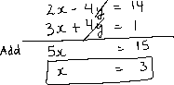

v) 



vi) 

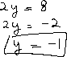

vii) 

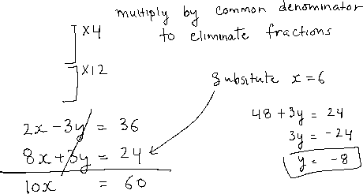

viii) 

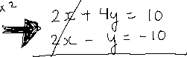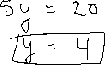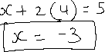

ix) 

