**Ch 6 Arithmetic Series (Day 6)**

A **sequence** is a list of numbers. (numbers separated by , )

A **series** is the sum of a sequence. (numbers separated by +)

**Example:**

Sequence: 2, 4, 6, 8, 10, …

Series: 2 + 4 + 6 + 8 + 10 + …



















Determine:



 



 



**Example:** The sum of the first 4 terms is 40, first 5 terms is 60 and first 6 terms is 84. Find the first 6 terms.



**The sum of a series can be found by the following process**

(First noticed by Gauss at age 5!)

Find the sum: 1 + 2 + 3 + …. + 98 + 99 + 100

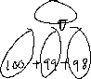

**Formula: The sum of the first *n* terms in an arithmetic series is**

 or 



**Where,**

**= the sum of the first *n* terms

*a* = first term

*tn* = *n*th (last) term



*n* = the number of terms



**Examples:**



i) Find  for the series 



ii) Find  for the series 



ii) Find the sum of the series: 

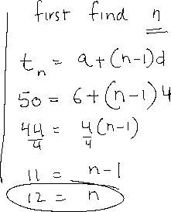

iv) Find the sum 

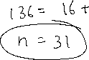

**Determine the indicated value given:**

i)  , , 

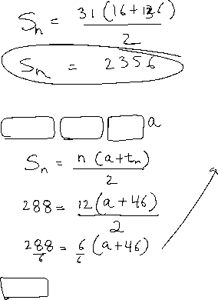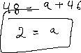

ii) , , 



iii) , , 

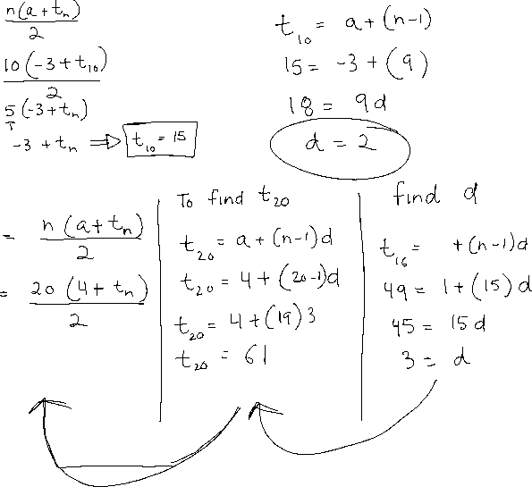

**Example:**

You have the choice of 3 summer jobs:

* Job A pays $500/month for 3 months
* Job B pays $100/week for 12 weeks, but with a $5 raise each week
* Job C pays $200 every other week, but with a $10 raise every 2 weeks.

Based on salary, which is the best job?