2.1 Analyzing Loans

By the end of the lesson you will be able to:
- Define collateral and amortization tables
- Solve problems that involve single payment loans and regular payment loans Taking what you know from investments and applying them to loans
- Analyze loan options

Collateral is an ______________ that is held as security against the repayment of a loan.
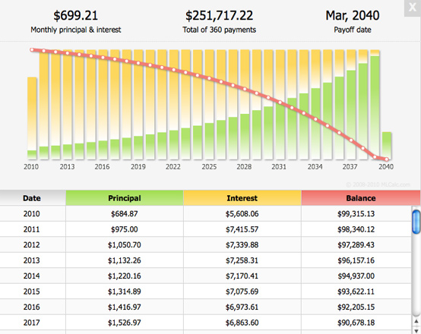
An amortization table lists regular payments on a loan and shows how much of the payment goes toward the _______________ and how much goes toward the ___________________.

Example 1
Lars borrowed $12,000 from the bank at 4.5% compounded monthly, to buy a car. The bank will use the car as collateral for the loan. Lars negotiated a regular loan payment of $350 at the end of each month in until the loan is paid off. Lars set up an amortization table to follow the progress of the loan.
Payment Period | Payment ($) | Interest Paid ($)  Balance x $\frac{rate}{compoundings per year}(\frac{r}{n})$ | Principal Paid | Balance
0 |  |  |  | 12,000
1 | 350
2 | 350

- How long will it take Lars to pay off his loan?
We could continue to work out the amortization table or we can also use the financial app on the graphing calculator to solve this!

N= ________________________________________________________
I% = ______________________________
PV = _____________________________________________________________________
PMT = ______________________________
FV = ______________________________________________________________
P/Y = _____________________________________________
C/Y = _________________________________________________

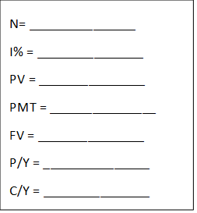

- How much interest will Lars have paid by the time he has paid off the loan?
Again, we can use our graphing calculator to solve for this!
APPS
1:Finance Press 1 or ENTER
Scroll down to A:$Σ Int$ Press ALPHA MATH (for A) or ENTER
$Σ Int$ (1, # payments)

Example 2
Matt is going to borrow $14,000 at 6% interest so that he can buy a car. He has gone to three banks, and they offer these terms:
- Bank A: Simple interest, a 3-year term, with one end-of-month payment
- Bank B: Interest compounded monthly, with regular monthly payments of $400
- Bank C: Interest compounded annually, single payment at the end of 5 years

Compare Matt’s options to find out which loan will have the least interest ?
Bank A

Bank B

N= _______________
I% = _______________
PV = _______________
PMT = _______________
FV = _______________
P/Y = _______________
C/Y = _______________

Bank C

Example 3
Bill has been offered the following two loan options for borrowing, $8500. What advice would you give him?
Option A: He can borrow at 4.06% interest, compounded annually, and pay of the loan in payments of $1800 at the end of each year.
Option B: He can borrow at 4.06% interest, compounded weekly, and pay off the loan in payments of $34.50 at the end of each week.

N= _______________
I% = _______________
PV = _______________
PMT = _______________
FV = _______________
P/Y = _______________
C/Y = _______________

N= _______________
I% = _______________
PV = _______________
PMT = _______________
FV = _______________
P/Y = _______________
C/Y = _______________

