**Ch 8 Special Angles (Day3)**

**45o- 45o- 90o**



An isosceles right triangle - the legs are equal in length (say 1). The hypotenuse will be _______

**30 o - 60 o - 90 o**

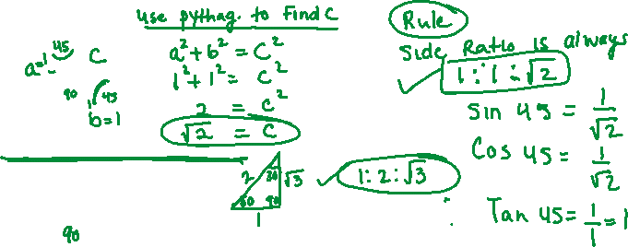

The hypotenuse is always twice the shortest side. The middle side is _______



**0o angle**

The adj and hyp are the same length, and the opp has length 0



**90o angle**

The opp and hyp are the same length and the adj has length 0.



**Summary**

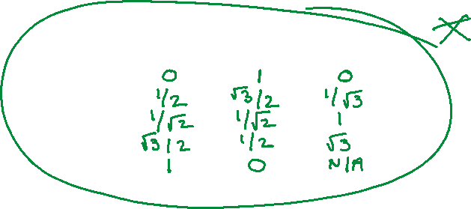

|  |  |  |  |
| --- | --- | --- | --- |
|  | sin | cos | tan |
| 0o |  |  |  |
| 30o |  |  |  |
| 45o |  |  |  |
| 60o |  |  |  |
| 90o |  |  |  |

**Examples:**

Answer the following as exact values (do not use a calculator)

1. A ladder is inclined at 60 degrees against a wall. If the foot of the ladder is 6 m from the wall, how long is the ladder and how high up the wall does it reach?

ii) Two ships are 24 km apart. One of the ships sights a lighthouse at 60 S of W and the other sights the lighthouse at 30 S of E. How far is each ship from the lighthouse?

iii) Find the length L:

20

30o

45o

L