Year End Review III

Unit 4: Linear Equations:

Slope 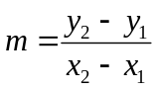

Slope-intercept Form 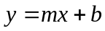

Slope-Point Form 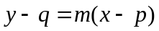

General Form 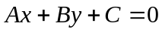

1. Given A(-2, 5) and B(6, 1) find the slope of AB

2. Given the points C(x, 3) and D(5, 8) find x if CD is:

a) parallel to a line with slope  b) perpendicular to a line with slope 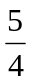

3. Graph the following lines on the given grid

a) 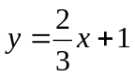

b) 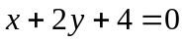

4. Find the equation of the line with slope  and passing through the point (8, -2)

5. Find the equation of the line passing through the points (4, 2) and (8, -1)

6. Find the equation of the line parallel to 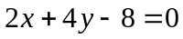 and passing through (-6, 2)

7. Find the x and y-intercepts of the line 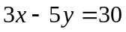

8. Find the equation of the line with slope -2 and with x-intercept 5.

Unit 5: Systems of Equations

1. Solve by substitution

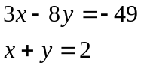

2. Solve: 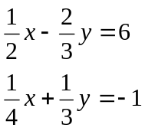

3. Megan invested $2000, part at 8% per annum and the rest at 10% per annum. After one year the total interest earned was $190. How much did she invest at each rate?

4. Determine the number of solutions



