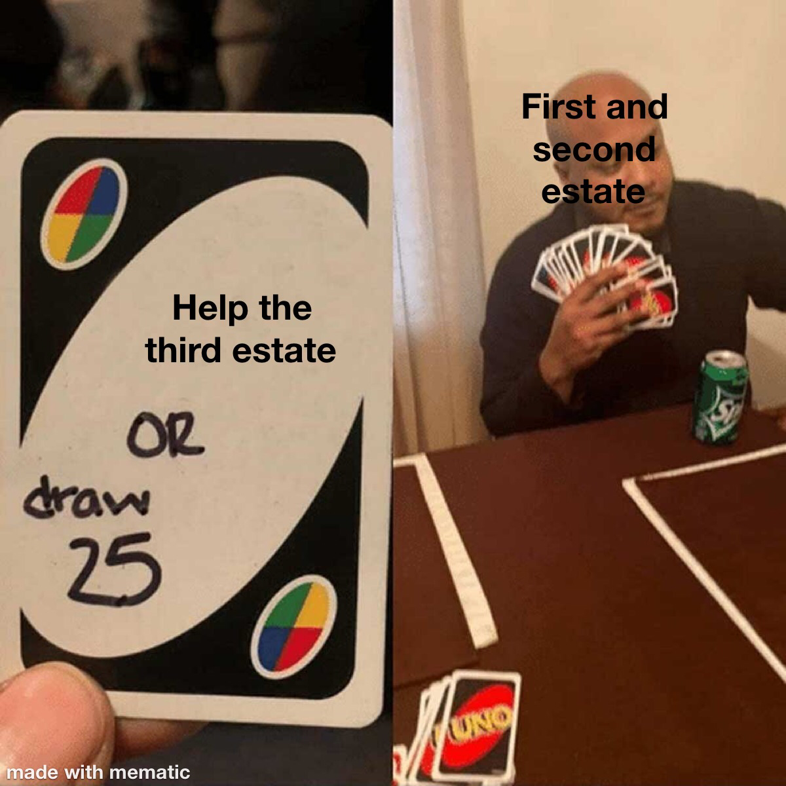
This meme demonstrates how the first and second estate wanted to keep their power. they let the other people in their kingdom suffer so they can be rich. The meme also demonstrates how much the first and second estate take granted of their power and how they can risk drawing 25 cards. Little did they know third estate is every other player and they’re going to team up on him. That what my memes about

