Create your own colony project writing part
The weather would be one of the hard parts building my colony and trying to find a nice and safe bay for the colony. My colony I made is called Green buck city. I chose the area to build the city because there was a bay, a big field and an island where the castle is. The Hardest part building this colony was the castle because I had to build most of the island and making the castle walls and guard towers was tough to make. I think The most important feature is probably the walls for protection, butcher for the villagers to eat food, the farm, homes for people to live in and the armoury. The least important feature is the. There are going to be farms, cattle, fishing and hunting. The thing I like about my colony is that there is a harbour for big ships to birth and there’s a market.

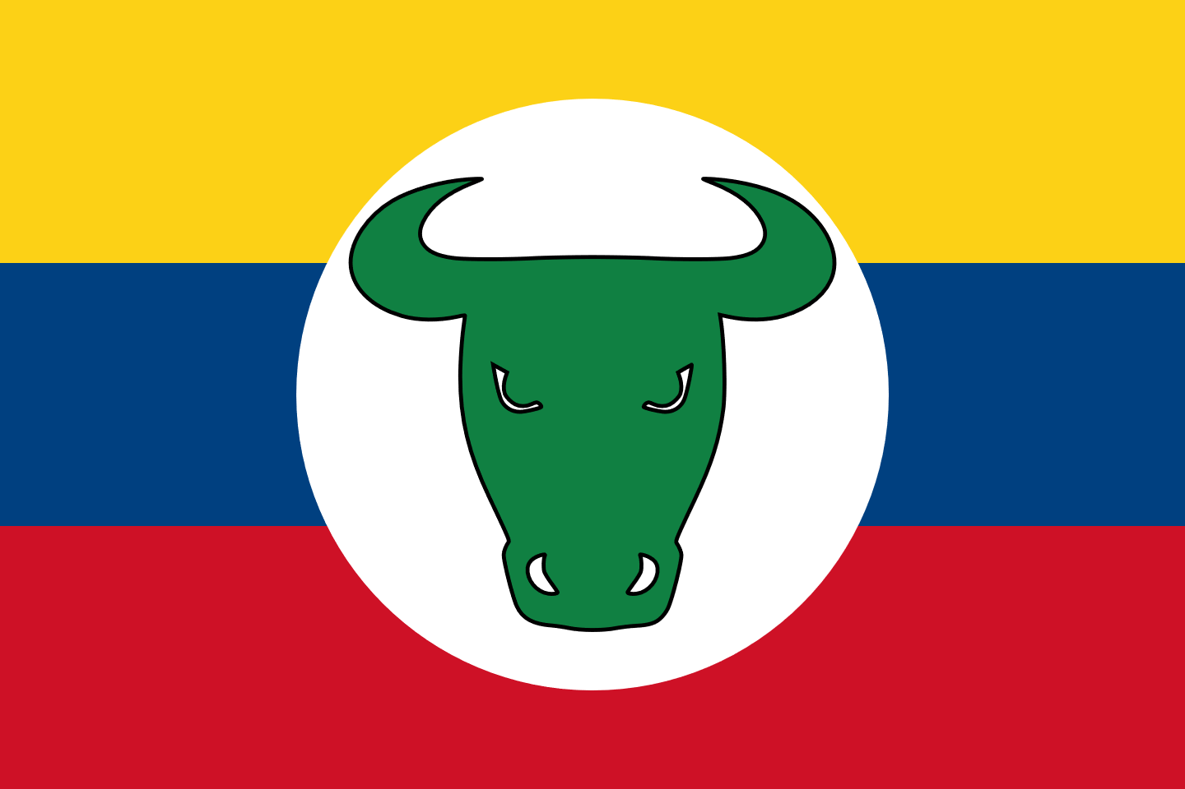
Green bull city flag

Part B
North America colonization faced a lot of hard ship and mistakes working and dealing with the indigenous people that led to wars and grief.
To have A successful colonization you need a very good working relationship with the indigenous people, the new settlers must on rely and respect each other and their surroundings. Respect and honesty are the key, dishonesty will lead to distrust and war. In my colony I will first meet with the elders and discuss to learn about there culture, language and there demands to co exist with them. Then I discuss work out trading patterns and large land areas which they can live for generations to come.

After establishing a relation ship with the elders and people, I would show them what we would be able to trade with them in return for fur, food, and trust. Alcohol would be forbidden to trade. We would establish a fair-trade cooperation between are people. Are colony would trade cooking pots and pans, tools for agriculture, clean clothes, guns and ammunition ( only for hunting), spices, clean blankets, fishing equipment and horses. In return the colony would receive from the native Americans furs to sell to the European markets.

We would not push teaching Catholicism to the indigenous community. The Jesuits priests will only be allowed to teach them English or French, but we encourage them to speak there own native language. In return, we hope that the native elders can teach my colony basic native language and their tradition. We want mutual respect between us. Any disagreement will be discussed regularly between are colony and the native tribe. id also try to establish annual festival and sporting activities to promote good sportsman ship and fun activities.

