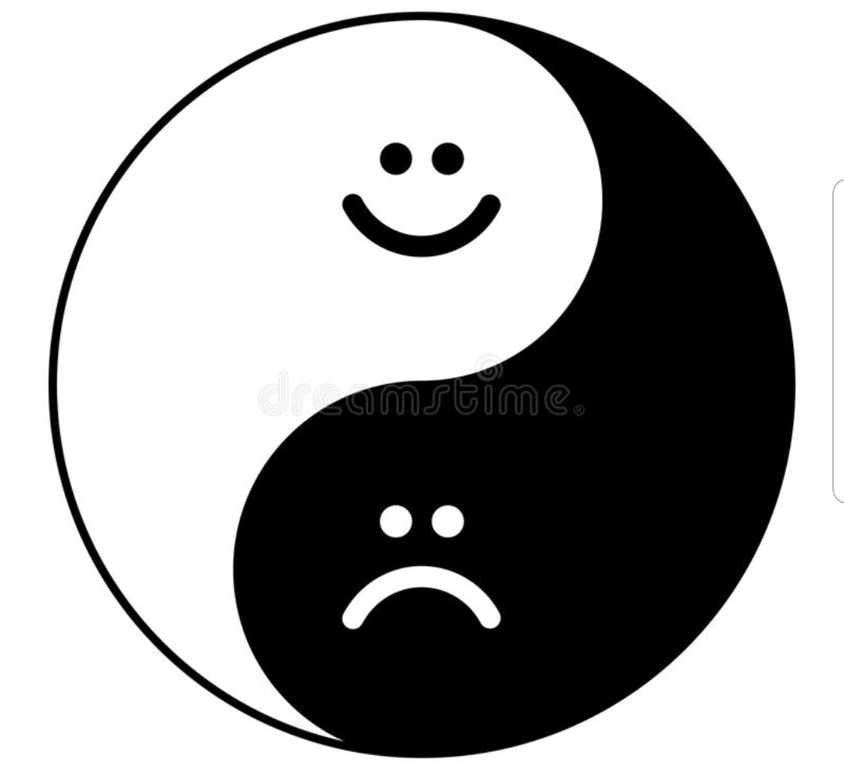

The world is black and white at the same time
It’s not always up it’s not always down
The world can be good and be bad at times
But it is fine when it is up or down
Even when you’re thinking your life is sad
Someone out there is wishing to be you
So now you know your life isn’t that bad
Now be grateful that this life is for you
Sometimes there is shiny sun and blue sky
Everything’s great this day is just khle fine
Sometimes you’re crying the sky is not blue
The day for two coffees for me and you
It’s a bad day know it will all be fine
It’s a good day enjoy it and have fun

Khle: very

Written by: Melika

