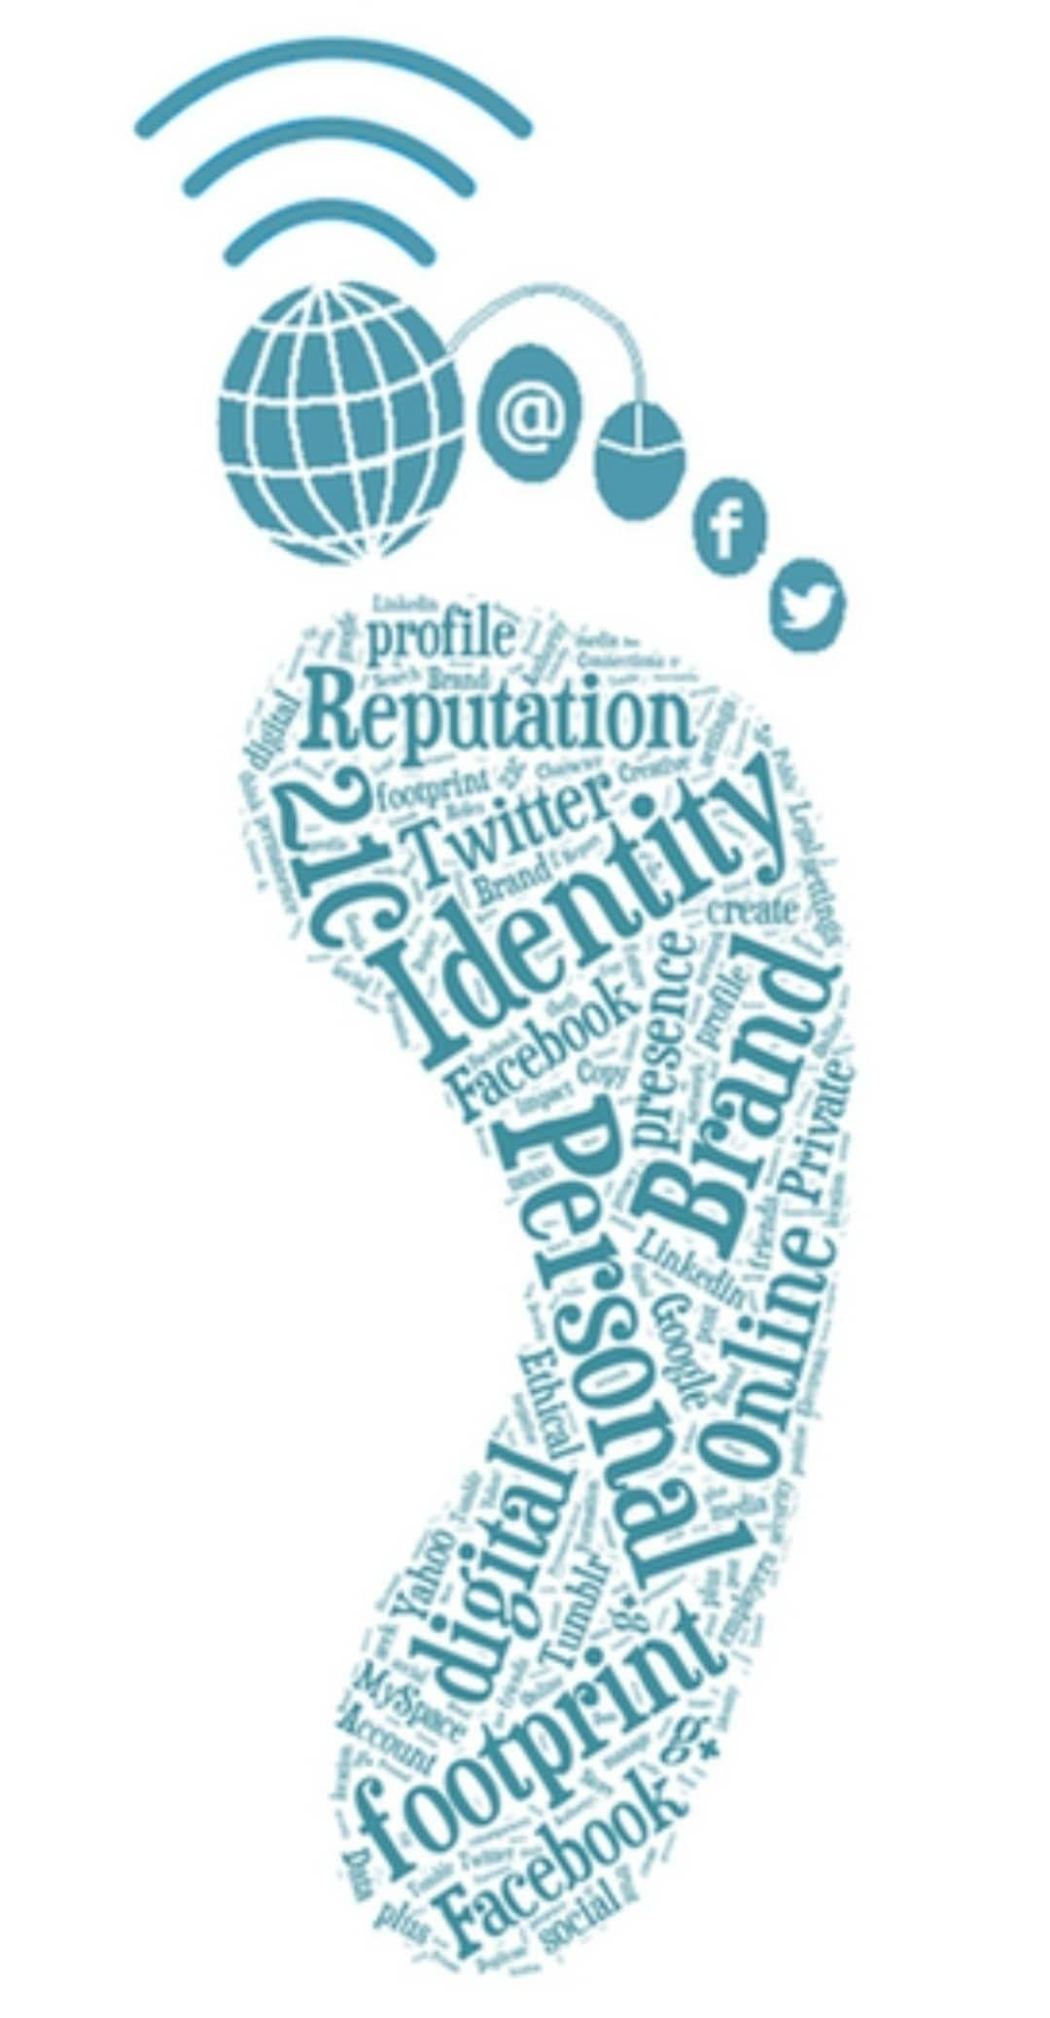
Your digital foot print is all the things you do on the internet. What you post on Instagram or that comment you put on Twitter they all stay. Making your digital footprint.

Digital footprints are usually checked when you apply for a job. If you have a clean digital footprint that will be a good point but if you have a bad digital footprint that will give you a negative point, The company that you have applied for will most likely not want to hire because your digital footprint partially explains who you are.

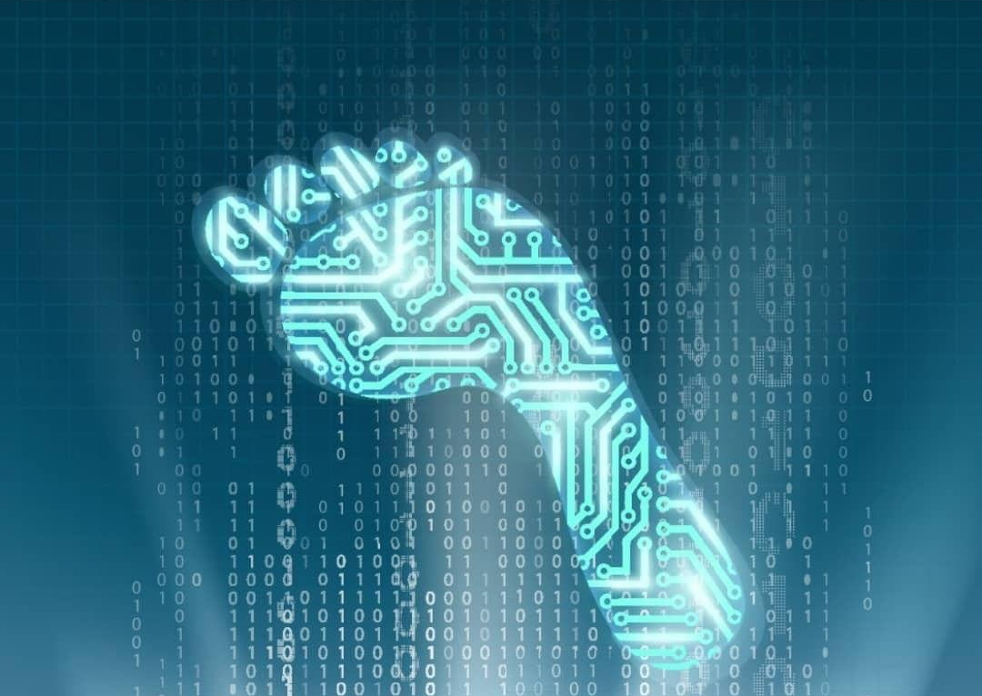
You can keep your digital footprint clean by not over sharing anything such as pictures or even your opinions. You need to use the internet wisely and be aware of the fact that no matter what you put on the internet everyone can see it. All those pictures or videos you put online when your were not in the right state of mind could hunt you one day.

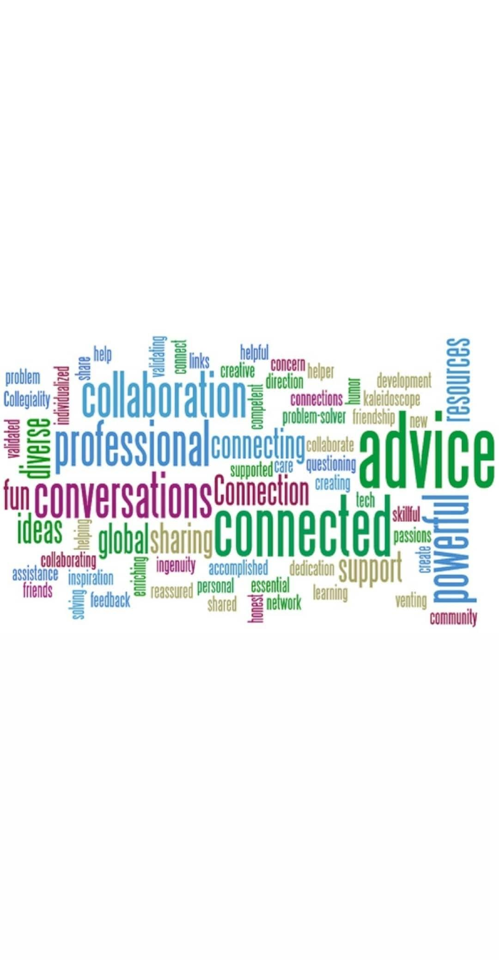

PLN stands for Personal Learning Network they are usually online websites for schools. Which means that teachers come together and make a network that only their students can access. The Kodiak s website is our schools PLN in which every teacher can interact with their own students.

Citations:
https://www.virtuallibrary.info/digital-footprint.html
https://www.istockphoto.com/ca/photos/job-interview?sort=mostpopular&mediatype=photography&phrase=job%20interview
https://au.hudson.com/insights/article/how-to-manage-your-digital-footprint
https://www.adaptemy.com/building-and-maintaining-your-personal-learning-network/

