- The official name of the invention our group is proposing to create is a temperature therapeutic cast

- Description of proposed invention, including an explanation of how it will work.
Our invention will consist of a regular cast, with a built in thermometer to help regulate the temperature to the desired liking of the consumer.
It consists of a temperature adjusting cast. It is simply a cast with an adjustable temperature. Either to become cold or hot. All you will have to do is press a button to adjust it to your desired temperature. (For the heating system, it will consist of flexible solar panels that help to generate the heat, thus making our invention environmental-friendly. Nonetheless for the cooling system, it will include cooling pads located in the inner portion of the cast (against your skin) to produce a cold-like temperature similar to an ice-pack to provide therapeutic treatment, and also help with comfort.

- Explain how well this idea meets the goals of the “triple bottom line”
  - How much potential does it have for economic profit?
Since it is scientifically shown that cold materials (ice packs) or warming items (hot water bottles) are therapeutic in different circumstances; not only will the temperature adjusting help with comfort, but will also be beneficial as well to help your "injured area" heal faster in some cases.
- Social benefit (how much of a positive impact will it have in people’s lives?)
Now with typical fiber-glass casts, they are unable to be reused; and only provide structural support for the wounded area. With our prototype however, it will allow the cast to provide comfort needed for the patient (by changing the temperature to their desired wanting). Now with this feature, it can also help to cut down on pain medication. Furthermore, it can also provide therapeutic benefits, to possibly help heal the area faster, as opposed a cast that would stay at room temperature. And finally, it will also be able to be reused; in order to help the environment, and save costs on material.
- Environmentally-friendly (does it help to solve an environmental issue?)
Though some components of this invention don't appear to be completely environmental friendly, the area consisting of the solar panels to generate heat helps the environment by reducing greenhouse gases and use natural energy/ power from the sun. Furthermore, with the cooling agent, it will consist of a smart "ice patch", similar to the way your car has heated seats, it bases around the same idea, however does the opposite. Instead of heating the cast, it will cool it to the patients desired temperature (cool). Another huge component leading for it to be enviornmental friendly, is that it is able to be reused unlike typical casts.

- Small illustration of proposed invention (doesn’t have to be to scale)

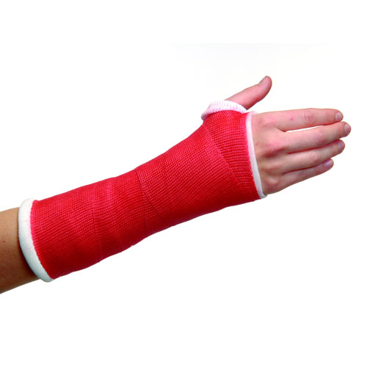

I will need the following materials to build our invention (include where you will find or buy these materials and the cost of each item).

- Flexible solar panels- Renogy 160 Watt 12 Volt Extremely Flexible Monocrystalline Solar Panel - Ultra Lightweight, Ultra Thin, Up to 248 Degree Arc, for RV, Boats, Roofs, Uneven Surfaces ($344)

- Fiberglass cast- $60 for the casting tape (material)

- Temperature cooling pads- $70 Therm-ic C-Pack 1300 and Cool Flat Set OS No Color.

- I estimate the cost of building this invention (per unit) will be:
Based on the costs of all the materials, connecting it to the cost of as regular casts which is approximately $60. The price of this invention would be $474. However, with the costs of all the materials, it would produce a couple units per purchase. So the cost of each individual unit would be sold at $95.

- I estimate the size of our invention will be:
The size of a regular cast (according to the type of cast [arm, leg, etc.])

- I estimate our invention will take approximately 1 hour and 30 minutes to build.

- Who is the target market for this product? (who will buy it?)
Medical practitioners (ex. Doctors, surgeons, physicians, etc.) Afterwards, they will then hand them out to their clients accordingly. We hope that these medical practitioners will change to our product as clients will have more comfort through our cast (therapeutic, heat, cold), and it is more eco-friendly.

- How will you advertise and market this product?
We will use the databases around social media, such as Instagram for it is the most accessible for people to recognize our invention, along with a website for investors to learn more about our product. We will also include a marketing video to advertise our video to our websites, as well as a poster and brochure to include more facts that we were not able to include in our other marketing tactics.

