Foods Room Search
- How many electrical plugs are in your unit?
- Where are the electrical plugs?
- Where is the pencil sharpener located in the classroom?
- Where are the clean dish cloths, drying towels, and oven mitts kept?
- Where are the extra paper towels kept?
- Where are the brooms and dustpans stored?
- Where are the food wraps stored?
- What types of food wraps do you find?
- What small electrical appliances are found in your unit?
- Where in the foods room would you find the extra flour and sugar to refill the canisters in your unit? How about the salt? How about the baking powder and baking soda?
- What are the staple food items in your unit?
- Where in the classroom are the cleaning supplies stored?
- Where in the room would you find the extra dish soap and hand soap?
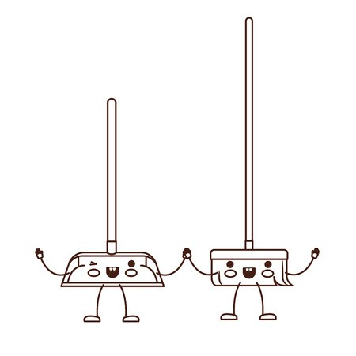

Equipment Search
For the following list of equipment, write down where in the unit it is located and its function:
Equipment | Location | Function/Use
Casserole Dishes
Custard Cups
Baking Sheets
Mixing Bowls
Oven Mitts
Mixing Spoons
Liquid Measures
Saucepan
Cakepan
Dry Measures
Metal Spatula
Measuring Spoons
Cutting Board
Rubber Spatula
Broom and Dustpan
Laundry Detergent
Cooling Rack
French Knife
Rolling Pin
