**Core Competencies Reflection**

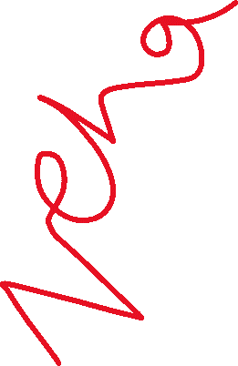

|  |  |  |
| --- | --- | --- |
|  | Core Competency: _______Communication_____________  **Here is evidence that I can…** collaborate, teach, be considerate to others, discuss, contribute to class discussion, explain, justify, share ideas, etc.  Communication is very important in my eye. That’s why I try my best to communicate and involve others in group projects or discussions. I think I do well with engaging others and sharing my ideas. In a science project I was partnered with Ella. We started with getting to know each other which I find is important if you are going to work with someone. Then we started brainstorming ideas and started to share. At times we did not agree but by communicating we compromised and got what was needed done. I had lots of fun getting to know her and we became friends.  I believe I am an active listener. I try to keep eye contact and reflect what the person said to make sure they understand that I am listening. I think that is very important because you want your partner to be happy and have a positive workspace. Its also good to make sure your heard and can do so. I make sure I’m heard, and others are heard otherwise it would be disrespectful. Therefore I think communication is key to a good partnership in anything. The Wood bug project is a great example of my strong suits and weaknesses.  Ways I want to improve are…  Communication is part of everyone day to day life. It can be difficult at times, but that is for everybody. One of my weak spots is when it comes to sharing my ideas, I can have self doubt and be scared that the answer is wrong. I am now understanding that it is ok not to be correct all the time. I am focusing on being more confident on my ideas. To improve I will try to not over think my answers or questions. I will try to accomplish this goal by the end of this semester. |  |