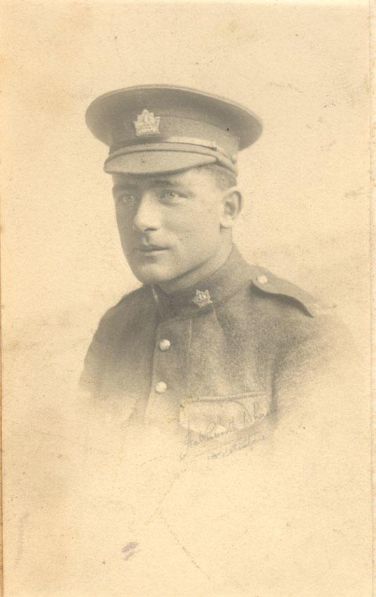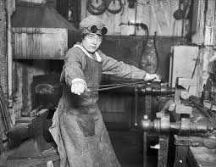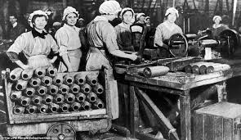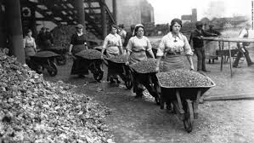

**ANOTHER SURVIVOR?**

THOMAS E. EARDLEY IS TAKEN PRISONER.

*WHEN/WILL HE BE RELEASED? WHERE ARE THEY KEEPING HIM?*

**1**

Lots of changes were happening during the war but one of the more unanticipated adjustments was the role women played. Women were eminently affected in all aspects of their life because of World War 1. Typically, women were expected to do housework, cook every meal, do the laundry, and were also boarding-house keepers during this time. World War 1 forced woman to work in non-traditional jobs. Their labor was essential, but in peace it was expendable. At the beginning of the war they started out as cooks, nurses and seamstresses. It was only intended for woman to be in clerical, administrative and supportive roles like stenographers, switchboard operators and secretaries. It eventually came time to work as parachute riggers, laboratory assistants, and within the electrical and mechanical trades, as well as becoming drivers and mechanics. Women were not allowed to fully enter into the armed forces until the late 1980s. Other things that were in charge of were organizing for home defense, outfitting themselves in uniforms, and training in rifle shooting and several military drills.

The struggle for the right to vote for women was overwhelming but Wartime Elections Act gave the opportunity for females to vote. The act was introduced in 1917, four years after World War 1 had started. It allowed female relatives of Canadian soldiers that were serving overseas in the First World War to vote. This sounds good but it would not be beneficial for us because it would cause the Liberals to beat the Conservatives in the next general election. For many years afterwards, Conservative support in Québec, and among a few ethnic and immigrant groups, was damaged quite badly.

So many people had to experience what is was like for one of your family members go off to war. Imagine someone you love getting sent far away from home knowing the fact that it is very likely that they will die. It was a traumatizing experience that affected the entire population.

**HOW CANADIAN WOMEN WERE AFFECTED BY WORLD WAR 1**

Everyone in Canada was greatly affected by the Great War. It was spring in 1917, and already more than 30,000 Canadians had died on the European battlefields. The quantity of men volunteering for the war was dropping rather quick, and Canadians have been expressing disagreements concerning the contribution of French-Canadian soldiers to the war.

**WHAT DID THE WAR DO TO OUR WOMEN?**

*D E C E M B E R 15th, 1916*

**LA CHRONIQUE QUÉBÉCOISE**