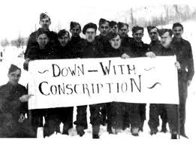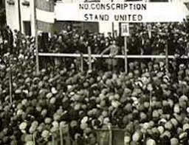

“Conscription Crisis of 1917.” *Wikipedia*, Wikimedia Foundation, 10 Apr. 2019, en.wikipedia.org/wiki/Conscription_Crisis_of_1917.

“French Canada and the War (Canada).” *New Articles RSS*, encyclopedia.1914-1918-online.net/article/french_canada_and_the_war_canada.

“Leaving the Station.” *Canada's History - Upheaval on the Homefront*, greatwaralbum.ca/Great-War-Album/About-the-Great-War/Unrest-on-the-homefront.

“Wartime Elections Act.” *The Canadian Encyclopedia*, www.thecanadianencyclopedia.ca/en/article/wartime-elections-act.

Conscription has even led to multiple deaths. During another riot soldiers were orders to fire on the crowds, therefor causing chaos and everyone trying to disperse. Official reports say that five men were killed by gunfire. There were dozens more who were injured. $300 000 in damage was reported. This incident happened because of conscription. In conclusion conscription causes catastrophic problems and leads to extreme issues like death.

descended upon the St. Roch District Police Station where the man was being held. During the riot the conscription registration office and two newspapers were ransacked. This whole situation could’ve been bypassed if it wasn’t for conscription. This event was futile and alarming for many.

Between March 28 and April 1, 1918 there was a brutal weekend of rioting due to anti-war ideas from French-Canadian nationalists. Nationalism is identification with one's own nation and support for its interests, especially to the exclusion or detriment of the interests of other nations. Conscription caused this riot. A French-Canadian ma had been detained because he had failed to present his draft exemption papers. Although the man was released, there was an angry mob of almost 200 people

should be conscripted to fight in the war. They should not be conscripted; they should be able to make the choice for themselves. It should be their choice. They should have the right to have the liberty in making their own decisions. This decision will definitely change their life. They should be treated with fairness and respect. The federal government enacted conscription initiating severe separation between English-Canadians, who generally supported the practice, and French-Canadians, who tended not to. Conscription only has negative effects. It creates unnecessary problems that could have very well been avoided. Majority of French Canadians opposed conscription; they felt that they were not particular loyalty to either Britain or France. Their only loyalty was Canada, their homeland.

**2**

Conscription is the compulsory enlistment, “call up” or “the draft” of citizens for military service. It was a political and military crisis. It was caused by disagreement on whether or not men

**THE CONSCRIPTION CRISIS CREATING MORE CRISIS**