Law 12 Mr. Aitken
Fairy Tale Stories and the Criminal Code of Canada

You are probably familiar with Little Red Riding Hood, Snow White and Hansel and Gretel, but did you know that aside from being fairy tale characters they were also hardened criminals? Yes, that is right. Hansel and Gretel may look like innocent little children but they would be violating the Criminal Code of Canada with their conduct.

As a means of learning about the Criminal Code of Canada and some of the provisions contained within it you are going to be reading a fairy tale and identifying the crimes that take place as the plot unfolds. All characters in the story are fair game in terms of being able to be charged with an offense (even if they end up meeting their doom at the end).

As a group you will then be responsible for creating a presentation (PowerPoint, Prezi etc.) outlining the plot of the story and detailing the charges that you feel are appropriate to your particular fairy tale. You will need to outline the relevant sections in the Criminal Code of Canada. Detail the charges and punishments associated with the crime as well as prove that it was a crime by demonstrating that both Mens rea and Actus reus were present in the thoughts and actions of the characters. You should look to emulate the example below.

https://prezi.com/y_xjgpbr4o8h/fairy-tale-crimes-project/

Fairy Tale Stories
As a group of three you will be assigned one of the stories below to read and research.
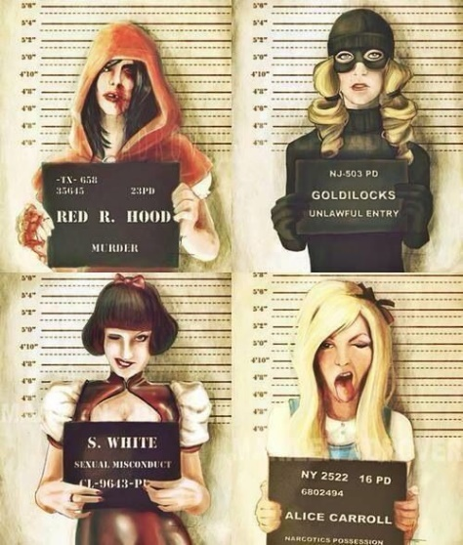
The Three Little Pigs
Rumpelstiltskin - Grimm
Little Red Riding Hood - Grimm
Hansel and Gretel - Grimm
The Pied Piper of Hamelin - Grimm
The Emperors New Clothes - Grimm
The Juniper Tree - Grimm
Tom Thumb (Little Thumb) - Perrault
Sleeping Beauty – Perrault
Cinderella - Perrault

To search for the text of your fairy tales online you should look to search the name and author of the fairy tale (provided above) as well as the file type .pdf – in this way you should be able to find most versions of the fairy tales.

