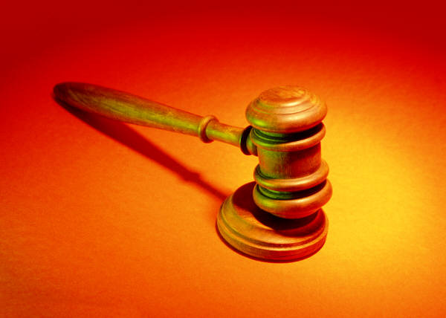
Evaluation Rubric for the Song, poem, music, video etc.
Student: ______________________ Case: ____________________________________
 | Beginning Developing Accomplished Excellent
 | 2(C/C-) | 3(C+) | 4(B) | 5 (A) | Mark
Organization | Audience cannot understand presentation because there is no sequence of information. | Audience has difficulty following presentation because student jumps around. | Student presents information in logical sequence which audience can follow. | Student presents information in logical, interesting sequence which audience can follow.
Content Knowledge | Student does not have grasp of information; student cannot answer questions about the limits of the Charter or the case. | Student is uncomfortable with information and is able to answer only rudimentary questions about the Charter or the case | Student is at ease with content, but fails to elaborate on the impact of the case on the legal system | 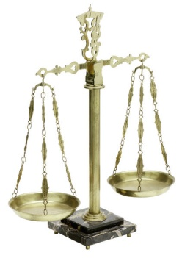  Student demonstrates full knowledge (more than required) with explanations and elaboration of the case and its impact on the legal system
Poetry | The form of the poem, song/rap/music/video/ is not appropriate to the legal subject. The poem, song, or rap does not enable audience or reader to see, hear, feel or think about the case. Not very creative or engaging. | The form of the poem, song/rap/music/video/ should be more appropriate to the legal subject. The poem, song or rap enables the reader to see, hear, feel or think about the case, but this is accomplished with clichés or other predictable choices. | The form of the poem/song/rap/music/video/ is appropriate to the legal subject. The poem enables the reader to see, hear, feel and think about the subject. There is some clear creativity. | Genuinely engaging and extremely creative. The form of the poem/song/ /video or rap is appropriate to the legal subject. The poem deeply engages the reader or audience.
Mechanics | Student's presentation had four or more spelling errors and/or grammatical errors. | Presentation had three misspellings and/or grammatical errors. | Presentation has no more than two misspellings and/or grammatical errors. | Presentation has no misspellings or grammatical errors.
Delivery | Student mumbles, incorrectly pronounces terms, and speaks too quietly for students in the back of class to hear OR just reads the presentation. | Student incorrectly pronounces terms. Audience members have difficulty hearing presentation. | Student's voice is clear. Student pronounces most words correctly. | Student used a clear voice and correct, precise pronunciation of terms.
Comments for Improvement:

