Social Studies 10 Mr. Aitken
Branches of Government & Functions
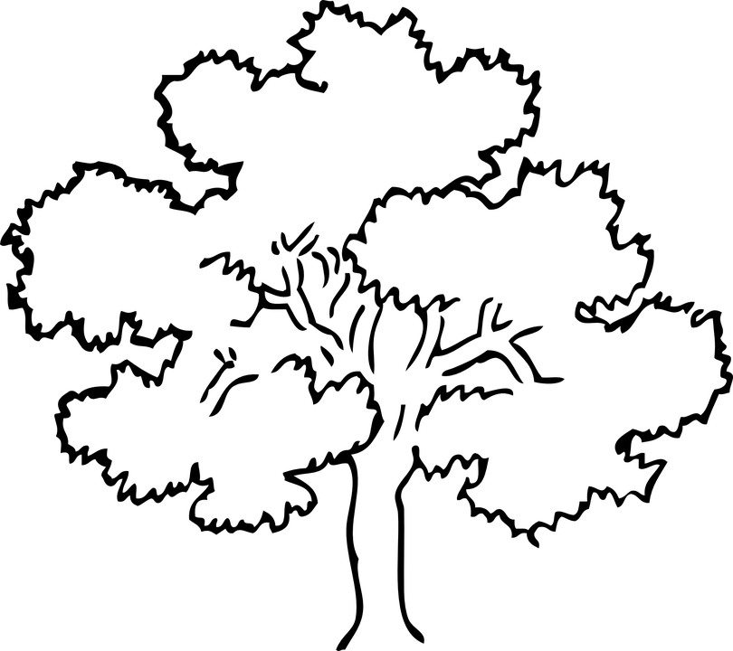
Complete the table below: the small boxes are reserved for the various branches of government – in the large box write point form information about the function of each branch. (304-311 2nd. Ed)

