Law 12 Mr. Aitken
Analyzing a Case

When you look at case law it is a good idea to review the specific cases in a step by step process in order to gain a greater understanding of the legal issues present in the case. Use the following questions to analyze the case that you have been assigned.

The title of your case analysis should be the case citation (ie. R v. Oakes). You should then address the following questions in paragraph format. Be as detailed as possible. See the format on the reverse page.
- Who are the key participants in the case and what actually happened?
- What is the argument? What legal questions need to be considered in this case?
- What laws are involved? Criminal Code, Charter of Rights and Freedoms etc.
- Facts v. Opinion. What might they be in this case?
- What was the decision?
- What is your opinion?
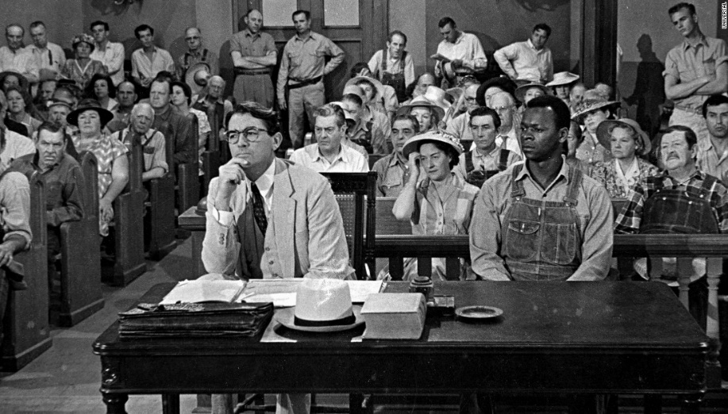

Your case analysis will be assessed on the following:
- How well do you describe the case, summarize the argument and demonstrate evidence that you have researched both the case and the laws involved?
- How well have you followed the formatting instructions for a case anaylsis?
- Are your explanations and descriptions thorough, detailed and do they take into account a variety of factors?
- Are your opinions evidence of thoughtful, sophisticated ethical judgements regarding the legal issues raised in the specific case?

Formatting your case analysis:

For all of the case analysis’ that we do in this class you should look to follow the similar format. In some cases certain sections of your write-up may be longer and in others they may be shorter. There is an example provided for this first case analysis to give you an indication of what you should look to write.

Case Analysis Format:
- Title – Use the citation for your title – R v. Oakes
- Describe the situation – present the key facts in the case and then describe, in detail, what is alleged to have occurred. Be as thorough as possible and look to research this case from multiple sources in order to get a clear picture as to what occurred.
- Note the questions to consider in the case – what are the arguments that are being made?
- Note the relevant sections of the law – this will involve you looking at the Criminal Code of Canada, The Charter of Rights and Freedoms or both of these documents. You are free to copy the relevant information from online sources for this section. You only need to copy the relevant sections – do not provide the whole section – only those parts that pertain to the case at hand.
- Discuss the relevant arguments that were made by both sides of the case – here you present the arguments that were made at trial in order to justify the decision which you will provide following this discussion.
- State the decision of the court in this case.
- Provide your opinion of the case – you can disagree with the court if you do not believe their decision was correct, or you can agree with them. Either way you must clearly articulate your position and explain the rationale behind your decision.

Charter Cases to use for this Assignment:
In this assignment you will be writing a reflection and analysis for a key charter related case in Canadian Law. You will need to choose one case from the following to research and write your opinion on.
R. v. Mann – detention of a suspected criminal
R. v. Askov – trial within a reasonable time
R. v. Collins – exclusion of evidence
R. v. Sparrow – application of aboriginal rights
R. v. Stinchcombe – disclosure of evidence at trial
R. v. Morgentaler – abortion rights
R v. Le – detention without reasonable suspicion
Ford v. Quebec – use of commercial signs in languages other than French – language rights
Vriend v. Alberta – legislative omission and issues of sexual orientation
Grant v. Canada – detention and exclusion of evidence
Singh v. Canada – immigration procedures
Andrews v. Law Society of British Columbia – citizenship and equality rights
Sue Rodriquez v. British Columbia – right to doctor assisted suicide

If you cannot find a case to choose from this list you are free to select another charter case that interests you. Please check with Mr. Aitken and get confirmation before proceeding with a case that is not listed above.

