Assignment #1
Personalizing Your Blog

Congratulations! You now have a blog as part of your Digital Literacy 10 course. This is going to be a space that you will use over the next four years to showcase your accomplishments and build a portfolio of your learning. It will provide an opportunity to connect with the world and reflect on your expanding repertoire of abilities and accomplishments.

At the moment, however, your blog is very generic. In fact, it is the same as everyone else’s. Your first task is going to be to make your blog unique. To personalize it. It is appropriate to remember however, that this is a space that is shared with the world. Personalizing your blog does not entail putting up selfies and personal information about yourself. It is rather an opportunity to showcase some of your interests and share these interests with the world.

In order to complete the assignment you will need to do the following:

- Select an appropriate Theme and customize it – you can customize a number of different aspects of your blog depending on your theme – you can switch your theme around later but it may involve you having to do a bit of extra work to ensure everything is up to date.
- Personalize the Header with a picture (not a picture of yourself – rather a place you like or an interest that you have. Tropical Beaches, Anime Characters, etc.)
- Change your Tagline – This currently reads “My Heritage Woods Digital Portfolio” change it to something more interesting.
- Complete the following on your About Me Page:
- Introduce yourself: Write a paragraph about yourself. It could include what you’re interested in, what you like to do in your spare time, hobbies and sports you play, your goals and dreams. Do not use your full name or provide any details that could directly identify you.
- What is your favorite quote. Find a favorite quote or one that is meaningful to you and copy and paste it, or type it into your page. Write a short paragraph explanation about why this quote is meaningful to you or why you chose it.
- What is your favorite YouTube Clip: Select your favorite YouTube clip and explain why it is meaningful to you (ensure that it is school appropriate/has a positive message or reflects well on you as a person – remember your digital footprint – and copy the embed code – embed the picture into your page and explain why you chose this clip. Click “Share” beneath the video, then click “Embed”. Click “Copy” to copy the embed code. On your blog, click “Add Media” and then “Insert Embed Code”. Paste the code from YouTube and click “Insert Into Post”.
- What is your favorite website? – Create a hyperlink to your chosen website and provide an explanation as to why this is your favorite website.
- Find a picture that has impacted you (This should not be a personal picture but rather an image that has affected you in some way) The image below would be a good example. 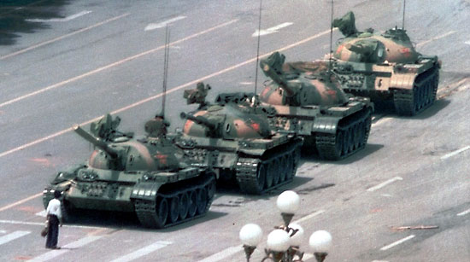

- Optional - Create a Wordle about yourself (need adobe flash). Again be sure not to include any personal information such as full name, address, birthdate etc.

Assignment Rubric – All Items below need to be completed to a satisfactory standard in order to receive a passing grade on this assignment.

- Changing Theme, Header Image and Tagline – Image and Title
- Paragraph about you completed – at least 5 sentences.
- Quote and paragraph about quote completed.
- Embedded video and explanation of its importance to you.
- Image and explanation of its importance to you.

