**Do not improvise unless your teacher specifies.**

Oh no! I shouldn’t have changed the procedure without permission!!

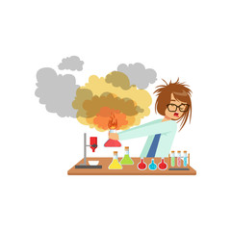

LAB SAFETY

**Wipe up and avoid a slip-up!**

**Dispel fear by wearing the proper gear!**

**The triangle of three that will guarantee your safety!**

