Student Name: Riane Lee

Student Email: 127-rlee@sd43.bc.ca

Date Started: Tuesday, October 20, 2020

Quarter: 1 Block: 2

Teacher: Mr. Viveiros

TEACHER E-MAIL: mviveiros@sd43.bc.ca

Long Term Health Goal(s) For This School Year:

My long term health goal for this school year is to feel physically and mentally healthier. For example, eating healthier, having a toned physique etc. In turn, eating healthy or exercising regularly can help boost my self-esteem and confidence, which will eventually lead to a positive mindset and perception of myself and increase my resiliency. Additionally, I would like to improve my stamina and endurance during cardio exercises. I find that my energy easily depletes after a short period of cardio (running, fitness circuits etc.) and I want to improve my endurance to the point that I don’t need as many breaks, or I don’t feel as winded and fatigued.

Short Term Health Goal(s) For This School Year:

My short term health goal for this school year is to exercise at least 4 times a week and monitor my sugar intake. I will monitor my sugar intake by ingesting less artificial sugar (candy, chocolate etc.) Although indulgence is allowed, I strive to eat less unnecessary junk food once or twice a week. If I can achieve that goal, I can then increase the restriction. For instance, completely skipping junk food three times a week etc. and working my way up. Also, I would like to try to incorporate more vegetables/fruit in my diet. Although I eat vegetables/fruit with my meals, I find that for breakfast, I’ll usually eat toast or a form of carbs. This is another way of eating healthier, by making sure that every meal has a vegetable/fruit component.

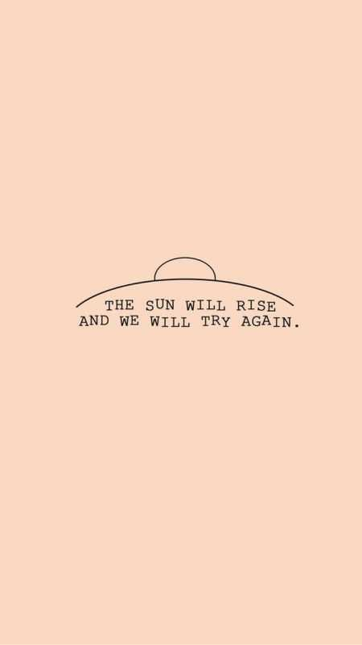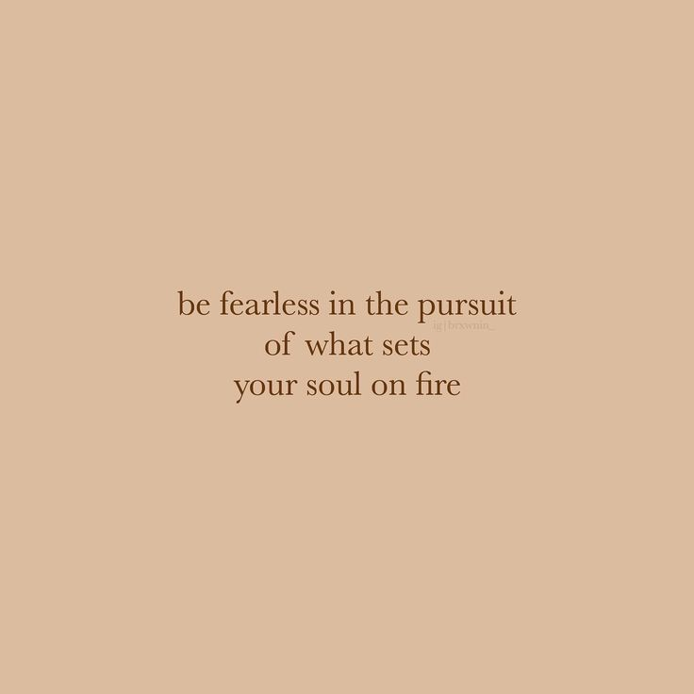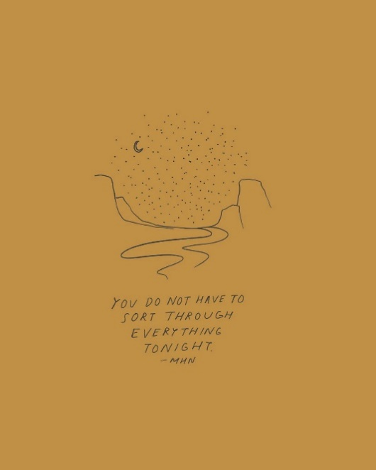

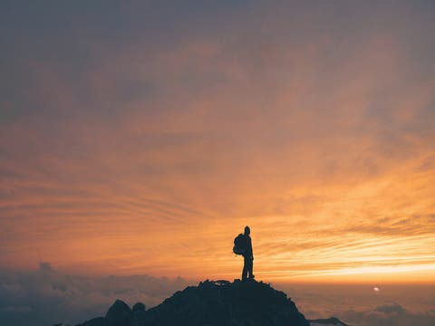
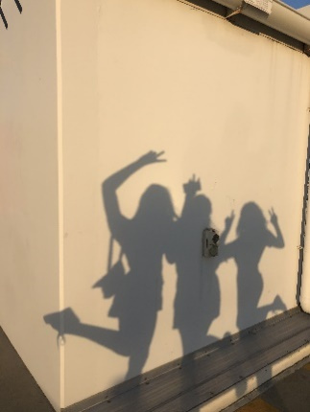

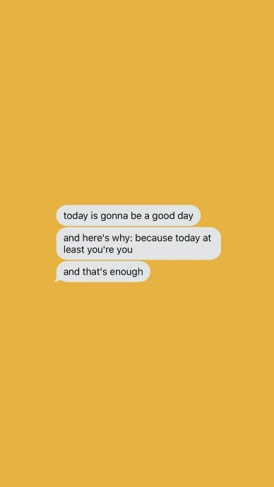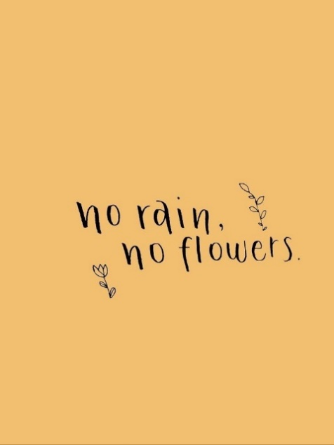

HWSS Hybrid Unit Weekly PHE Log
Week 1: October 19th-25th

Date | Exercise | Strength Exercises |  |  | Cardio Exercises |  |  | Physical Literacy
 |  | Sets | Reps | Weight | Time Spent | Distance | Interval | Skills Developed
Monday | N/A | N/A | N/A | N/A | N/A | N/A | N/A | N/A
Tuesday | HIIT training (full-body circuit) | N/A | N/A | N/A | 15:30 | N/A | 15 exercises (50 secs on with 10-sec breaks) | These exercises help me train my stamina to improve it. Although I have to stop occasionally (besides the actual break) while doing the exercises, eventually, I’m sure I’ll be able to exercise without stopping or slowing down.  Most of the exercises require balance or core strength to properly work on certain areas/muscle groups. There were occasions where I had to stop in the middle of exercising to regain my balance.
 | Abdominal training | 16 exercises with 5-10 sec breaks | 15 reps every exercise (minimum) | 11:02 (time) | N/A | N/A | N/A
 | Plie squats & pulses (5 variations) | 1 (5 exercises, 1 min 30 secs on with no breaks) | 30-50 reps | 7:30 (time) | N/A | N/A | N/A
 | Hike | N/A | N/A | N/A | 18:56 | 1.6 km | Uphill and downhill
Wednesday | Hike | N/A | N/A | N/A | 27:17 | 2.17 km | Uphill and downhill | All the workouts required endurance (my heartbeat had quickened, I was sweating profusely, my muscles started aching etc.) and by trying my best, I knew that I would be able to gradually improve my stamina.  The yoga exercise was mainly for strengthening the upper body (arms, shoulders etc.), utilizing chaturanga (a pose where you lower yourself until you are parallel to the ground and push back up) and planks to work the muscle groups and variations of the child’s pose to relax and stretch stiff/tense muscles. Although I could barely carry out the exercise, I strive to continue at it to improve my physique and athleticism.
 | Core workout |  | 20-50 reps every exercise | 20:00 (time) | N/A | N/A | N/A
 | Yoga (for upper-body strength) | 2 sets | 10-15 reps | 13:00 (time) | N/A | N/A | Constant movement
Thursday | Hike | N/A | N/A | N/A | 42:38 | 3 km | Uphill and downhill | Throughout the walk, I kept a moderate pace but constantly going uphill and downhill had me tired. I noticed that my stamina was slowly improving (I wasn’t as tired as I thought I would be).
 | HIIT training (full-body circuit) | N/A | N/A | N/A | 15:30 | N/A | 15 exercises (50 secs on with 10-sec breaks)
Friday | HIIT full-body workout | N/A | N/A | N/A | 30:00 | N/A | 20-30 secs on and 5-20 secs break | Throughout the two workouts, I was starting to tire from all the cardio and my muscles were aching, but I knew that it would pay off, so I persisted. I also noticed that my endurance for higher-intensity cardio workouts was weaker than if I were to constantly hike uphill.
 | Core training | 8 back-to-back exercises with 5-10 secs breaks | 20 reps (minimum) | 15:10  (time) | N/A | N/A | N/A
Saturday | Hike | N/A | N/A | N/A | 43:12 | 3.9 km | Uphill and downhill, at a brisk pace but with occasional jogging | I changed the path I usually took on a hike and it was more challenging because the distance was longer, and it required more endurance to walk up and down long hills. I noticed that all my effort from prior exercises paid off because I was surprised that I wasn’t particularly exhausted like I initially thought.
 | HIIT full-body circuit | N/A | N/A | N/A | 21:14 | N/A | 4 sets, 30 exercises (30 secs on with 10-30 sec break between sets)
Sunday | Hike | N/A | N/A | N/A | 45:33 | 3.9 km | Uphill and downhill, at a brisk pace | Unfortunately, I was not feeling like exercising so I opted to just do a long hike instead. Throughout the hike, I was wondering if I could just slack off and return home half-way. However, I kept a positive and determined mindset, finishing the hike. It felt more rewarding and satisfying than if I were to not exercise.
Your goal should be to meet the Canadian Physical Activity guidelines for one hour of moderate- to vigorous-intensity activity every day you do not have PE.
Choose vigorous activities at least three days a week. Get stronger by doing activities that build muscles and bones at least three days a week. Combining aerobic and strengthening activities will improve your health and well-being.
https://www.canada.ca/en/public-health/services/publications/healthy-living/physical-activity-tips-youth-12-17-years.html

HWSS Hybrid Unit Weekly PHE Log
Week 2: October 26th-November 1st

Date | Exercise | Strength Exercises |  |  | Cardio Exercises |  |  | Physical Literacy
 |  | Sets | Reps | Weight | Time Spent | Distance | Interval | Skills Developed
Monday | HIIT full-body workout | N/A | N/A | N/A | 13:16 | N/A | 20 exercises (30 secs on with 5-10 secs of rest) | Instead of simply finishing the full-body circuit and going on a hike like I usually do, I decided to do a simple exercise in between. Doing butt-kicks for 2 minutes at a consistent speed was more challenging than I originally thought, and I overestimated my ability. However, it proved my increased stamina as I was able to do it for 2 minutes at a fast pace (although my legs felt weaker after).
 | Butt kicks | N/A | N/A | N/A | 2:00, no breaks |  | A gradual increase in speed
 | Hike | N/A | N/A | N/A | 43:01 | 3.9 km | Uphill and downhill, occasional jogging but only uphill
Tuesday | HIIT full-body workout | N/A | N/A | N/A | 21:14 | N/A | 30 exercises (30 secs on with 5-30 secs of rest) | As it was raining, I couldn’t spend a part of my daily exercise outside, so I had to follow more workouts on YouTube. This was the most strenuous exercise I encountered because of the increased amount of cardio. I exerted the best of my ability and I was surprised that I didn’t quit half-way through, even though I was exhausted. Between the videos, I made sure to constantly move and cool-down slightly before switching to the next exercise.
 | Abs and HIIT workout | N/A | N/A | N/A | 21:49 | N/A | 2 sets (45 secs on with 15-sec rest), warm-up and cool-down included
 | Abs workout |  |  | 11:18  (time) | N/A | N/A | N/A
 | Lower abs workout | 16 exercises (each 30-40 secs on) with 10 secs rest | Minimum 20 reps per exercise | 11:03  (time) | N/A | N/A | N/A
Wednesday | HIIT full-body workout | N/A | N/A | N/A | 26:39 | N/A | 4 sets (20-30 secs on with 5-20 secs rest), warm-up and cool-down included | It was raining again, so I followed the same routine as yesterday, although I switched out some videos for a variety of exercises. Realizing that I usually focus on my upper-body and neglect my lower-body, I decided to incorporate a leg workout. I noticed the effectiveness of yesterday’s workout when my muscles were slightly sore and ached. However, they did hinder my ability today. Although it felt easier to not work out (my brain registered my sore muscles as a “valid excuse”), I persisted but ensured that I wasn’t pushing myself too hard or else I’d injure myself.
 | Leg workout (mainly thigh area and calves) | 3 sets (6-8 exercises per set) | Minimum 15 reps per exercise | 16:08  (time) | N/A | N/A | N/A
 | Abs workout | 16 exercises (each 30-40 secs on) with 10 secs rest | Minimum 20 reps per exercise | 11:03  (time) | N/A | N/A | N/A
Thursday | HIIT full-body workout | N/A | N/A | N/A | 16:12 | N/A | 3 sets x 8 exercises (30 secs on with 5-20 secs of rest) | Today’s workout was average, although it still felt satisfying after finishing the exercise, my muscles were still sore from the previous exercise. However, the soreness in my core muscles had decreased and it was mainly my inner thighs.
 | Hike | N/A | N/A | N/A | 45:00 | 3.9 km | Uphill and downhill, at a brisk pace without breaks
Friday | HIIT full-body workout | N/A | N/A | N/A | 15:43 | N/A | 24 exercises (30-60 secs on with 5-15 secs of rest) | While exercising, I noticed that my right leg is physically stronger than my left. For instance, while doing lateral lunges, my right leg did not require as much force to push myself back up into the standing position. My left leg needs strengthening because it gets fatigued and unstable very easily, forcing me to take more breaks than I would when I am repeating the exercise on the other leg.
 | Hike | N/A | N/A | N/A | 45:00 | 3.9 km | Uphill and downhill, at a brisk pace (had to slow down due to other people)
Saturday | Hike | N/A | N/A | N/A | 42:38 | 3.9 km | Uphill and downhill, occasional bursts of speed | Instead of hiking by myself (like I usually do), I spent time with my dad! The hike was as usual, at a quick pace without any breaks. When I was doing the full-body workout, I realized that my left leg was more stable than my right leg, even though my right leg is physically stronger. This means that I can balance better on my left leg without tipping or shaking. I also realized that my left leg is more flexible, as I can kick higher.
 | HIIT full-body workout | N/A | N/A | N/A | 15:49 | N/A | 15 exercises (50 secs on, 10 secs off)
 | Abs workout | 1 (21 exercises, 30 secs on with 10 secs off) | Minimum of 25 reps per exercise | 11:04 (time) | N/A | N/A | N/A
Sunday | Hike | N/A | N/A | N/A | 40:33 | N/A | N/A | Despite my continuous perseverance and motivation, some days I still find myself dreading exercising, especially on the weekend. The potential reason could be because of repetitive exercises. My muscles have already gotten used to the current exercises that I frequently rotate through, so I’ll need to find other videos with a variety of exercises to further train my body.
 | HIIT full-body workout | N/A | N/A | N/A | 16:08 | N/A | 19 exercises (30-40 secs on, 5-10 secs off). Alternating between high-intensity and lower-intensity exercises
Your goal should be to meet the Canadian Physical Activity guidelines for one hour of moderate- to vigorous-intensity activity every day you do not have PE.
Choose vigorous activities at least three days a week. Get stronger by doing activities that build muscles and bones at least three days a week. Combining aerobic and strengthening activities will improve your health and well-being.
https://www.canada.ca/en/public-health/services/publications/healthy-living/physical-activity-tips-youth-12-17-years.html
HWSS Hybrid Unit Weekly PHE Log
Week 3: November 2nd-8th

Date | Exercise | Strength Exercises |  |  | Cardio Exercises |  |  | Physical Literacy
 |  | Sets | Reps | Weight | Time Spent | Distance | Interval | Skills Developed
Monday | HIIT full-body workout | N/A | N/A | N/A | 21:27 | N/A | 3 sets (30-40 secs on, 0-10 secs of rest). Alternating between high-intensity and lower-intensity exercises (e.g., burpees then push-ups) | Doing 20-minutes of cardio was more exhausting than I expected because the previous days I spent doing only 10-15 minutes of cardio since my muscles were still sore from the 1-hour session. However, it is beneficial because it got my blood pumping and helped me feel more motivated with the energy burst.
 | Hike | N/A | N/A | N/A | 43:15 | 3.9 km | Uphill and downhill, at a brisk pace.
Tuesday | HIIT full-body workout | N/A | N/A | N/A | 21:15 | N/A | 4 sets (30 secs on, 5-30 secs off). Alternating between high-intensity and lower-intensity exercises (e.g., cross jacks then lateral lunges) | The 20-minute cardio workouts are getting progressively easier as my body is gradually adapting to the duration of high-intensity exercises. Although there is a low-intensity or “no jumping” variation provided in the video, I did my best to always execute the exercise to the limit of my ability. I revisited the “plie squat” workout from the first week to test my balance and strength of my legs. To my surprise, I was able to execute the exercises with fewer breaks than I predicted.
 | Abs workout | 1 (17 exercises, 30 secs on, 5-10 secs off) | Minimum of 30 reps per exercise | 11:18 (time) | N/A | N/A | N/A
 | Plie squats & pulses (5 variations) | 1 (5 exercises, 1 min 30 secs on, no breaks) | 30-50 reps | 7:00 (time) | N/A | N/A | N/A
Wednesday | HIIT full-body workout | N/A | N/A | N/A | 26:39 | N/A | 4 sets (20-30 secs on with 5-20 secs of rest). Alternating between high-intensity and lower-intensity exercises (e.g., shuffle then push-ups) | Today’s exercise was very fulfilling because I was super motivated and productive, and I decided to exercise multiple areas of my body instead of simply doing a full-body circuit and working on my core muscles. I have done the arm workout many times in the summer, and I was curious about the strength of my arms, so I revisited it. I was pleasantly surprised when I was able to do many exercises back-to-back without any rests, especially arm pulses and circles, which were right after each other. Usually, I would take a break in between to let my tense muscles relax but I didn’t need to today.
 | Abs workout | 1 (21 exercises, 30 secs on with 10 secs off) | Minimum of 25 reps per exercise | 11:04 (time) | N/A | N/A | N/A
 | Arm workout | 1 (14 exercises, 40 secs on, 0-5 secs of rest) | Minimum of 25 reps per exercise | 10:58 (time) | N/A | N/A | N/A
Thursday | Weightlifting (P.E.) | 2 (40 secs on with 5 secs of rest in between each exercise) | 5-10 reps per exercise | 5 lbs. | N/A | N/A | N/A | The weight-lifting I did in class wasn’t too tiring but it was rewarding because I have always considered my arms to be the weakest muscle group in my body. It was something new and I thoroughly enjoyed the entire experience.  Returning from school, I didn’t have a lot of motivation to exercise even though I knew it would be more fulfilling. Initially, I was going to just do my regular hike but I decided to muster motivation and try to do another video. Since I was feeling uninspired, I opted to just do an abs workout instead of a full-body circuit.
 | Abs workout | 1 (17 exercises, 30 secs on, 5-10 secs off) | Minimum 30 reps per exercise | 11:18 (time) | N/A | N/A | N/A
 | Hike | N/A | N/A | N/A | 46:33 | 3.9 km | Uphill and downhill, varying between a moderate and fast pace
Friday | HIIT full-body workout | N/A | N/A | N/A | 16:11 | N/A | 4 sets, 24 exercises (30 secs on, 5-20 secs off). Alternating between high-intensity and lower-intensity exercises | Today, instead of selecting exercises that I usually do, I decided to push myself out of my comfort zone by doing more recent videos. These videos included a larger variety of exercises and did not repeat a lot of the same exercises that usually appeared in workout videos. For instance, in the abs workout, I did not know the majority of the exercises, such as hollow crunches. The variety of exercises piqued my interest as it felt less repetitive. I also surprised myself because when I finished the full-body workout, I was sweating so much, I physically felt sweat trickling down my temples. Even with a 1-hour session of non-stop cardio, I never sweat that profusely. Additionally, I altered the hiking route by choosing a steeper and longer hill to test my endurance.
 | Abs workout | 1 (14 exercises, 30-40 secs on, 5-10 secs off) |  | 11:06 (time) | N/A | N/A | N/A
 | Hike | N/A | N/A | N/A | 37:37 | 3.9 km | Uphill and downhill, at a fast pace
Saturday | Hike | N/A | N/A | N/A | 40:34 | 3.9 km | Uphill and downhill, starting at a moderate then increasing to a face pace | Today, I challenged myself by picking workouts that included completely new exercises that I have never tried before. Honestly, some of the exercises I never even heard of before, and I felt discouraged when I spend some of the time getting the gist of it. However, I reminded myself that exercising in good form is more important than the number of reps. For the core & arms exercises, my arms ended up getting a good workout, but my core didn’t. Perhaps it’s because I didn’t engage my core muscles as much.
 | HIIT full-body workout | N/A | N/A | N/A | 15:25 | N/A | 3 sets (30 secs on, 5-15 secs off). Alternating between high-intensity and lower-intensity exercises
 | Core & arms workout | 1 (18 exercises, 30 secs on, 5-15 secs off) | 15-20 reps | 11:32 (time) | N/A | N/A | N/A
Sunday | Hike | N/A | N/A | N/A | 42:11 | 3.9 km | Uphill and downhill, at a consistently brisk pace | For the hike, I did the same route, but the reverse (instead of going down Forest Park Way, I hiked up). It was more challenging because there were steeper hills to climb. Hiking up Forest Park Way was a lot more difficult than I had predicted and my quad muscles were tired when I got home so I made sure to stretch. Throughout the second workout, I was aware of my tired legs, so I made sure to limit myself to prevent injuries. Also, the workout completely includes new exercises, and the variation was interesting and challenging.
 | Abs & full-body workout | Core:1 super-set (14 exercises, 30 secs on, 10 secs off)  Full-body: 2 (30-50 secs on, 5-15 secs off) | 15-25 reps | 9:48 (duration of set of abs exercises) | 21:22 (total) | N/A | 3 sets in total with occasional rest.
Your goal should be to meet the Canadian Physical Activity guidelines for one hour of moderate- to vigorous-intensity activity every day you do not have PE.
Choose vigorous activities at least three days a week. Get stronger by doing activities that build muscles and bones at least three days a week. Combining aerobic and strengthening activities will improve your health and well-being.
https://www.canada.ca/en/public-health/services/publications/healthy-living/physical-activity-tips-youth-12-17-years.html

HWSS Hybrid Unit Weekly PHE Log
Week 4: November 9th-15th

Date | Exercise | Strength Exercises |  |  | Cardio Exercises |  |  | Physical Literacy
 |  | Sets | Reps | Weight | Time Spent | Distance | Interval | Skills Developed
Monday | HIIT full-body cardio | N/A | N/A | N/A | 26:10 | N/A | 4 sets, 31 exercises (30-40 secs on, 5-20 secs off). Alternating between high and lower-intensity exercises (e.g. plank with bunny hops then corkscrew) | Today’s workout was intense, especially the full-body cardio as I was constantly moving, and I gradually started to get more tired in the third set. I decided to exercise more muscle groups, so I included a lower-body workout (since I usually just do full-body cardio and an abs workout). The full-body cardio and lower-body workout are both new workouts that I have never done before but I used the same abs workout as last week because it’s a lot more intense than previous ones. Additionally, after each exercise, I did a 2-3-minute cool-down to help stretch and relax my tense muscles.
 | Abs workout | 1 (14 exercises, 30-40 secs on with 5-10 secs off) | 15-20 reps per exercise | 11:07 (time) | N/A | N/A | N/A
 | Lower body workout | 1 (19 exercises, 30-50 secs on with 5-10 secs off) | 10-15 reps per exercise | 13:11 (time) | N/A | N/A | N/A
Tuesday | HIIT full-body workout | N/A | N/A | N/A | 15:26 | N/A | 3 sets (30 secs on, 5-15 secs off). Alternating between high and lower-intensity exercises (e.g., high knee then spider-man plank) | Today’s exercise is shorter because I didn’t have enough time to fit in a full hour of exercising. The full-body workout was higher in intensity compared to the 20-minute workouts because it consisted of mainly high-intensity cardio (burpees, jumping jacks, mountain climbers, high knees etc.) while the 20-minute workouts alternated evenly between high and low-intensity exercises. For the abs workout, while doing bicycle crunches, my core muscles were incredibly sore, and it gave me a sign that I was engaging the correct muscles and exercising in proper form. Additionally, for the lower body workout, my glutes, hamstrings and quads were also very sore, and I knew I was properly exercising each muscle group. Between each video, I made sure to do a 2-3-minute stretch corresponding to the muscle groups that were targeted (e.g., after the abs workout, I used the Cobra and Child’s Pose to stretch my abdominal muscles).
 | Abs workout | 1 super-set (21 exercises, 30 secs on, 10 secs off) | Minimum of 15 reps per exercise | 11:04 (time) | N/A | N/A | N/A
 | Lower body workout | 1 (20 exercises, 40 secs on, 10-15 secs off) | 15-20 reps per exercise | 16:06 (time) | N/A | N/A | N/A
Wednesday | Hike | N/A | N/A | N/A | 36:00 | 2.4 km | Uphill and downhill (but less than my usual 45-minute route) | Even though today’s workout is shorter than usual, it still got me tired. My quads were still slightly sore from yesterday’s lower body workout and the weather is rapidly getting too cold for longer walks. As usual, I made sure to stretch for a while after the workout and replenish on water.
 | HIIT full-body cardio | N/A | N/A | N/A | 16:11 | N/A | 4 sets, 24 exercises (30 secs on, 5-20 secs off). Alternating between high and lower-intensity exercises (e.g. overhead jumping jacks then reverse lunges + kicks)
Thursday | HIIT full-body workout | N/A | N/A | N/A | 31:19 | N/A | 4 sets (10 each set, minimum 30 secs on, 20 secs of rest between sets, 5-10 secs off between exercises) | Since today is the last workout that I’m going to record before I finish the assignment, I decided to test my stamina, since my long-term goal is to improve my overall stamina. Doing half an hour of cardio was extremely exhausted as I predicted, but besides the scheduled breaks, I didn’t take any extra rests. As I began the third set, I started to feel fatigued, especially when I repeated burpees and jumping jacks again. For the abs workout, I was aware of the soreness of my abdominal muscles, which told me that I was doing the exercises properly. Likewise, for the leg workout, my quads were burning. As usual, I made sure to drink water and stretch after each workout.
 | Abs workout | 1 (14 exercises, 30-40 secs on, 5-10 secs off) | 15-25 reps (depending on the exercise) | 11:06 (time) | N/A | N/A | N/A
 | Leg workout (glutes & quads) | 3 sets (17 exercises, 30-45 secs on, 10-20 secs off) | 10-15 reps | 15:48 (time)
Friday | N/A | N/A | N/A | N/A | N/A | N/A | N/A | N/A
Saturday | N/A | N/A | N/A | N/A | N/A | N/A | N/A | N/A
Sunday | N/A | N/A | N/A | N/A | N/A | N/A | N/A | N/A
Your goal should be to meet the Canadian Physical Activity guidelines for one hour of moderate- to vigorous-intensity activity every day you do not have PE.
Choose vigorous activities at least three days a week. Get stronger by doing activities that build muscles and bones at least three days a week. Combining aerobic and strengthening activities will improve your health and well-being.
https://www.canada.ca/en/public-health/services/publications/healthy-living/physical-activity-tips-youth-12-17-years.html

HWSS Hybrid Unit Weekly PHE Log
Week 5: Dates: N/A

Date | Exercise | Strength Exercises |  |  | Cardio Exercises |  |  | Physical Literacy
 |  | Sets | Reps | Weight | Time Spent | Distance | Interval | Skills Developed
Monday | N/A | N/A | N/A | N/A | N/A | N/A | N/A | N/A
Tuesday | N/A | N/A | N/A | N/A | N/A | N/A | N/A | N/A
Wednesday | N/A | N/A | N/A | N/A | N/A | N/A | N/A | N/A
Thursday | N/A | N/A | N/A | N/A | N/A | N/A | N/A | N/A
Friday | N/A | N/A | N/A | N/A | N/A | N/A | N/A | N/A
Saturday | N/A | N/A | N/A | N/A | N/A | N/A | N/A | N/A
Sunday | N/A | N/A | N/A | N/A | N/A | N/A | N/A | N/A
Your goal should be to meet the Canadian Physical Activity guidelines for one hour of moderate- to vigorous-intensity activity every day you do not have PE.
Choose vigorous activities at least three days a week. Get stronger by doing activities that build muscles and bones at least three days a week. Combining aerobic and strengthening activities will improve your health and well-being.
https://www.canada.ca/en/public-health/services/publications/healthy-living/physical-activity-tips-youth-12-17-years.html

Week 3 Food Project – Calorie Food Reference
KEEP NUTRITION INFORMATION ON THE FOODS YOU EAT THE MOST!

FOOD | CARBS (G) | PROTEIN (G) | FAT (G) | CALORIES
White rice  Per ¼ cup | 36 g | 3 g | 0 g | 160 calories
Brown rice  Per ¼ cup (45 g) | 34 g | 3 g | 1 g | 160 calories
2% milk  Per 1 cup (250 mL) | 12 g | 9 g | 5 g | 130 calories
Peanut butter  Per tbsp. (15 g), 1 kg in total | 3 g | 3 g | 8 g | 90 calories
Banana  Per 1 banana | 22.8 g | 1.1 g | 0.3 g | 89 calories
Egg  Per 1 egg (53 g) | 1 g | 6 g | 5 g | 70 calories
Bean-curd sheet | 8 g | 17 g | 6 g | 160 calories
Dried tofu  Per 1 piece (70 g) | 4 g | 14 g | 5 g | 120 calories
Whole wheat bread  Per 2 slices (71 g) | 31 g | 7 g | 2 g | 170 calories
Gala apple | 23.5 g | 0.4 g | 0.2 g | 98 calories
Kale | 9 g | 4.3 g | 0.9 g | 49 calories

WEEK OF: October 26th-November 1st | BREAKFAST | LUNCH | DINNER | SNACKS | WATER
M | Half a cheese bagel spread with margarine and a glass of 2% milk | Vermicelli in chicken broth with kale and chicken breast | Bowl of white rice mixed with brown rice, homemade BBQ pork, choy sum (dark leafy greens), tofu dish and a Chinese soup (containing pork bone, fuzzy melon, dried scallop...) | Some goldfish crackers, maltose crackers and a glass of 2% milk  After dinner:  An apple, mandarin and grapes | 10 glasses
T | Half an “Everything” bagel (poppy seeds, sesame seeds, onion, garlic) spread with margarine, a bowl of red grapes and a glass of milk | Rice noodle stir-fry with soy sauce (beef, carrot, enoki and shitake mushrooms, firm tofu, green pepper, choy sum, onion, green onion) | Bowl of white rice/brown rice, braised dish (chicken drumstick, boiled egg and tofu marinated in dark soy sauce) and bok choy | Some goldfish crackers, dried cranberries and a glass of 2% milk  After dinner:  An apple and mandarin | 11 glasses
W | Crumpet spread with peanut butter, banana and a glass of 2% milk | Tomato egg rice with mushroom and onion | Bowl of white/brown rice, curry (bean medley, potatoes, pumpkin, carrots and onion), broccoli and chicken drumettes | Some peanuts, flax crackers and a glass of 2% milk  After dinner:  An apple and mandarin | 11 glasses
T | Crumpet spread with peanut butter, banana and a glass of milk | Fried rice (minced pork, zucchini, mushroom, corn, peas) | Bowl of white/brown rice, braised dish (tofu puffs stuffed with minced pork, bean curd sheet, radish, lotus root), Chinese cabbage with vermicelli (mung bean) | A red bean sesame ball and gala crackers  After dinner:  An apple, mandarin and grapes | 8 glasses
F | Pineapple bun, grapes and a glass of milk | Rigatoni pasta (sauce: curry powder, coconut milk, pasta water) (spinach, yellow pepper, carrot, eggplant, basil, garlic, mushroom) | Wonton noodle soup (homemade pork wontons, fried egg, noodles, bean curd, choy sum) | Peanuts and a glass of milk  After dinner:  An apple and mandarin | 10 glasses
s | Coconut bun, green grapes and grape tomatoes, a glass of milk | Leftover rigatoni pasta in mushroom soup (cauliflower, pumpkin, pepper, snap peas, mushroom), three slices of pizza (topped with tomatoes, peppers, onions, eggplant) | Rotini pasta in curry sauce (zucchini, mushroom, pepper, tomato, pumpkin, cauliflower), beef, broccoli | Glass of milk  After dinner:  An apple and mandarin | 8 glasses
s | Half a tortilla with cheese and baby spinach, mandarin and a glass of milk | Leftover rotini pasta in curry sauce (additional ingredients: beans), broccoli, chicken drumstick | Bowl of white/brown rice, braised dish (bean curd sheet, bean medley, shitake mushroom), chicken drumstick and choy sum | Homemade vegan cinnamon roll and a KitKat, glass of milk  After dinner:  An apple and mandarin | 9 glasses

Detailed Strength Recording Sheet
MUSCLE GROUP(S): TRICEPS, CORE, QUADS AND GLUTES
Date: November 5, 2020

EXERCISE | SET I | SET 2 | SET 3 | SET 4
1 Squats | 10 reps | 15 reps | N/A | N/A
2 Reverse lunges | 10 reps | 15 reps | N/A | N/A
3 Push-ups | 10 reps | 15 reps | N/A | N/A
4 Reverse plank | Hold for 40 secs | Hold for 40 secs | N/A | N/A
5 Russian twists | 25 reps | N/A | N/A | N/A
6 In & outs | 20 reps | N/A | N/A | N/A
7 The Hundred | 45 reps | N/A | N/A | N/A
8 Crunches | 20 reps | N/A | N/A | N/A
9 Up & down planks | 20 reps | N/A | N/A | N/A
10 Plank | Hold for 30 secs | N/A | N/A | N/A
11 Heel taps | 25 reps | N/A | N/A | N/A

Please detail the progress you have made towards meeting your short and long term goals from the beginning of this unit. Please write in paragraph form using formal conventions.

To meet my short and long term goals, I have set weekly objectives for myself. For example, for the first week, I have set a goal to remember to exercise a minimum of three times a week, which is part of my short term goal. Since I have achieved that, I will then gradually increase it, from three times to four times and so on. By exercising daily, I can progressively improve my stamina, which is my long term goal. Additionally, to remind me to exercise, I usually set an alarm or leave this document open so I can remember when I turn on my laptop. However, since my mom knows of this project, usually, after school she will ask me what exercises I’m going to incorporate in my workout, and it helps remind me as well. I have also tried to challenge myself by incorporating new and different exercises and increasing the duration of cardio and strength training. For instance, for the first couple of weeks, I only did a maximum of 15 minutes for cardio but for the later weeks, I started to do 20 minutes of cardio to test and gradually improve my endurance. Furthermore, I made sure to plan my workouts ahead of time so I could balance the daily exercises, food journal and calorie calculator, as well as other assignments. To have a healthier and balanced diet, I made sure to include more vegetables/fruits in my meals. Also, I usually have a glass or bottle of water with me. I tend to forget to replenish my body, as I am usually too concentrated to go downstairs, so I end up becoming dehydrated.

Give yourself 2 stars and a wish
2 stars:
- I was able to motivate myself to exercise every day and I tried my best to meet the expectations of exercising at least three days a week, for around an hour. In addition, I showed perseverance, as there were times when I didn’t feel like exercising, or I wanted to quit after doing one workout video.
Wish:
- I wish I had a variety of exercises. Instead of just following cardio and strength workouts on YouTube, I wish I could’ve switched it with skipping rope, dance or other creative exercises that still give the desired effect but are more interesting and diverse compared to repeating similar workouts every day.

