Digital Literacy Overview

We are Part of an Everchanging World
The digital world offers tremendous benefits to us all. It provides platforms that allow us to connect and collaborate. It opens up opportunities to learn about new and important issues, and it empowers innovation in ways that were unimaginable just a few years ago.

What is Digital Literacy?
Making sure pupils are employable is an obvious driver for schools. So, developing technical skills is crucial. But digital literacy doesn’t just mean IT proficiency (although knowing how to use tech is now an essential life skill). In fact, digital literacy is separate from computer literacy. It requires critical thinking skills, an awareness of the necessary standards of behaviour expected in online environments, and an understanding of the shared social issues created by digital technologies. Or alternatively: digital literacy = digital tool knowledge + critical thinking + social engagement.
Digital literacy is the ability to navigate various digital platforms and understand, assess and communicate through them. It's the measure used to determine a user's ability to properly access and consume content from digital sources such as the internet, smartphones and mobile devices etc.

Why is Digital Literacy important in education?

Digital literacy also creates new ways to teach and learn within the classroom. Students are discovering new ways to interact with their interests online and through other digital media. They are no longer confined to just physical text when it comes to reading or learning more about their possible interests. Opportunities are created which involves the use of networking tools for the purpose of developing a community and within communities to then connect, inquire, share and collaborate. Demonstrate skills essential for safety and security in the digital world; protection of passwords, personal privacy, privacy of others etc. Ultimately, Digital literacy is necessary in education to become digital citizens; individuals responsible for how they use technology to interact with the world around them.

Deep Learning and Digital Literacy
One essential component of digital literacy when it comes to the field of pedagogy is deep learning; of which there are six core skills:
- Collaboration. The ability to work collaboratively with others, with strong interpersonal and team-related skills.
- Creativity. Being able to weigh up opportunities in an entrepreneurial manner and ask the right questions to generate new ideas.
- Critical thinking. Being able to evaluate information and arguments, identify patterns and connections, and construct meaningful knowledge and apply it in the real world.
- Citizenship. The ability to consider issues and solve complex problems based on a deep understanding of diverse values and a worldview.
- Character. Traits such as grit, tenacity, perseverance, and resilience; alongside a desire to make learning an integral part of living.
- Communication. Being able to communicate effectively through a variety of methods and tools to a range of different audiences.

Digital Literacy Conceptual Framework:
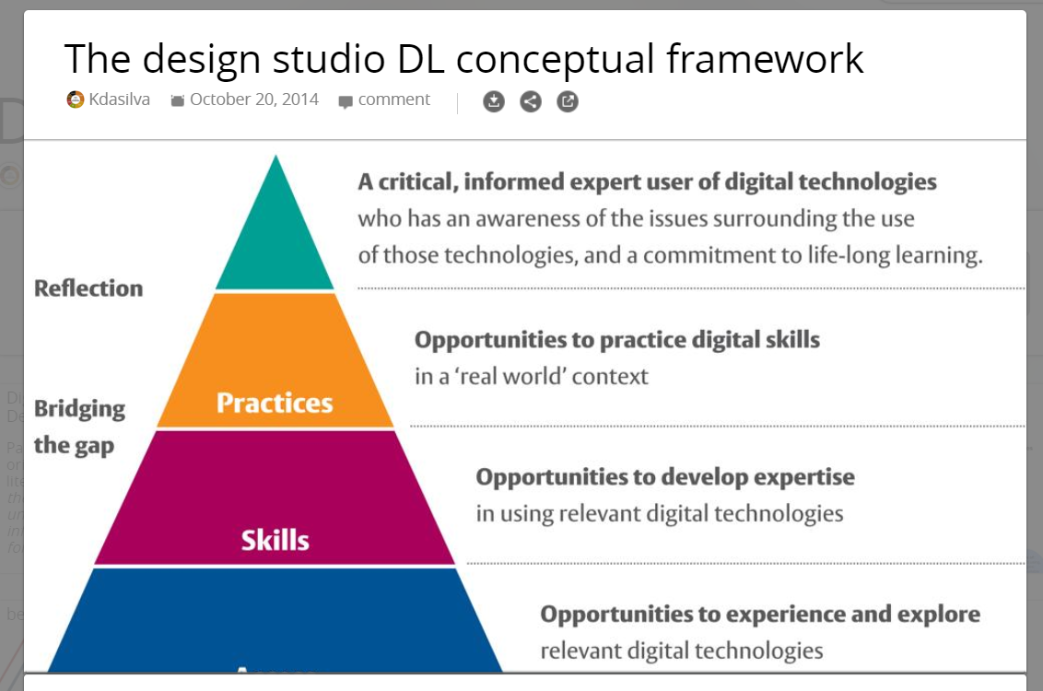
Nine Elements of Digital Citizenship:
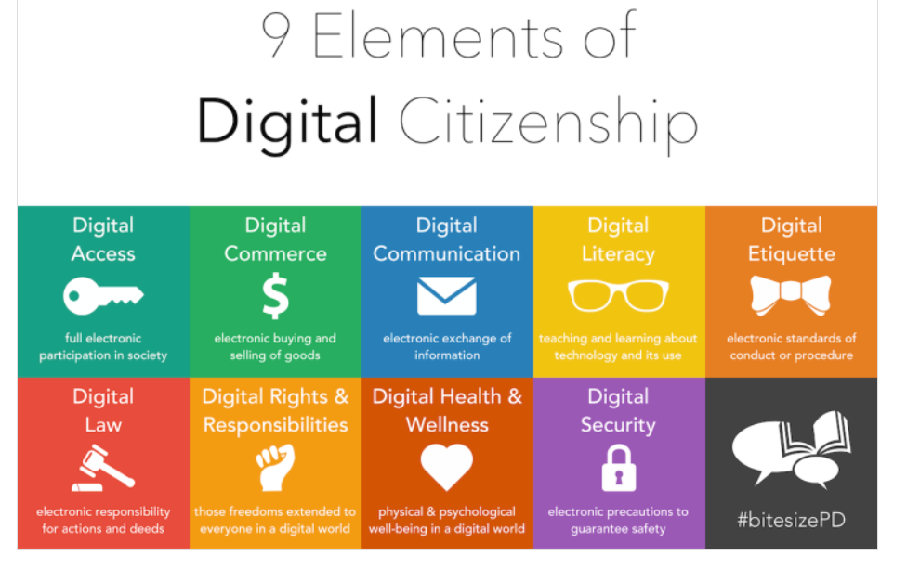
Digital Literacy Course Syllabus 20-21

Teacher(s): Mr. Blake, Ms. Kim, Mr. Raghoobarsingh
Course Portal: Digital Learning Microsoft Teams Site

Course Description:
This course is designed to provide students with opportunities to explore elements of digital citizenship, identify and classify digital terminology, demonstrate knowledge of current and potential uses of digital resources and tools, and aptitude for working in an online environment and establishing an online portfolio.

Course Objectives:
Through Tutorials and Course Assignments Students will:
- Develop communication skills using a variety of digital tools as they relate to online learning, sharing, and collaboration
- Identify and use appropriate tools, technologies, materials, and processes for production.
- Make a step-by-step plan for digital production and carry it out, making changes as needed while providing ongoing feedback
- Understand the process of creation with respect to digital media
- Identify and use a variety of sources of inspiration and information
- Analyze the capabilities and limitations of current and emerging technology resources and assess their potential to address personal, social, lifelong learning, and career needs.
- Explore, Investigate and Design a Blog/Web site that meets accessibility requirements.
- Model legal and ethical behaviors when using information and technology by properly selecting, acquiring, and citing resources.
- Create media-rich presentations for other students on the appropriate and ethical use of digital tools and resources.
- Configure and troubleshoot hardware, software, and network systems to optimize their use for learning and productivity.

Tutorials:
- Tutorial One-Introduction to Course, Navigation through Digital Literacy Teams Site, Assignment Info.
- Tutorial Two- Explore elements of digital citizenship, implications of digital footprints, Assignment Info
- Tutorial Three- identify and classify digital terminology, exploration of current and potential uses of digital resources and tools, Assignment Info
- Tutorial Four- Explore, Investigate and Design a Blog/Web site that meets accessibility requirements.

Assessment:
- Assignment 1: DIGITAL LITERACY QUESTIONNAIRE (5%)
- Assignment 2: Digital Literacy 10 Scavenger Hunt (15%)
- Assignment 3: Digital Literacy Scrapbook Project (20%)
- Assignment 4: Sway Multimedia Project (25%)
- Tutorial Participation – Online Tutorial Videos & Quizzes (20%)
- Edublog Design and Applications (15%)

Course Pacing and Completion Policies
1. Students are expected to complete all self-paced, online course requirements within the QUARTER period.
2. Students are expected to complete 5% of course material within the 1st week of course.
3. A final mark will be assigned to all students who complete at least 50% of the course requirements.

