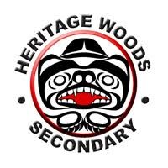

The Assignment:
..................Column Break..................
Name: Sarah M
(First Name and Last Initial)
Advisory #:__________
You will be observing your host throughout the day. There are 3 parts to this assignment:

Part 1- The Interview: Observe your host at work, at some point interview your host and record/make notes of the results
Part 2 - Reflection: After the day is finished, reflect upon your experience and answer the reflection questions Part 3 – Post Your Assignment to Your Blog: Once your have completed Part 1 and Part 2 post it on your blog. Make sure you take pictures and/or videos to document your day, you can place them in your blog.

Name of your host: Shant Bedrossian Relationship to you: Friends dad

The Interview: (ask your host these questions)

1. What is your job title? Maintence planner

2. What is your job description? Planning and scheduling sewer and water maintenance for Metro Vancouver

3. What are the duties and/or tasks you perform at your job? Go on work order system (EAM) and schedule work order jobs onto planning schedule, every different group will have a different chart. Shant works for the construction maintenance

4. What qualifications do you have for this job in the following areas:
a) training? Traffic control courses, confined space entry training and rescue

b) education? Went to BCIT and got a diploma for civil and structural engineering, and a bachelor of engineering

c) experience? Worked in reviewing video footage of sewer (CCTW)

d) skills and attributes (personal qualities)? Good with people, good multitasker, management with field staff

- What are some of the things you like about the job? The people, field staff, real work feeling, working with construction equipment

- What are some of the things you dislike about this job? Large corporation with 1600 employees, cant connect with everyone

- How do you anticipate this job changing in the next 5 years or so? Its constantly changing, all digital with ipads, no paper work, higher tech, improve eliminate combine sewer overflows

Other question (s):
______________________________________________________________________________

Student Reflections:
- Give three reasons why you would like this job (be specific):

A) Good working environment (kind employees)
D) Get the opportunity to work with a variety of different skilled individuals
C) Hands on job (working with construction equipment)

- Give three reasons why you would not like this job (be specific):

A) Dealing with waste in the septic systems and sewer pipes
B) Having to be the middle man between the field workers and office workers
C) Could be messy

- Is this job for you? Why or why not?
Personally this job is not for me. This is because I’m just not interested enough in it and I would Probably find it a bit boring at times. Although I found it cool to see what we saw and it was a very informing and fun day.
- Explain the value of the TYKTW experience in relation to your ideas about your post secondary (after high school) plans (education?, training?, travel?, work?)
I think it was important for us to see what it was like to have to go to work everyday. I don’t know what I’m going to do after high school but I want to travel a lot and have a job that was flexible about moving around a bit later on.

Picture:
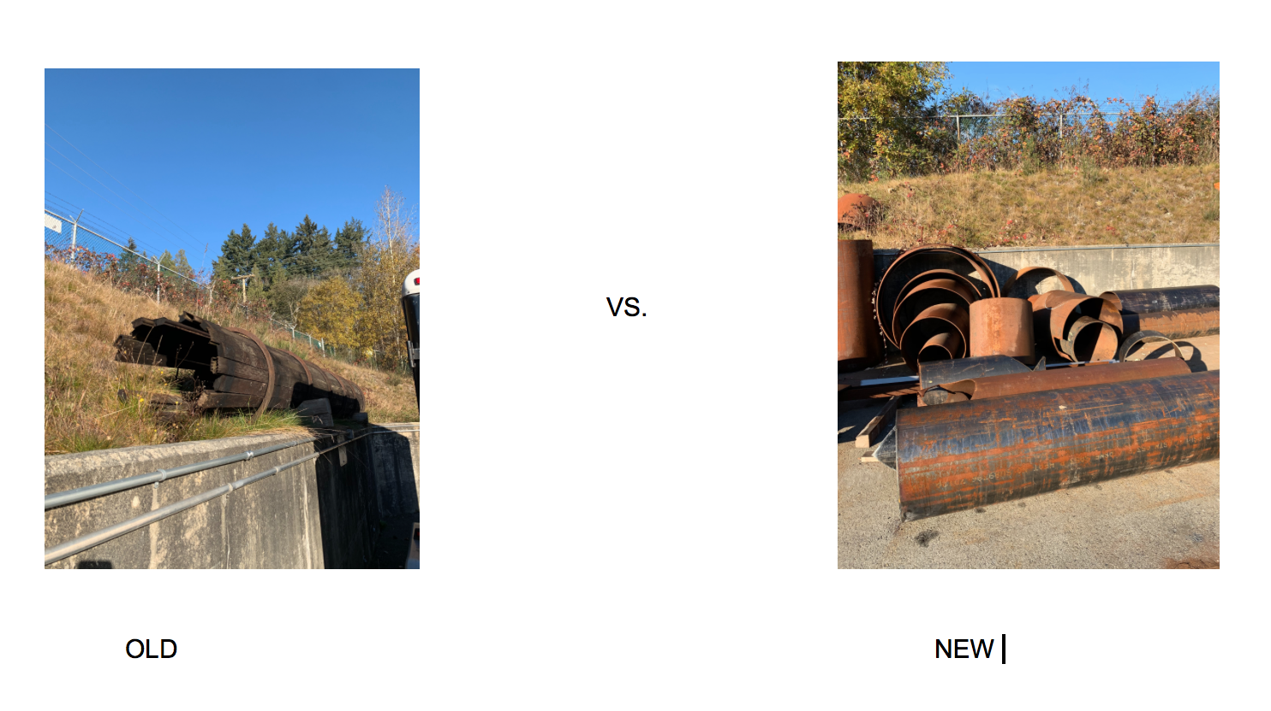
This picture is comparing the old water pipes to the new ones

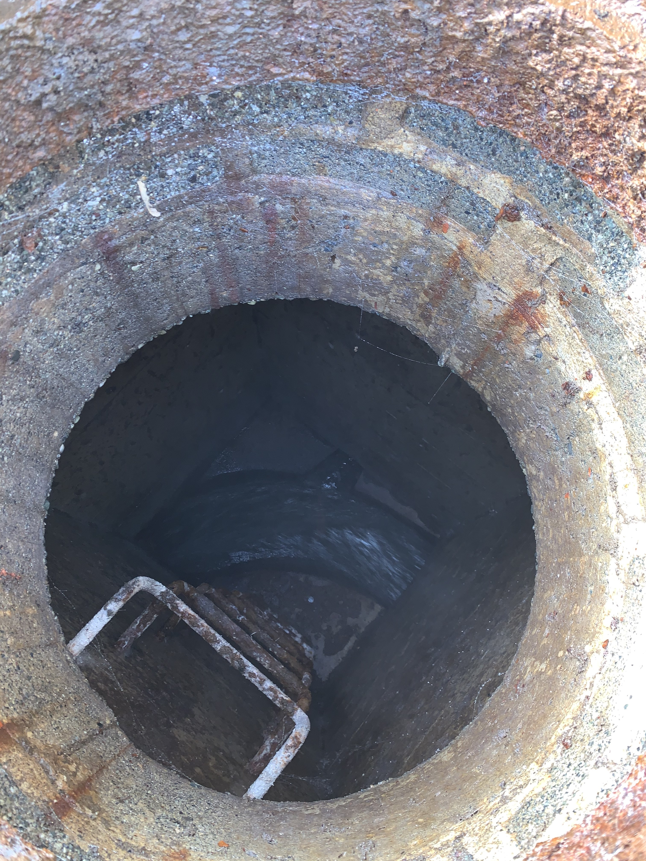

This is a picture of the sewer when we opened the man hole

Blog Post:
Step 1: Go to your Blog Step 2: Create a new POST
- Title: Take Your Kid To Work Day 2018
- Category: Extracurricular
- Tag: This varies by teacher:
    - Aitken - TYKTW2019A
    - Castonguay – TYKTW2019C
    - Raghoobarsingh – TYKTW2019R
    - Hewitt – TYKTW2019H
- Add Media: Add a picture or video of your work place Step 3: Add your assignment to the post by doing one of the following
- Copy and paste the assignment from a word document
- Type in all of the questions and answers
- Upload a PDF or a completed Word Document
Step 4: Click Publish

