Credit Page:

Jenna: Editing, formatting, Materials list, Procedure, Data Table,

Graph, Pictures, Observations

Kimiya: Materials list, Procedure

Ivy: Qualitive Observations, Conclusion

Seojin: Observations Page, Hypothesis, Poster

Do wood bugs prefer...

 Lettuce

              V.S.

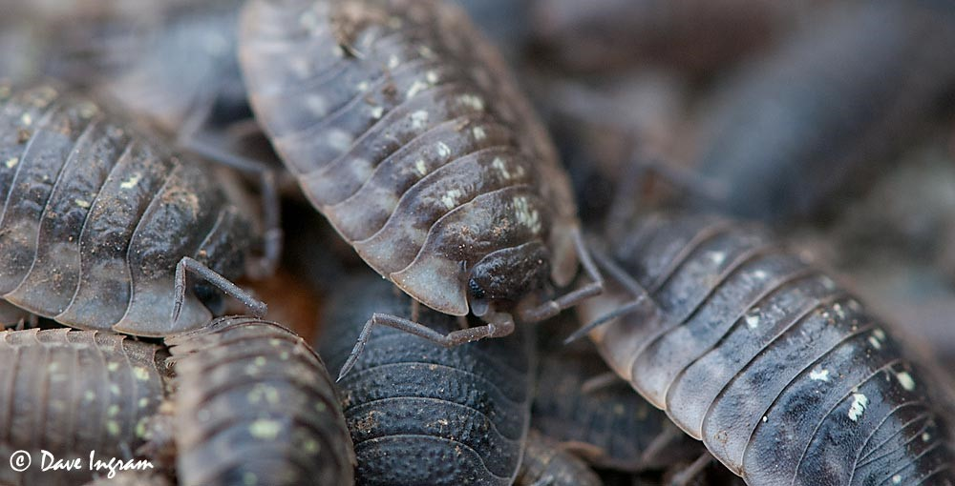

  Berries?

OBSERVATIONS PAGE: We used a cardboard box, filled it with dirt and a few leaves. We placed some salmon berries on the right side of the box and placed one leaf of lettuce on the left. Then, we used a spray bottle and sprayed a little bit of water on the dirt (to keep it moist and wet). Lastly, we placed the 5 bugs inside the middle of the bay, so it can decide where to go. (pictures are on page)

HYPOTHESIS: If the wood bugs stay on either berries or lettuce, then it prefers that over the other.

**Materials List;**

* Container or box (preferably cardboard)
* 5-10 Wood bugs (we used 5)
* Collect dirt and twigs (maybe also some leaves)
* Lettuce (shredded) and berries (we used salmon berries)
* Spray bottle to ensure the habitat is moist.
* Laptop for recording observations and writing a lab
* Pencil (to safely move the bugs away from the edge)

**Procedure:**

Step 1: Find a large enough container to fit up to five wood bugs.

Step 2: Add moist dirt to the container, containing lettuce and salmon berries. (Spray down habitat every so often)

Step 3: Write a hypothesis based on what we know about wood bugs already.

Step 4: Put wood bugs in the enclosed environment.

Step 5: Observe which side the bugs prefer (lettuce side or berries side)

Step 6: Write up a lab, and conclusion

Step 7: FREE THE BUGS 😊 Also properly dispose of your dirt, and clean out your container or box before disposing or re-using

Observations: The wood bugs would not willingly go to the food. We would have to place them on top of the food to test our hypothesis. They stayed on the lettuce, but immediately left the berries. Bigger ones tried to escape more. Smaller one's sort of hid more. They were not as active as we thought they would be. They stayed still a lot, and even when we sprayed down the environment with water, they did not move a lot.

Quantitative observations Data Table:

|  |  |  |  |
| --- | --- | --- | --- |
| Number of bugs | Lettuce preferred | Berries preferred | None |
| 5 | 2 | 0 | 3 |
| Escaped bugs | Attempted escape bugs | Bugs who liked to hide | Active (moved around the most) |
| 1 | 1 | 1 | 2 |

Qualitive observations:

The bigger woodbugs like the lettuce better than the smaller woodbugs. The smaller woodbugs like berrys better than bigger woodbugs.

Graph:

Quantitative observations for do wood bugs prefer lettuce of berries



# of bugs

Cardboard preferred over dirt



escaped



Berries

None

Lettuce



Quantitative Observations

Conclusion: All the woodbugs like humid place. Bigger woodbugs like the lettuce because they are prefer more humid one and smaller woodbugs prefer berry because they prefer less humid yes.

Pictures of natural environment (where you would find wood bugs) *Found off internet*

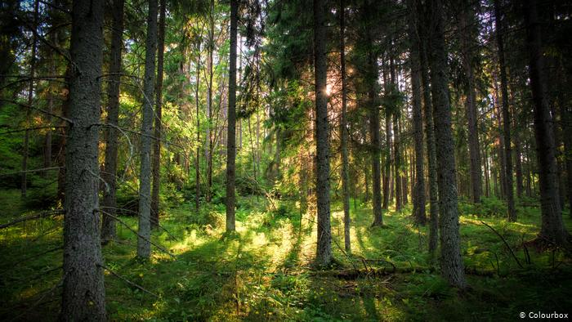

Pictures of our environment that we made:

Scroll down to see (Pictures on next few Pages)

