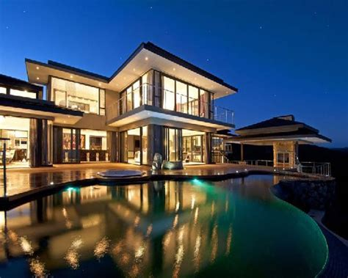
And this house is fully eco friendly
Buy the house and get a FREE tesla

This house is fully furnished with incredibal technollagy. It is a three story house with a fully equipet maid on each floor.This maid can cook, clean, tidy, babysit, and it can preform first aid. It has 4 sweets, 3 closet rooms, an indoor kitchen, an outdoor kitchen, and a infinity pool that’s tempreture is set acording to your skin type and your comfort tempratue without you setting it! It also has a huge back yard with its own robot gardner, and the whole house has heated flooring,and is fully run on solar energy and when you leave the room the lights automaticly closes to save energy.it is located in 112-eagle pass –banff .All this is only for 899,999,999$!!!(tax inculded)For more information call or text this number 778 319 6992 .

Includes all this for FREE: 